Go Social Website Design

Audience Analysis with User Profiles

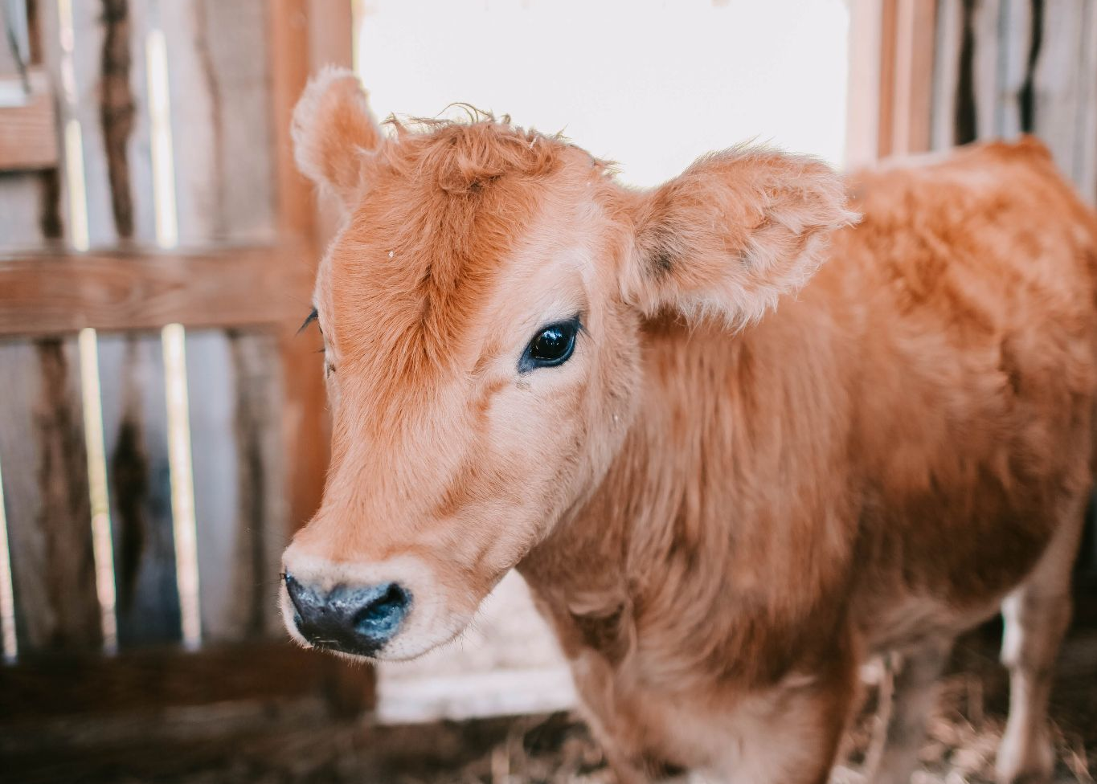
Photo by Leah Newhouse: https://www.pexels.com/photo/brown-calf-inside-barn-1449656/

Demographics
- 47% of dairy farmers are employed full-time while 53% are employed part-time.
- 57% of males are interested in dairy farming as a career and females are at 43%.
- The gender mix for a dairy farmer is 47% for men and 53% for females.

General User Profile
The average dairy farmer is usually a family member or relative of a family farm. They are often managed by the retired dairy farmer from the previous generation. The first generation mentoring the second generation of farmers to run the farm is common since they have the most experience on the farm (being born and raised on the farm). The average age of a dairy farmer is 40+ years old representing 50% of the dairy farmer population.

Detailed User Profile
Richard is a beef farmer looking to find a dairy farm to buy calves from. He has a growing beef herd that he wants to eventually combine with dairy cows, but he’ll keep the beef and dairy cattle separate. To make these changes possible, Richard plans on starting small using the two calves that he bought from the dairy farm. They are two Holsteins, female and male, and have genetics from the best cow on the farm.
With a local dairy farmer willing to mentor the beef farmer on his new dairy production future, Richard has doubled his herd from two to seventy-five head in as little as two years. Being able to use the milk to sell at his local farmers market makes a bit more profit than raising beef cattle alone.

User Scenario 1
Gilbert’s Dairy has been in the dairy business since 1956, starting with Richard Gilbert deciding to care for a Holstein calf whose mother no longer wants to care for. He bottle-fed her, made her a barn to sleep in safely, and decided to buy a tractor to plant corn to feed the calf when she was older. He stays up late at night working on his crop rotation and studying crops and basic bovine health. Richard had a calf that grew into a heifer and was ready to start producing milk. He started his family legacy with one calf named “Miss Moosy” and has since grown into a 500-head dairy farm. In memory of the first calf he raised with his own money, Richard still uses the barn he had built for Miss Moosy for calving.

User Scenario 2
Dairy Farmer Edward Hillbilly, age 65, is a first-generation dairy farmer. His son, Edward Jr, 23, is looking to take the reins of the 200-acre farm. He has a steady income but refuses to quit his job to take over full-time for his father's farm. Edward Jr is constantly watching the markets that his father often ignores. To keep his job and work full time on his father's farm, father and son decided to hire a few college kids who were looking for hands-on work. They would be paid the same salary as Edward Jr is being paid, which is $13 an hour, and all were in agreement. Today Hillbilly Dairy Farm's herd increased from 200 to 500 cattle, thanks to the three college men that worked while attending college, decided to continue working at the farm after graduation, and to Edward Jr for keeping the family farm running under his father's name.

Dairy farmer demographics in the United States - CareerExplorer. (n.d.). Dairy Farmer Demographics in the United States - CareerExplorer. https://www.careerexplorer.com/careers/dairy-farmer/demographics/
Dairy Farmer Demographics and Statistics [2024]: Number Of Dairy Farmers In The US. (2021, January 29). Dairy Farmer Demographics and Statistics [2024]: Number of Dairy Farmers in the US. https://www.zippia.com/dairy-farmer-jobs/demographics/

