Competitive Analysis Report

For Red Bovine Dairy Farm’s

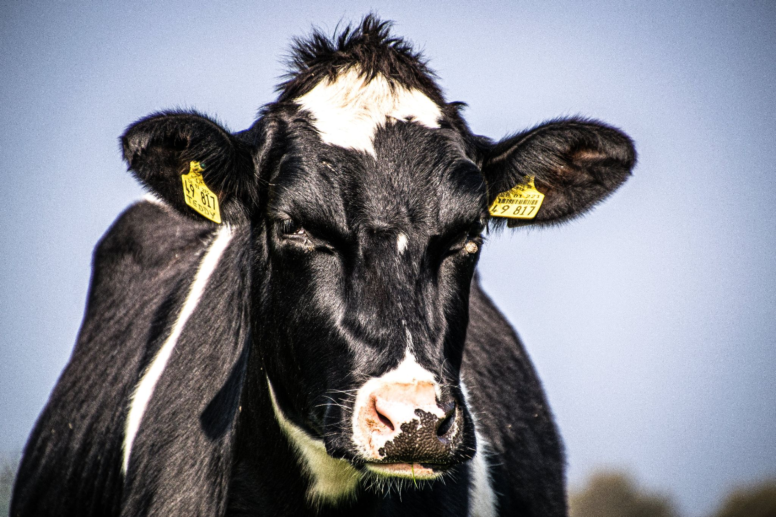
Photo by Matthis Volquardsen: https://www.pexels.com/photo/close-up-photo-of-cow-2350739/

Executive Summary

Red Bovine Dairy is a local dairy farm in south-eastern Wisconsin that's been in business for over 100 years. Its 100th year is coming up and the dairy farm came to us for assistance on promoting the 100th year on their website. With Red Bovine Dairy being a third generation family owned business, the need of a modern website layout and design would make new opportunities for growth.

Methodology/Process/Approach
Red Bovine Dairy’s Marketing Manager, Adam Northwest, approached us for assistance on creating an updated layout and modernizing the existing website to explore more growth opportunities, rather than be in employment or expansion.

Industry Information
According to the Wisconsin State Farmer, Dairy Farms in Wisconsin have been struggling since 2017. 10% of farms have been lost when the United State’s Agriculture census came out in 2022. 30% of farms are dairy. But the dairy farms that have been surviving thus far have only been getting bigger with expansions on herd and production. Milk cows have declined less than 2% by 2017, despite dairy farms calling it quits.

Overview of Competition

Pine Wood Farm’s

Pine Wood Farm’s is a growing herd of 200 head and is located just a few short miles East of where Red Bovine Dairy is located. They raise both beef and dairy cattle along with a flock of 20 southdown sheep. They have no website but do have a Facebook page showcasing their hard working farm hands, and their breeding stock. They also have a Twitter account that they haven’t updated in a while.

The Little Moo LLC

The Little Moo LLC is a family owned business with a 50 cow herd. They have a small blog consisting of pages that are outdated and unorganized. The menu is the only functioning item besides the content itself consisting of images of the cows and the ice cream the farm produces in its own facility.

Findings and Recommendations
Findings:
- Slow loading speeds
- Lack of contrast in navigation bar and links
- Not mobile friendly
- Various crawl errors
- Outdated Hours
Recommendations:
Ensure Website Functionality
- Check for abandoned links
- Make sure the header, nav, and footer match for every page
- Optimize images for faster loading speeds
Review Company Information
- Update hours to ones that are current
- Keep seasonal information seasonal, only release it when it's pertinent
Farm Design, but Modern
- Keep the color scheme of previous website, but improve on it
  - Less black coloring and more white, and include a hero image
  - Think https://www.almanac.com/

Grid Overview

Competitor Feature Comparison Card | Red Bovine Dairy | Pine Wood Farm's | The Little Moo LLC
URL | RedBovineDairy.com | https://www.pinewoodfarns.com/ | https://www.thelittlemoollc.com
Meta Keywords | No | Yes | No
Responsive Design | Yes | Yes | Yes
Logo | Yes | No | No
Navigation | Yes | Yes | Yes
User Friendly | No | No | No
Images | Yes | Yes | Yes
Online Store | Yes | No | No
Contact Info | Yes | No | Yes
Hours of Operation | Yes | Yes | No
Load Time | Fast | Good | Slow at times
Web Server | Wordpress | Facebook | None
Reviews | Yes | Yes | No

Overall Ratings

Competitor Scoring Card |  | Red Bovine Dairy | Pine Wood Farm's | The Little Moo LLC
 |  | (Rank performance on a scale of 1-5) | (Rank performance on a scale of 1-5) | (Rank performance on a scale of 1-5)
Usability Rating of Site |  | 5 | 5 | 1
Content Rating of Site |  | 4 | 4 | 2
Design Rating of Site |  | 5 | 2 | 1
Average User Ratings of Business |  | 5 | 5 | 5
Total |  | 19 | 16 | 9

Appendix

Wisconsin lost 10% of farms, 30% of dairies in 5 years, U.S. agriculture census shows. (n.d.). Wisconsin State Farmer. https://www.wisfarmer.com/story/news/2024/02/15/latest-census-of-agriculture-finds-wisconsin-farms-still-declining/72570807007/
Dairy Farmer Demographics and Statistics [2024]: Number Of Dairy Farmers In The US. (2021, January 29). Dairy Farmer Demographics and Statistics [2024]: Number of Dairy Farmers in the US. https://www.zippia.com/dairy-farmer-jobs/demographics/
Dairy farmer demographics in the United States - CareerExplorer. (n.d.). Dairy Farmer Demographics in the United States - CareerExplorer. https://www.careerexplorer.com/careers/dairy-farmer/demographics/

Wisconsin lost 10% of farms, 30% of dairies in 5 years, U.S. agriculture census shows. (n.d.). Wisconsin State Farmer. https://www.wisfarmer.com/story/news/2024/02/15/latest-census-of-agriculture-finds-wisconsin-farms-still-declining/72570807007/

