Project Scope
Red Bovine Dairy Farms

Molly Atkinson
Dorothy McChesney
Danielle Robinson

Table of Contents
Mission Statement 4
Project Goals 4
Objective Statements 4
Schedule Overview 5
Budget Overview 6
Details and Assumptions 7
Contract Components 8
Appendix 11
Creative Brief 11
Detailed Budget 14
Detailed Schedule 15
Work Breakdown Structure 20

Mission Statement
Our mission is to redesign our current website to promote the inviting feeling of home and community. We would like to build our brand as a place to visit with family or friends and build excitement around our farm and farming. We want to spread the knowledge and education of farming to those who visit with various classes and learning opportunities. We want to incorporate several new pages to include several new events, our products, and the services we offer. We also want to make sure our new design emphasizes our core values of tradition, quality, and integrity.

Project Goals
- Redesigning current website to match the visual qualities of Red Bovine Dairy.
- Promote several events to educate the community about agriculture.
- Red Bovine Dairy wants to promote its milk, cheese, and a variety of products and services on its site to encourage people to support small businesses and farms.
- Having an accessible, family-friendly, and fun website will encourage people to visit the farm and meet our four-legged friends!

Objective Statements
- Craft a visually captivating website redesign for Red Bovine Dairy, capturing the essence of warmth and community, while spotlighting our core values of tradition, quality, and integrity.
- Introduce fresh website sections dedicated to upcoming events, product showcases, and detailed service descriptions for Red Bovine Dairy.
- Integrate informative content about farming, offering diverse classes and learning opportunities directly on the website.
- Boost website traffic by 20% within the initial two weeks of the redesign launch.
- Draw a minimum of 200 visitors to each event promotion through targeted website marketing efforts within the debut month.
- Attain a 10% uptick in online sales of Red Bovine Dairy products within three weeks of the website's fresh look.
- Ensure project feasibility within the allocated resources and budget, emphasizing streamlined processes and prioritizing essential features.
- Collaborate closely with Red Bovine Dairy to swiftly gather content and feedback, expediting the development process.
- Concentrate on key website components aligning with our mission and goals, avoiding unnecessary complexities in design or functionality.
- Harmonize the website redesign with our mission of fostering community, education, and support for small businesses and farms, spotlighting these aspects throughout the design and content.
- Reflect the brand identity of Red Bovine Dairy as a welcoming, family-oriented locale with a passion for agriculture, resonating with our intended audience.
- Achieve website redesign completion and launch within the one-month timeframe, honoring agreed-upon milestones and timelines.
- Coordinate educational content updates and event promotions to coincide with the website launch, sustaining engagement and momentum.
- Provide ongoing website support and updates post-launch, promptly addressing any issues or implementing enhancements.

Schedule Overview
Task | Date Started: Wed 3/13/24 | Final Day: Tue 6/18/24
Define the project | 3/13/24 | 3/25/24
Develop Project Analysis and Plan | 3/14/24 | 3/19/24
Develop Site Structure | 3/26/24 | 3/29/24
Design Visual Interface | 4/1/24 | 4/12/24
Create Design and Concepts | 4/1/24 | 4/10/24
Build and Integrate | 4/15/24 | 5/20/24
Content and File Structure | 4/15/24 | 5/10/24
Delivery and Launch | 5/21/24 | 5/31/24
Handoff and Launch | 5/24/24 | 5/27/24

Budget Overview
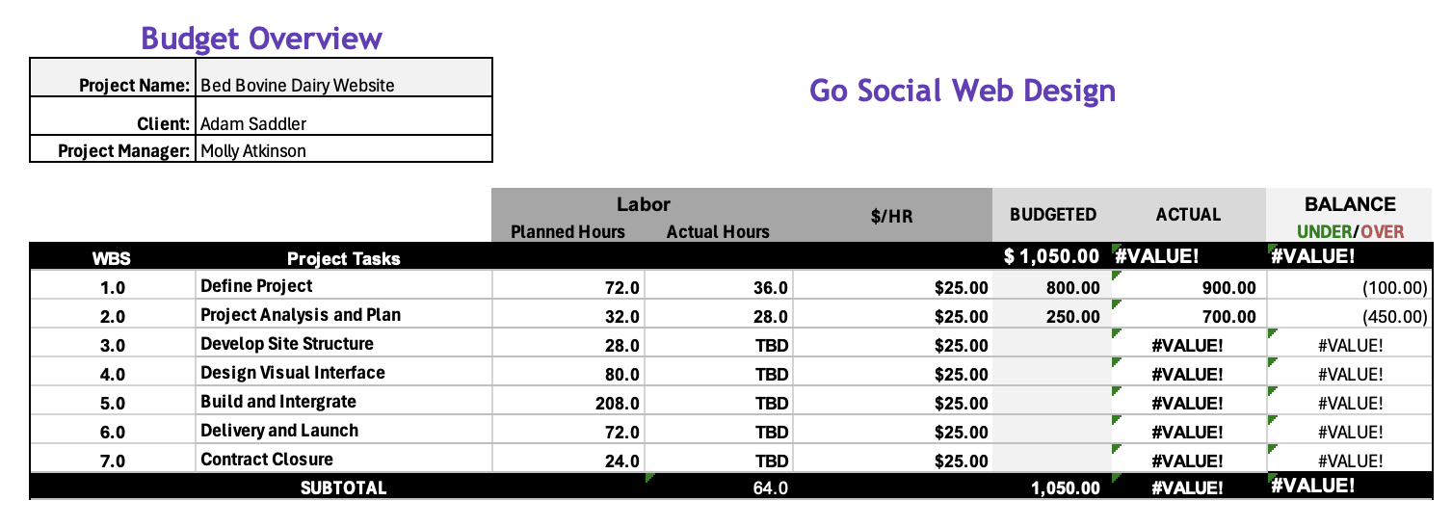

Details and Assumptions
PROJECT
- Go Social Web Design (GSWD) was hired by Red Bovine Dairy Farms to redesign their website with an estimated completion date of July 2024
- HTML5 and CSS3 coding will be used for site design
- Any additions or changes not included in this scope may result in additional time and costs
- Additions or changes will be relayed by using the change form and approved/denied by the Project Manager
- Website will have compatibility with Chrome, Edge, Firefox

CLIENT
- Required client documents for content should be submitted in MS Word format
- Required client graphics and images should be submitted in .jpg or .png format
- Client will meet all due dates or alert GSWD to the delay in delivery of any requested items promptly
- Client will provide logo and color palette before the start of the project
- Client will formally submit any additions or changes via the change form
- Client will follow the payment schedule
DEVELOPER
- GSWD will comply with current accessibility and validation standards
- GSWD will be consistent with the layout and theme of the website
- GSWD will use responsive design
- GSWD will provide weekly meetings or updates about progress
- GSWD will provide training on website maintenance and updates to the site
- GSWD will follow this Scope as closely as possible but it is subject to change

Please keep in mind, that 2 or 3 rounds of design are appropriate/expected, if more rounds are asked for or needed, it will affect the budgets and schedules.

Contract Components
Web Design Contract

Parties: [Name of Client] (“Red Bovine Dairy Farms”)
[Name of Designer/Agency] ("Go Social Website Design")

Date of Agreement: [3/13/2024]

1. Scope of Work: Designer agrees to provide web design services for the Client, including but not limited to:
- Creation of a custom website design
- Development of website functionality
- Integration of client-provided content
- Testing and deployment of the website
- Use responsive design

2. Payment Terms:
- The total project cost is [Total Amount], payable as follows:
  - $500 dollars will be deposited on agreement of terms.
  - Paid monthly.
- Payment shall be made in [U.S Dollars] via [check, debit, CC, PayPal].
- Late payments shall incur a [1.5%] fee for each [month] overdue.

3. Timeline: The project timeline shall be as follows:
Define the project | 3/13/24 | 3/25/24
Develop Project Analysis and Plan | 3/14/24 | 3/19/24
Develop Site Structure | 3/26/24 | 3/29/24
Design Visual Interface | 4/1/24 | 4/12/24
Create Design and Concepts | 4/1/24 | 4/10/24
Build and Integrate | 4/15/24 | 5/20/24
Content and File Structure | 4/15/24 | 5/10/24
Delivery and Launch | 5/21/24 | 5/31/24
Handoff and Launch | 5/24/24 | 5/27/24
Maintenance | 5/31/24 | 6/13/24
Contract Closure | 6/14/24 | 6/18/24
4. Client Responsibilities: Client agrees to provide the following:
- Required client documents for content should be submitted in MS Word format
- Required client graphics and images should be submitted in .jpg or .png format
- Client will meet all due dates or alert GSWD to the delay in delivery of any requested items promptly
- Client will provide logo and color palette before the start of the project
- Client will formally submit any additions or changes via the change form
- Client will follow the payment schedule

5. Revisions: Designer will provide [Number of Revisions] rounds of revisions. Additional revisions will be billed at an hourly rate of [$25.00].

6. Ownership and Rights: Upon full payment, the Client owns the website design and content. The Designer retains the right to showcase the project in their portfolio.

7. Termination: Either party may terminate this contract by providing written notice to the other party at least 30 days prior to the desired termination date.

8. Confidentiality: The Receiving Party agrees not to disclose any Confidential Information to any third parties without the prior written consent of the Disclosing Party.

9. Governing Law: This contract shall be governed by and construed in accordance with the laws of [United States of America] and the [State of Wisconsin].

10. Entire Agreement: This contract constitutes the entire agreement between the parties and supersedes all prior agreements or understandings.

IN WITNESS WHEREOF, the parties hereto have executed this contract as of the date first above written.

[Signature of Client] Adam Saddler/Red Bovine Dairy

[Signature of Designer/Agency] Molly Atkinson/Go Social Website Design

[Printed Name of Client] Red Bovine Dairy

[Printed Name of Designer/Agency] Go Social Website Design

Appendix

Creative Brief

Overview
Red Bovine Dairy is a century-old dairy located in Southeastern Wisconsin. They are looking to create a warm and inviting online presence as they build on their history and offer new experiences. They would like to embrace a modernistic design while holding onto the authenticity and natural charm their current site has, resulting in a more efficient, easy-to-navigate site with a fresh look. They want to include smoother navigation, and customer reviews, highlight upcoming events, showcase products and services, and offer a careers page.

Mission Statement
Our mission is to redesign our current website to promote a homey and inviting feel. We want to incorporate several new events, products, and services, as well as emphasize our core values. We would like to build our brand as a place to visit with family or friends and build excitement around farming and our farm.

Target Audience (Profile)
People looking to have a good time or get a hand in the farming industry. Farming isn’t for the faint of heart, typically, young adults are brought into the farming business due to being raised on a farm or from working as a farm hand. Some people even start up their farming adventure from scratch. However, all adults must have some kind of experience with farming or with agriculture in general. Agriculture is one of the most dangerous fields of work. With the celebration of 100 years, highlight the various services and products we have to offer.

Competitive Positioning
https://budjon.com/

Budjon Farms has a lot of experience in the dairy industry despite being in business for 25 years. I chose their website because the images were not only eye-catching, but they were telling a story. Their website is easy to navigate and you don’t have to scroll as much for information about the farm. They value their clients and share their reviews on the page. A great website and an even better competitor.

Creative Tone (Perception)
The creative tone of this website should come off as a natural, welcoming, at-home experience. When one visits Bovine Dairy Farms, we want them to feel like they just stepped into a happy and welcoming environment, where they can have a great time with their friends or family (or, just solo). We want our clients to be excited to learn about our farm, and even more excited to come back.Goals
- Increase web traffic to 1,500 viewers
- Increase foot traffic by at least 250 people
- Highlight the events we have planned for our 100-year celebration
- Revamp the site to look modern, comforting, warm, and natural
  - New fonts
  - Updated images
  - Updated open hours
- Include reviews
- Include a careers page
  - May or may not be hiring, but will deliberate
- Smoother navigation
- Highlight our core values
  - Family, organics, small business importance, quality
- Highlight products and services
  - Must be ordered via a form or via the phone

Target Message
After 100 years in the business, Red Bovine Dairy Farm wants to thank one person: you, the customer. Since we’ve been running, it’s you who’s kept us up and operating, especially through the rough patches. We want to show you just how much we’ve grown over these years and appreciate all of the support we’ve gotten from our neighbors, families, and friends, as we continue our business. Without you, we wouldn’t be where we are today, and by visiting our farm or buying products from us, you’ll get to experience the wonder that comes with our 100-year celebration.

Signature
Client Signature: x_Adam Saddler___ Date: __2/28/2024___

Detailed Budget
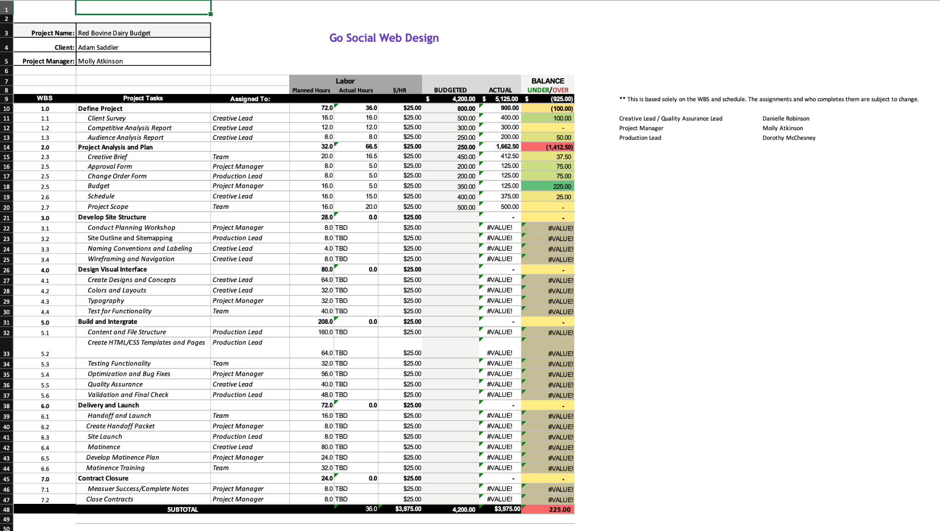

Detailed Schedule
Task | Work Days | Date Started: Wed 3/13/24 | Final Day: Tue 6/18/24
Define the project | 9 days | 3/13/24 | 3/25/24
Client Survey | 2 days | 3/14/24 | 3/19/24
Develop Project Analysis and Plan | 4 Days | 3/14/24 | 3/19/24
Competitive Analysis Report | 1 1/2 Days | 3/14/24 | 3/15/24
Audience Analysis Report | 1 Day | 3/15/24 | 3/18/24
Creative Brief | 1 Day | 3/18/24 | 3/19/24
Develop Project Plan | 1 day | 3/19/24 | 3/20/24
Set Budget and Create Schedules | 2 days | 3/20/24 | 3/21/24
Create Scope | 2 days | 3/21/24 | 3/22/24
Develop Site Structure | 3.5 days | 3/26/24 | 3/29/24
Conduct Planning Workshop | 1 dat | 3/26/24 | 3/29/24
Site Outline and Sitemapping | 1 day | 3/27/24 | 2/27/24
Technical Architect
Naming Conventions and Labeling | 1/2 day | 3/28/24 | 3/28/24
Technical Architect
Wireframing and Navigation | 1 day | 3/28/24 | 3/29/24
Technical Architect
Design Visual Interface | 10 days | 4/1/24 | 4/12/24
Create Design and Concepts | 8 days | 4/1/24 | 4/10/24
Colors and Layouts | 4 days | 4/1/24 | 4/4/24
Technical Architect
Typography and Graphics | 4 days | 4/3/24 | 4/8/24
Technical Architect
Test for Functionality | 5 days | 4/8/24 | 4/12/24
Technical Architect
Build and Integrate | 26 days | 4/15/24 | 5/20/24
Content and File Structure | 20 days | 4/15/24 | 5/10/24
Create HTML/CSS Templates and Pages | 8 days | 4/15/24 | 4/25/24
Technical Architect
Testing Functionality | 4 days | 4/24/24 | 4/29/24
Project Manager
Quality Assurance Manager
Technical Architect
Optimization and Bug Fixes | 5 days | 4/26/24 | 5/6/24
Technical Architect
Quality Assurance | 5 days | 4/26/24 | 5/6/24
Validation and Final Check | 6 days | 5/13/24 | 5/20/24
Quality Assurance Manager
Technical Architect
Project Manager
Delivery and Launch | 9 days | 5/21/24 | 5/31/24
Handoff and Launch | 2 days | 5/24/24 | 5/27/24
Create Handoff Packet | 1 day | 5/24/24 | 5/24/24
Site Launch | 1 day | 5/27/24 | 5/27/24
Maintenance | 10 days | 5/31/24 | 6/13/24
Develop Maintenance Training | 3 days | 6/5/24 | 6/7/24
Technical Architect
Maintenance Training | 4 days | 6/10/24 | 6/13/24
Technical Architect
Contract Closure | 3 days | 6/14/24 | 6/18/24
Measure Success/Complete Notes | 1 day | 6/17/24 | 6/17/24
Close Contract | 1 day | 6/18/24 | 18-Jun

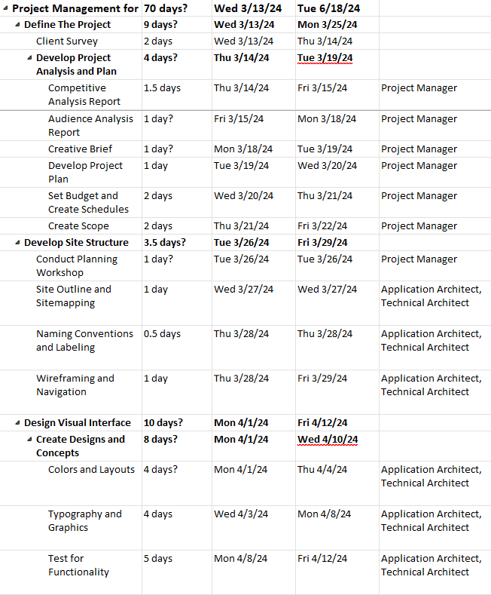
Work Breakdown Structure
