Key User Path and User Scenarios
Red Bovine Dairy Farms

Molly Atkinson
Dorothy McChesney
Danielle Robinson
User Scenarios
Detailed User Scenario
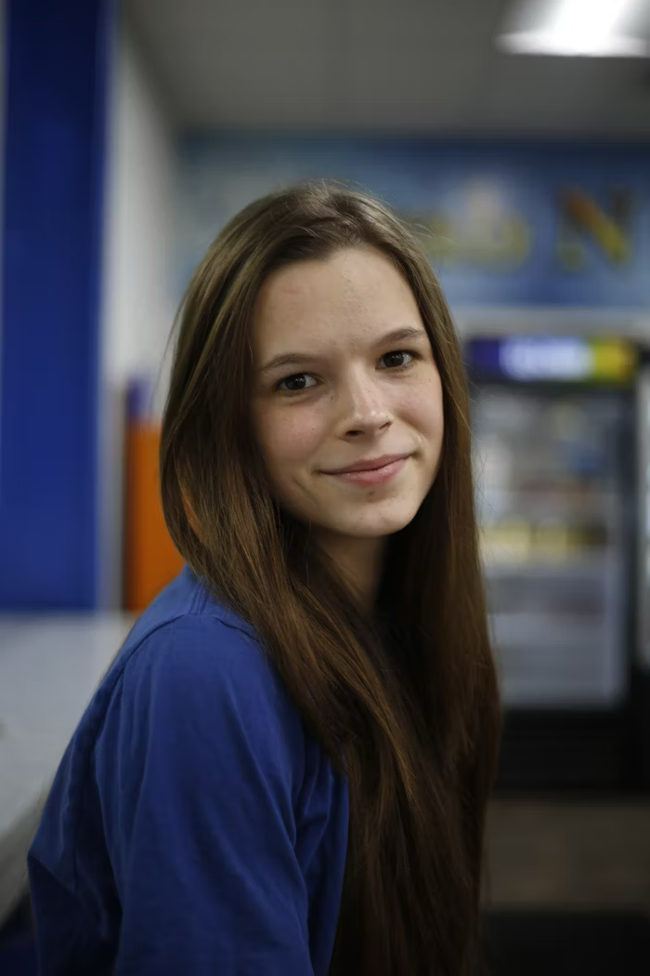
Pictured: Lorelai Martin
Lorelai Martin comes from Milwaukee, where she graduated from the University of Wisconsin Madison with a bachelor’s degree in accounting. After graduating, she found herself less than happy with the path her life was going and decided she wanted to have a more “hands-on” experience In the work field. She had heard about different opportunities that would allow her to remain in Milwaukee but decided she didn’t want to live there.
Using her laptop, she searched online for places in Wisconsin that were looking for help, like the DNR, city governments, and farms. After searching for a bit, she found Red Bovine Dairy’s website, saw they had a careers tab, and decided to fill out an application.
She heard back within a week and was told that they were looking for help around the farm during the upcoming summer season. Red Bovine Dairy sent over different benefits, including room and board, that she would get if she were to work there. Starting in May, Lorelai will start working at Red Bovine Dairy as a farm hand and has been told if it works out, she may be able to stay further than the season.
User Scenario 1

Pictured: Christine Diaz
Ms. Diaz is an elementary school teacher in the Brownsville area, and her class has begun their agriculture unit. She wants to take them on a field trip to a friendly, open environment where they can learn about the agriculture field, while still having fun. She has recently come across Red Bovine Dairy after her friend had told her about their 100-year celebration and thinks it would be a great experience for the kids.
User Scenario 2

Pictured: Dolly and Richard Lewis
Richard and Dolly are an older couple that have decided to spend their retirement venturing around their home state of Wisconsin. After their travels, they’d heard that Red Bovine Dairy was “being upgraded”, and had one of their children show them their website. There, they found out about their 100-year celebration event, and have decided that they wanted to attend, see some friends, and see how far the farm has come from when they saw it in their late teens.
Key User Path
The navigation bar will be the same across all pages, so the user is able to access them quickly and easily. There is the home, about, events, learning, and careers page, which all have a description below.
Home: Welcomes the user to the site, provides a few buttons that connect to about pages (owner and the farm), which connect to the history portion as well.
About: Introduces the owner of the farm, Adam Saddler, as well as has a virtual tour (images in a slideshow/column) that highlights the main parts of the farm and a one sentence description about them.
Products: View the products available from the farm
Services: View available services
Events: Provides information about upcoming events, where they take place, and when the take place
Learning: Provides how to bring students to the farm for a field trip or have some members of the farm come out to the school for an educational day.
Careers: Connects to the contact page as well as provides a download for an application to turn into the farm via mail (hardcopy/scanned email only)
Gallery: View photos of the farm!
Contact: Provides contact information for the farm.
