NAVIGATION
The website will be structured in a tabbed model for organization. The navigational links (Home, About, Events, Products, Services, Learning, and Gallery) will be located at the top of each page with clear and understandable wording to direct the user to the desired location. The company logo will be located in the upper left corner and will link to the home page.
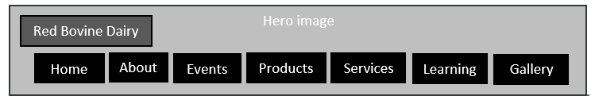
In the footer of each page, links to the Careers and Contact Information will be included as well as the copyright, address, and phone number of the business.

