Sitemap and Wireframe
Red Bovine Dairy Farms

Molly Atkinson
Dorothy McChesney
Danielle Robinson
Sitemap
Zoom to see details.
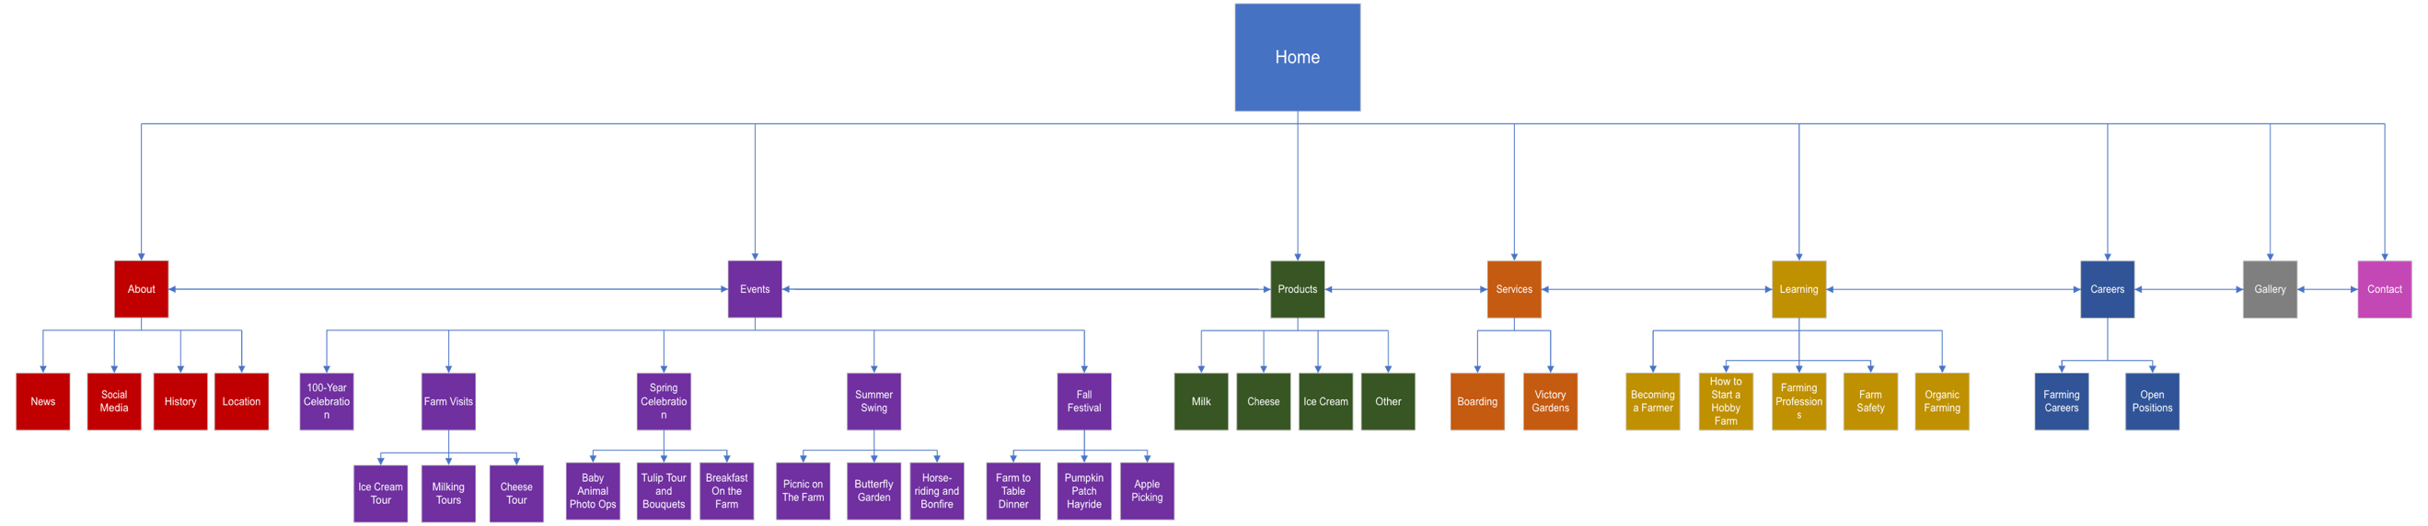

Wireframe
Hero image
Red Bovine Dairy
Gallery
Learning
Services
Products
Events
About
Home
Welcome Paragraph
Lorem ipsum lorem ipsum Lorem ipsum lorem ipsum Lorem ipsum lorem ipsum Lorem ipsum lorem ipsum Lorem ipsum lorem ipsum Lorem ipsum lorem ipsum Lorem ipsum lorem ipsum Lorem ipsum lorem ipsum Lorem ipsum lorem ipsum Lorem ipsum lorem ipsum Lorem ipsum lorem ipsum Lorem ipsum lorem ipsum Lorem ipsum lorem ipsum Lorem ipsum lorem ipsum Lorem ipsum lorem ipsum

Picture of Farm

Careers
Contact
About Summary
Lorem ipsum lorem ipsum Lorem ipsum lorem ipsum Lorem ipsum lorem ipsum Lorem ipsum

Read More -> [About]
Meet the Farm ->
Picture of Cow
Picture of Owner
Meet Us ->

