Design Approval Document
The following website layout and color palette have been approved for:
Red Bovine Dairy Farm
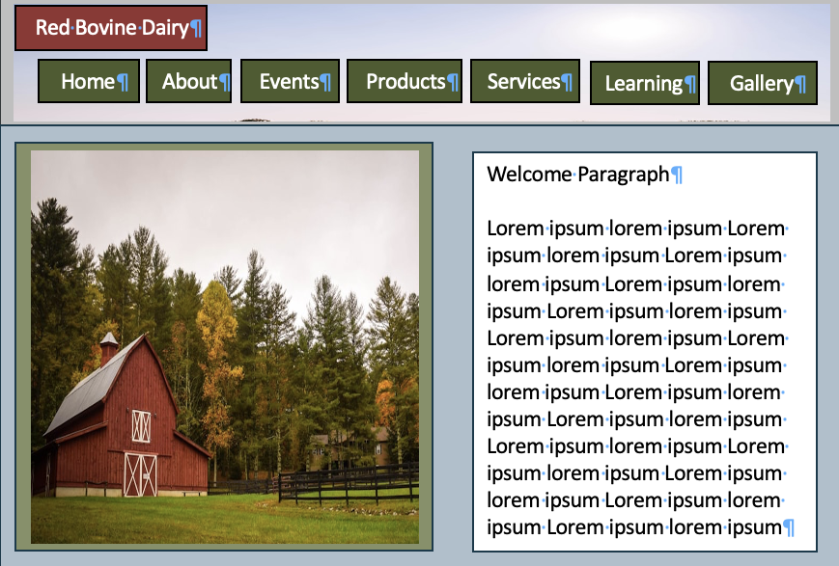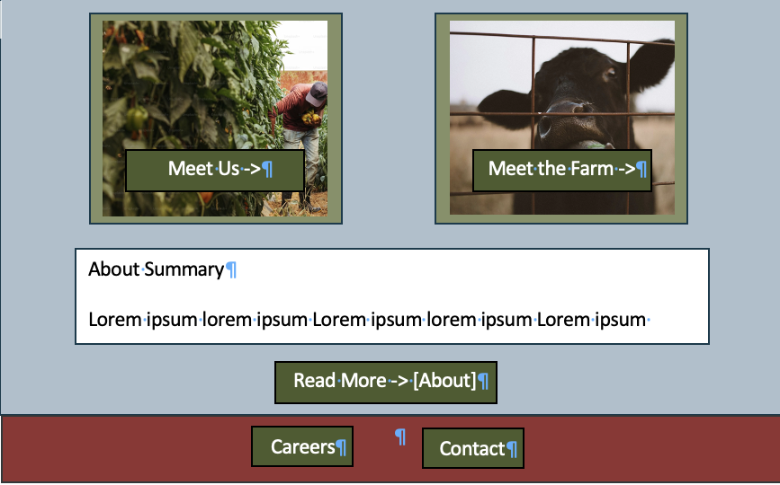
#89966A
#4D5A2E
#CBB48B
#ACC0CB
#923432
By signing this document, both parties have approved the layout and color palette for Red Bovine Dairy’s website. Any changes to be made going forward must be made through a change order form.
Client Signature:
x_Adam Saddler___ Date: __4/4/2024___
Project Manager Signature:
x_Molly Atkinson ___ Date: __4/4/24___

