Functional Specifications

Summary
The primary goal for the Red Bovine Dairy Farm website is to enable users to navigate effortlessly and explore all the products and services offered by the farm. The design strategy aims to maintain simplicity for universal usability, yet with sufficient sophistication to accommodate future enhancements and expansions.

Assumptions
The website will be functional and responsive on all device types, including smartphones, tablets, and computers.

Global Elements
All global elements will be consistent throughout the website, including the header, navigation, and footer.

Page-Specific Elements

Home Page
The home page consists of a primary text box for welcome information and images representing the farm and its activities. It also includes links to position opportunities and career information.
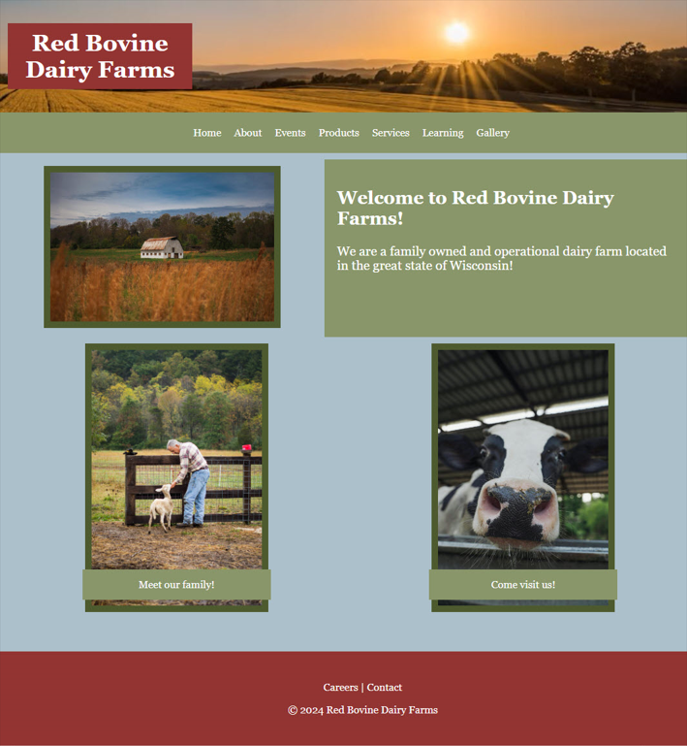

About Page
The About page will showcase images of the owner and the farm, along with general information about the farm. Additionally, secondary information related to the history of the farm will be included.

Events Page
The Events page will highlight the upcoming events, accompanied by images from previous events. The secondary details will provide expected dates, updates to the event, and a synopsis of the event.

Products Page
The Products page will feature images, descriptions, and prices for all available products at Red Bovine Dairy Farm. The description and price will be underneath the corresponding product image.

Services Page
The Services page will contain images and information on the services offered, boarding and Victory Gardens.

Learning Page
The learning page will contain images and information about farming, organic farming, hobby farming, professions in farming, and farm safety for educational purposes.

Careers Page
The Careers page will offer information on careers in farming and list open positions at the farm. There will be a link to an application to apply for any farm positions that are available.

Gallery Page
The Gallery page will highlight images from red Bovine Dairy Farm’s past events, family of animals, tours, and harvests.

Contact Page
The Contact page will have the Red Bovine Dairy Farm address, phone number, and map at the top of the page. Below will be a general contact form asking for name, email address, and feedback.

Acknowledgment
The client consents to all the details outlined in the technical specifications section of the design style document. Any updates must be submitted through a change form and approved by Go Social Web Design.

Approval
Client Signature:
x_Adam Saddler___ Date: __4/8/2024___

