Color Palette and Wireframe Options
Red Bovine Dairy Farms

Molly Atkinson
Dorothy McChesney
Danielle Robinson

Wireframe Option 1
Color Palette 1
#89966A
#4D5A2E
#CBB48B
#ACC0CB
#923432
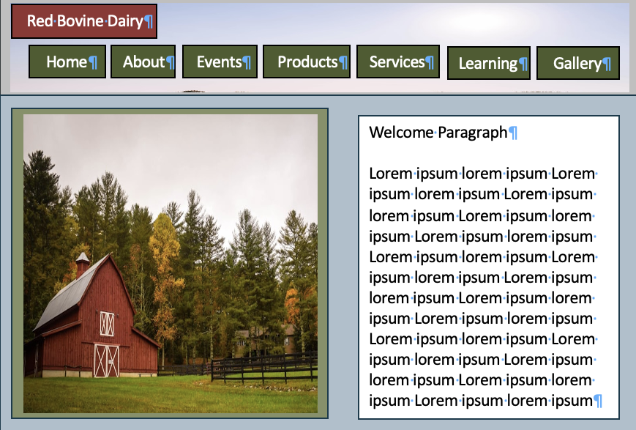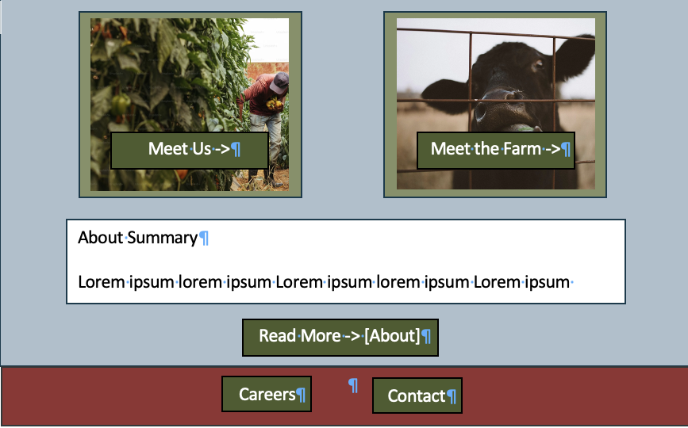

Color Palette 2
#8C1C13
#BF4342
#E7D7C1
#A78A7F
#735751
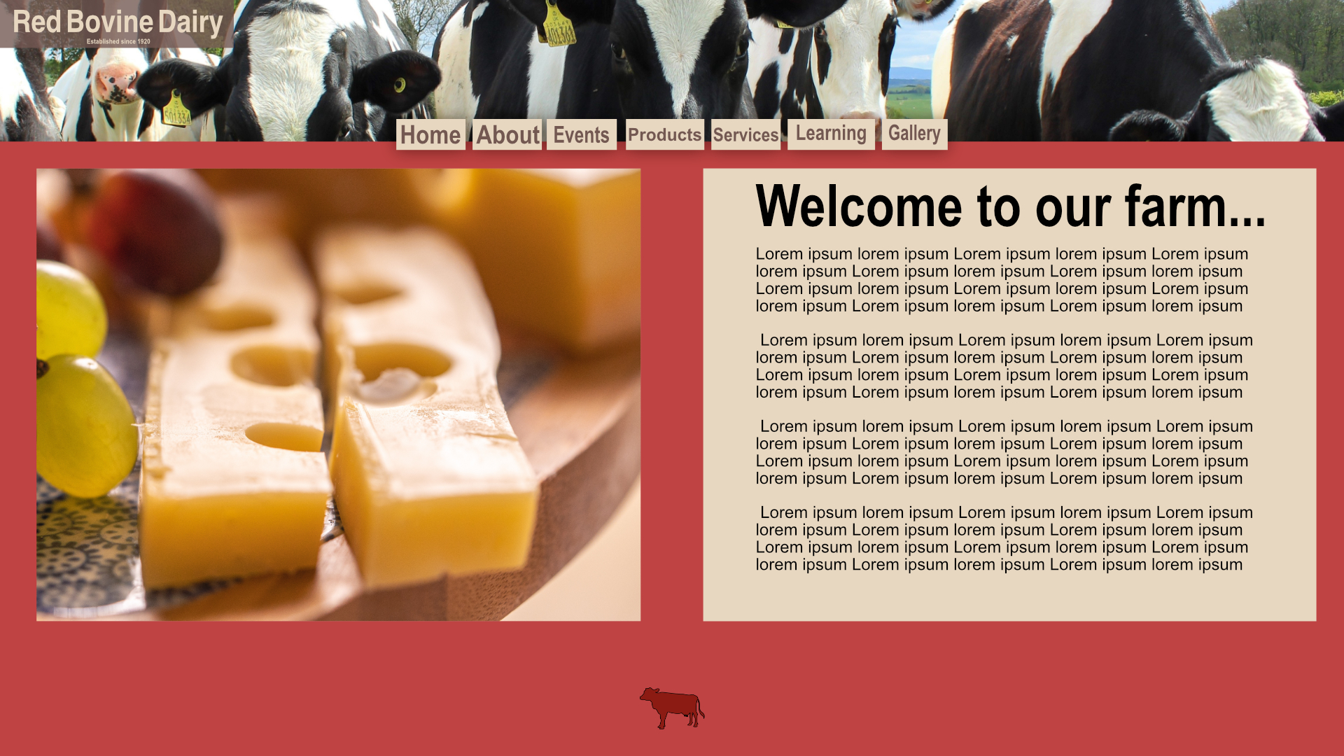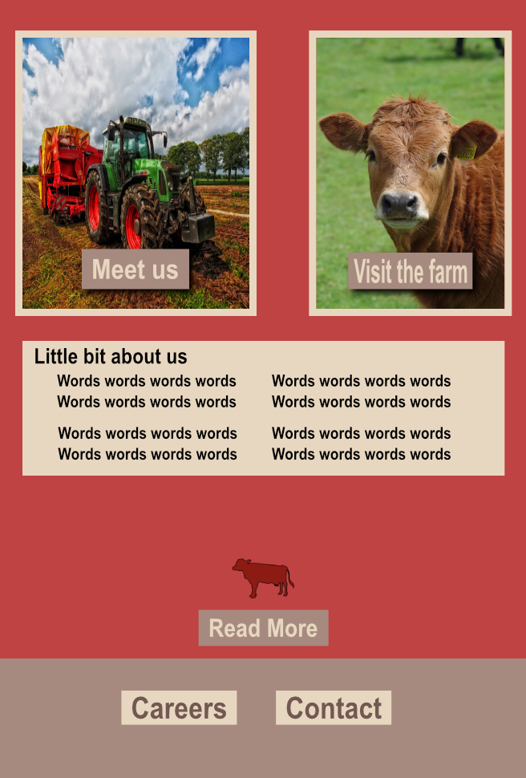
Color Palette 3
#141E28
#103F50
#770018
#903403
#E17C1D
Wireframe Option 2
Color Palette 1
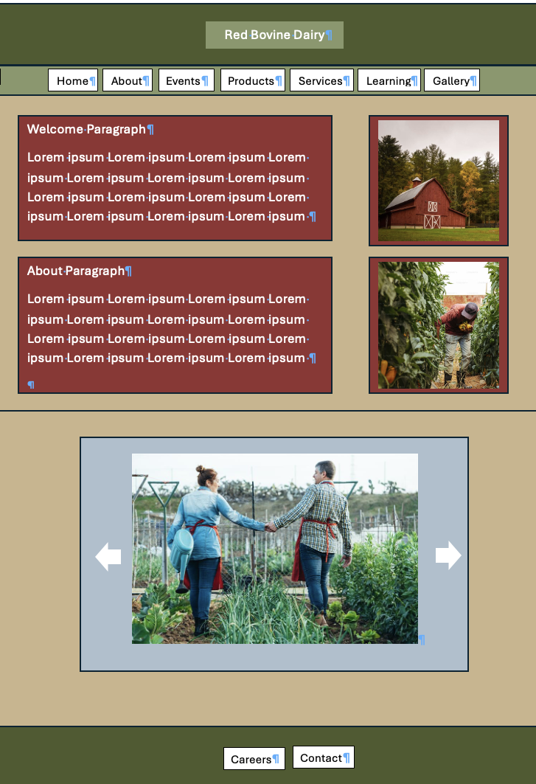
Color Palette 2
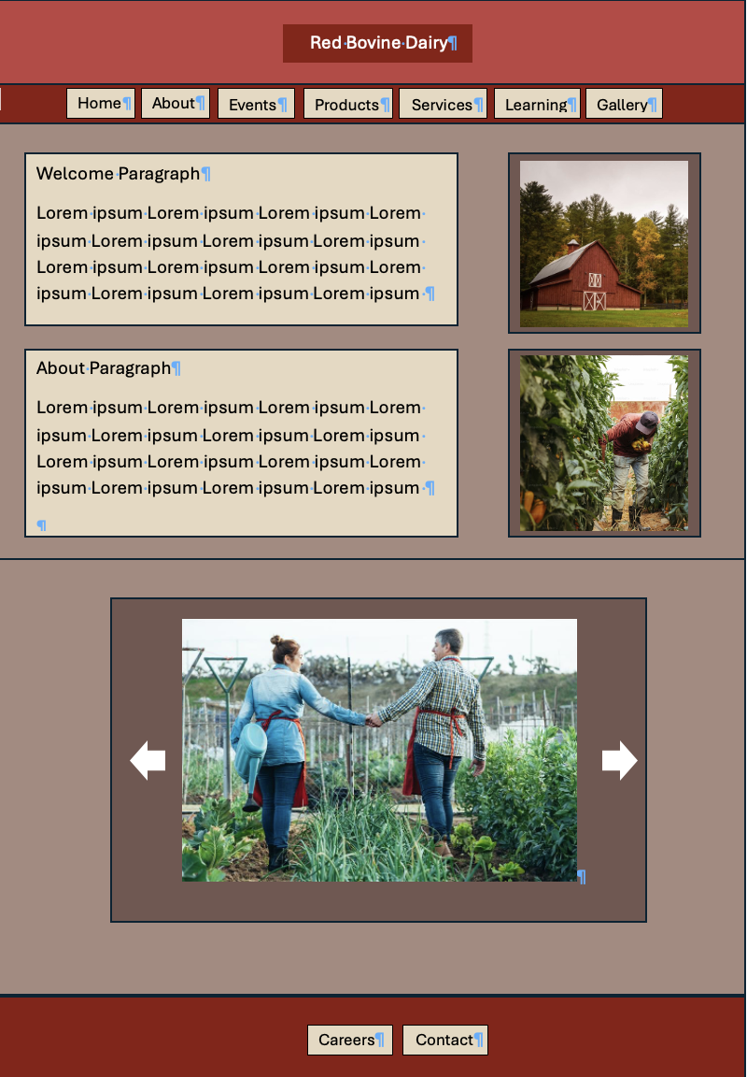
Color Palette 3
