Design Style Document
Red Bovine Dairy Farms

Molly Atkinson
Dorothy McChesney
Danielle Robinson

Contents
Design Style 5
Global Elements 5
Page Dimensions 5
Global Element Sizes 5
Colors 6
HTML Text 6
Graphic Type 7
Page-Specific Elements 8
Home 8
About 8
Events 8
Products 9
Services 9
Learning 9
Gallery 10
Contact 10
Careers 10
Acknowledgment 11
Approval 11
Technical Specifications 12
Technical Summary 12
Assumptions 12
Global Elements 12
Template 13
Color Scheme 14
Global Elements 14
Global Header 14
Global Navigation 16
Global Footer 17
Page-Specific Elements 18
Home Page 18
Naming Conventions 20
File Extensions 21
Navigation Bar Labels 21
Programming 22
Languages 22
Development Tools 22
Acknowledgment 23
Approval 23
Functional Specifications 24
Summary 24
Assumptions 24
Global Elements 24
Page Specific Elements 25
Home Page 25
About Page 26
Events Page 27
Products Page 27
Services Page 27
Learning Page 27
Careers Page 27
Gallery Page 28
Contact Page 28
Acknowledgment 28
Approval 28
File Structure 29
Privacy Policy 30
1. Information We Collect: 30
2. How We Use Your Information: 30
3. Information Sharing: 31
4. Security: 31
5. Third-Party Links: 31
6. Updates to Privacy Policy: 31
7. Contact information: 31
Signatures and Approvals 32

Design Style
The information outlined in this document is for the code and design for Red Bovine Dairy, which can be found at: https://dotmcchesney.com/redbovinedairyfarms/

Global Elements

Page Dimensions
Page dimensions will vary under media queries, which ensures a responsive website.
- max-width: 600px
- max-width:767px
- min-width: 768px and max-width 1023px

Global Element Sizes
Header Text: 10px padding on all sides, #923432, inside of banner, float center-left
Banner: Fixed at top of page, #CBB48B
Navigation: Fixed under the header, #89966A
Footer: Fixed at bottom of page, #923432

Colors
Text Background: #89966A
Button Background, Image Border: #4D5A2E
Header Background: #CBB48B
Background: #ACC0CB
Logo Background: #923432

HTML Text
Primary: Georgia
Secondary: Times
Fallback Order: Georgia, Times, Times New Roman, Serif
H1 Text Size: 2.25 REM (36px)
H2 Text Size: 1.75 REM (28px)
H3 Text Size: 1.5 REM (24px)
H4 Text Size: 1.25 REM (20px)
H5 Text Size 1.125 REM (18px)
H6 Text Size: 1 REM (16px)
Navigation Text Size: 1 REM (16px)
Body Text Size: 1 REM (16px)

Graphic Type
The graphic type should match the font selected for the HTML of the page (Georgia) and should follow the same fallback hierarchy as the HTML as well (Times, Times New Roman, Serif) if the option before isn’t available.

Page-Specific Elements

Home
- Header-navigation spans the top of the page.
- Footer spans the bottom of the page.
- All text boxes have a white font color and a background color of #89966A
  - Text boxes are responsive and will change size depending on media query
- All images have a solid, 10px #4D5A2E border
  - Images are responsive and will change size depending on media query

About
- All text boxes have a white font color and a background color of #89966A
  - Location will be listed
  - Hours will be listed
  - Text boxes are responsive and will change size depending on media query
- All images have a solid, 10px #4D5A2E border
  - Image of Adam Saddler, including a brief history of the farm

Events
- All text boxes have a white font color and a background color of #89966A
  - List of events during the upcoming season (Summer 2024)
  - Description of events under listing
  - Text boxes are responsive and will change size depending on the media query
- All images have a solid, 10px #4D5A2E border
  - Images of the farm applicable to the season of the event

Products
- All text boxes have a white font color and a background color of #89966A
  - Feature products with images
  - All images have a solid, 10px #4D5A2E border
    - Cheese
    - Milk
    - Ice Cream

Services
- All text boxes have a white font color and a background color of #89966A
  - Feature services with images
    - Photo ops
    - Learning days (link to Learning page)

Learning
- All images have a solid, 10px #4D5A2E border
  - Images of kids with the animals OR with product
- All text boxes have a white font color and a background color of #89966A
  - Description of learning opportunities that RBD offers
    - Farm Visits
    - School Visits

Gallery
- All images have a solid, 10px #4D5A2E border
  - Feature major parts of the farm, animals, etc
- All text boxes have a white font color and a background color of #89966A
  - Provide a brief sentence for the gallery explaining what it is

Contact
- All text boxes have a white font color and a background color of #89966A
  - Provide phone number, email, and address of RBD / Adam Saddler
- Include a contact form to reach RBD

Careers
- All text boxes have a white font color and a background color of #89966A
  - Provide 1-2 job descriptions with application download
  - Link to contact page to submit application
    - Include email subject line to use when submitting

Acknowledgment
The client consents to all the details outlined in the technical specifications section of the design style document. Any updates must be submitted through a change form and approved by Go Social Web Design.

Approval
Client Signature:
x_Adam Saddler___ Date: __4/8/2024___

Technical Specifications

Technical Summary
The website of Red Bovine Dairy Farm can be reached via a sole homepage, providing users with access to all other pages through a navigation bar. The homepage includes the company name, images, text, and links.

Assumptions
Red Bovine Dairy Farm will supply Go Social Web Design with all current content, images, graphics, and specified color schemes outlined in the project documentation. Any additional content, including text, images, and graphics, will be generated or sourced by Go Social Web Design and undergo formal approval from Red Bovine Dairy Farm before integration into the website. Both parties will uphold the existing content through secure and backed-up systems.

Global Elements
Consistent global elements will be maintained across the entirety of the website. Red Bovine Dairy Farm can be accessed via a single homepage featuring a navigation bar enabling users to navigate to all relevant pages associated with the website.

Template
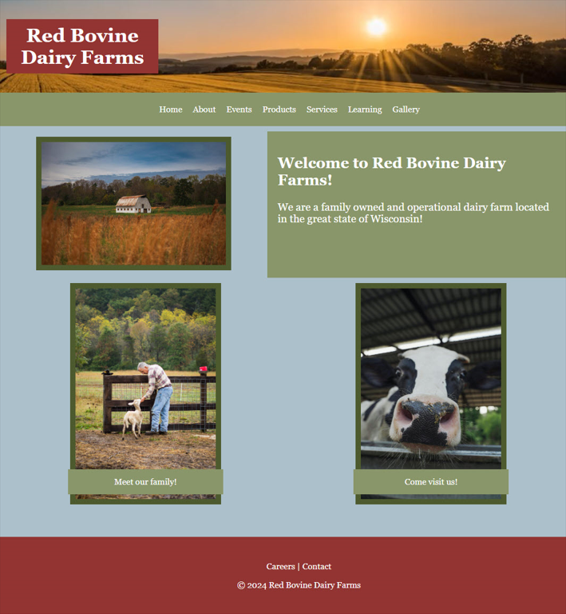

Color Scheme
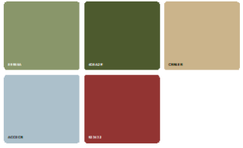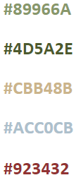

Global Elements

Global Header
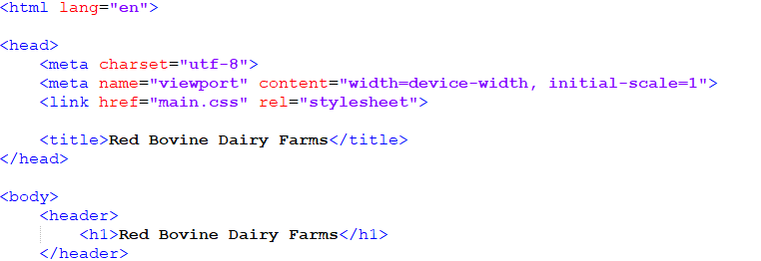
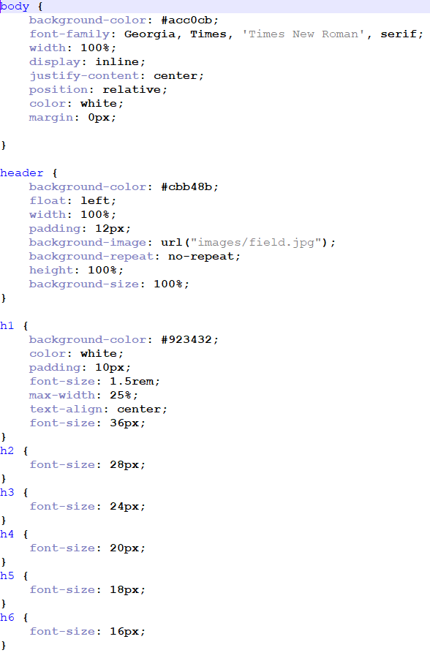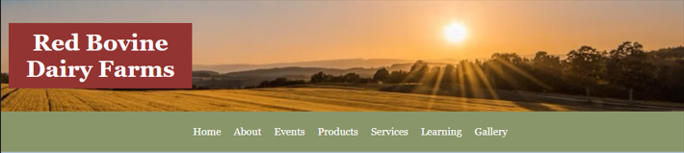

Global Navigation

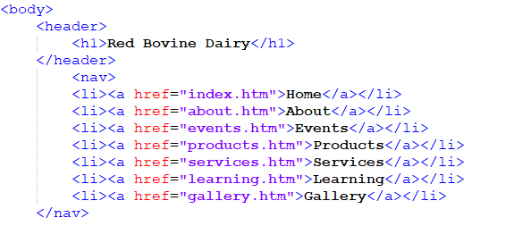
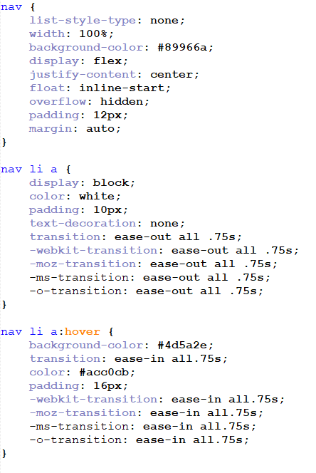

Global Footer
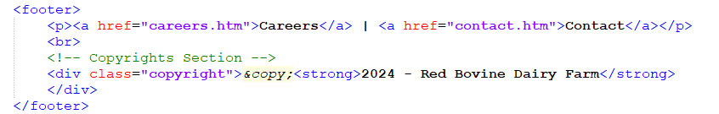
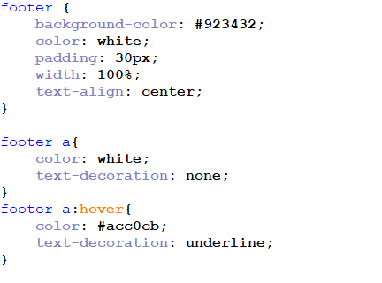


Page-Specific Elements
Since the content pages share a similar design and nature, only the home page will be displayed in the current version of the design style document. This decision was pre-approved by the client.

Home Page
When visitors access the Red Bovine Dairy Farm website, they will land on the home page. This page features a banner displaying the Red Bovine Dairy Farm company name, an image of the farmland, and a navigation bar. The main body of the page includes primary images positioned on the left and right sides, with the “Welcome” text box located on the right side.
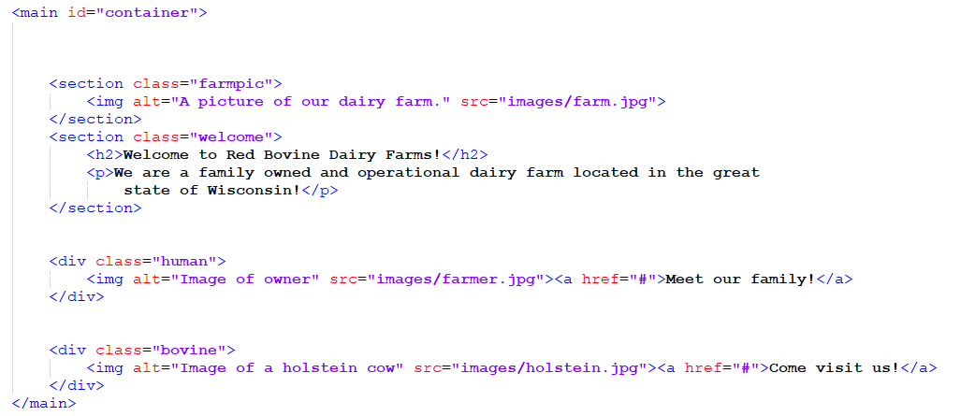
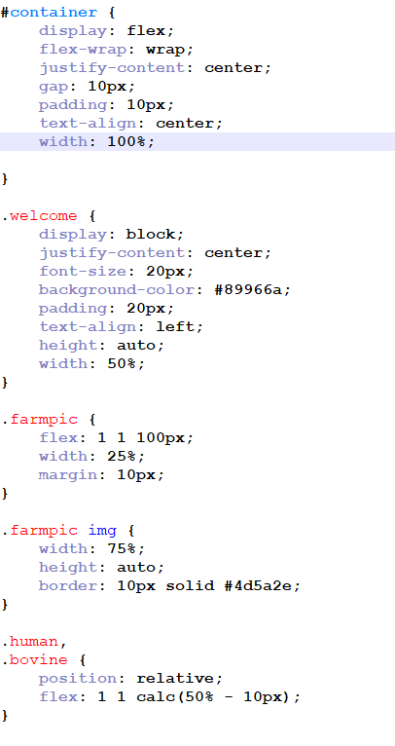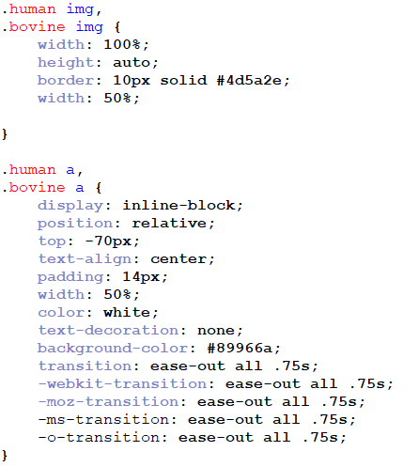
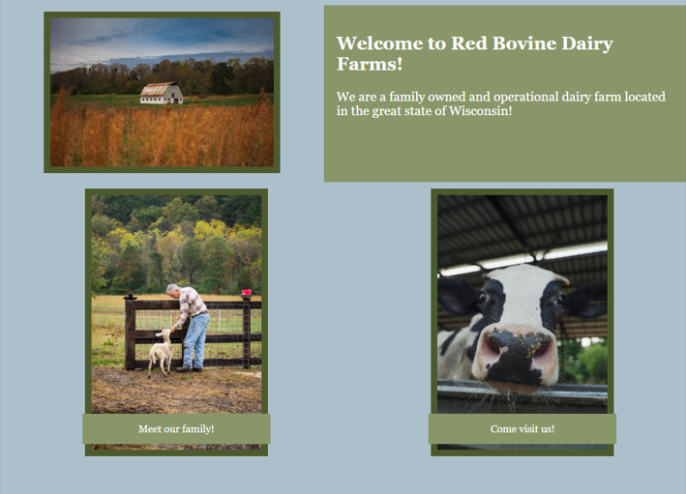

Naming Conventions
- Do not use special characters (!,@,#,$,%,^,&,*,(,), etc.)
- Use short and descriptive file names
- Use relevant keywords for all files
- Use underscores as separators
- Use all lowercase letters
- Avoid abbreviations
- Use meta tags and alt text when possible
Examples of filename: products.htm, cheddar_cheese.jpg
Both examples follow the naming convention guidelines: short, descriptive, lowercase, and using underscores to separate words.

File Extensions
- Web pages will end in: (.htm, .css, .php & .js)
- Image file extensions will be: (.jpg, .png, .gif, .svg)
- Text documents will be: (.pdf, .doc, .docx, .xls, .txt)

Navigation Bar Labels
- Company Name (top left of page) – index.htm
- Home – index.htm
- About – about.htm
- Events – events.htm
- Products – products.htm
- Services - services.htm
- Learning - learning.htm
- Careers - careers.htm
- Gallery - gallery.htm
- Contact– contact.htm

Programming
Document type declaration: <!DOCTYPE html>

Languages
HTML
CSS
JavaScript

Development Tools
Adobe Dreamweaver
Notepad++
Microsoft Office
GoDaddy Hosting
W3C HTML validation
W3C CSS validation
WAVE accessibility tool

Acknowledgment
The client consents to all the details outlined in the technical specifications section of the design style document. Any updates must be submitted through a change form and approved by Go Social Web Design.

Approval
Client Signature:
x_Adam Saddler___ Date: __4/8/2024___

Functional Specifications

Summary
The primary goal for the Red Bovine Dairy Farm website is to enable users to navigate effortlessly and explore all the products and services offered by the farm. The design strategy aims to maintain simplicity for universal usability, yet with sufficient sophistication to accommodate future enhancements and expansions.

Assumptions
The website will be functional and responsive on all device types, including smartphones, tablets, and computers.

Global Elements
All global elements will be consistent throughout the website, including the header, navigation, and footer.

Page Specific Elements

Home Page
The home page consists of a primary text box for welcome information and images representing the farm and its activities. It also includes links to position opportunities and career information.
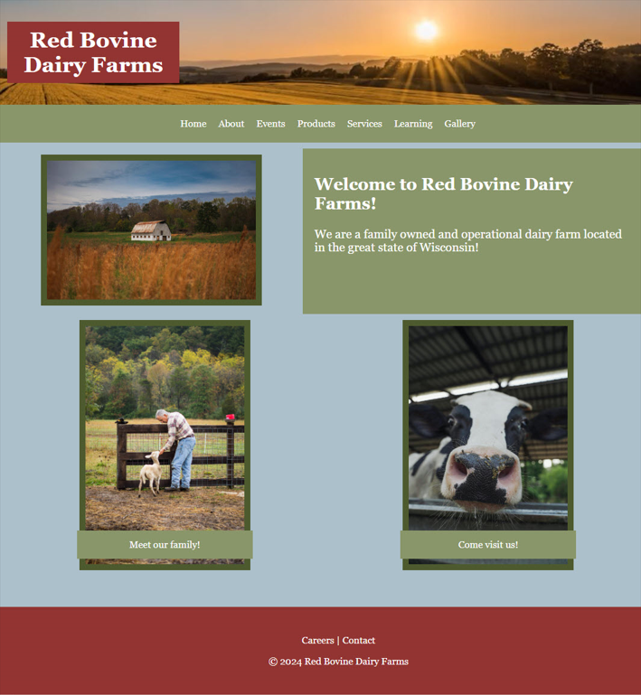

About Page
The About page will showcase images of the owner and the farm, along with general information about the farm. Additionally, secondary information related to the history of the farm will be included.

Events Page
The Events page will highlight the upcoming events, accompanied by images from previous events. The secondary details will provide expected dates, updates to the event, and a synopsis of the event.

Products Page
The Products page will feature images, descriptions, and prices for all available products at Red Bovine Dairy Farm. The description and price will be underneath the corresponding product image.

Services Page
The Services page will contain images and information on the services offered, boarding and Victory Gardens.

Learning Page
The learning page will contain images and information about farming, organic farming, hobby farming, professions in farming, and farm safety for educational purposes.

Careers Page
The Careers page will offer information on careers in farming and list open positions at the farm. There will be a link to an application to apply for any farm positions that are available.

Gallery Page
The Gallery page will highlight images from red Bovine Dairy Farm’s past events, family of animals, tours, and harvests.

Contact Page
The Contact page will have the Red Bovine Dairy Farm address, phone number, and map at the top of the page. Below will be a general contact form asking for name, email address, and feedback.

Acknowledgment
The client consents to all the details outlined in the technical specifications section of the design style document. Any updates must be submitted through a change form and approved by Go Social Web Design.

Approval
Client Signature:
x_Adam Saddler___ Date: __4/8/2024___

File Structure
Project Folder Name:
Folder Structure: redbovinedairy
- HTML Pages
  - index.html
  - about.html
  - events.html
  - products.html
  - services.html
  - learning.html
  - gallery.html
  - careers.html
  - contact.html
- CSS (all stylesheets)
- Images (Logos, feature images, etc)
  - JPG
  - PNG
  - GIF
- Metadata
  - <meta charset="utf-8">
  - <meta name="viewport" content="width=device-width, initial-scale=1">
  - <link href="main.css" rel="stylesheet">

Guidelines
- All documents’ images, etc, are to be kept in their respective folders
  - Contact website developer with questions
- HTML pages are to end with ‘.html’
- All documents are to be clean and easy to understand

Privacy Policy
This Privacy Policy outlines how Go Social collects, uses, discloses, and protects the information gathered from users of our website dotmcchesney.com/gosocial2/index.html and any related services. By using our Services, you agree to the terms outlined in this Privacy Policy.

1. Information We Collect:
We may collect personal information, including but not limited to names, email addresses, and other contact details, when you interact with our Services. Additionally, we may automatically collect non-personal information such as IP addresses, browser information, and usage data.

2. How We Use Your Information:
We use the collected information to provide and improve our Services, respond to inquiries, and personalize user experience. Your information may also be used for marketing and communication purposes, but only with your explicit consent.

3. Information Sharing:
We do not sell, trade, or otherwise transfer your personal information to outside parties unless we provide you with advance notice. This does not include trusted third parties who assist us in operating our website, conducting our business, or servicing you, as long as those parties agree to keep this information confidential.

4. Security:
We implement a variety of security measures to maintain the safety of your personal information. However, no data transmission over the internet or method of electronic storage is 100% secure, and we cannot guarantee absolute security.

5. Third-Party Links:
Our website may contain links to third-party websites. We have no control over the content or privacy practices of these sites and encourage you to review their privacy policies.

6. Updates to Privacy Policy:
We reserve the right to update this Privacy Policy at any time. The date of the latest revision will be displayed at the top of this page.

7. Contact information:
If you have any questions or concerns about this Privacy Policy, please contact us at gosocial@gosocialweb.com.

Signatures and Approvals
By signing this document, both parties have approved the layout and color palette for Red Bovine Dairy’s website. Any changes to be made going forward must be made through a change order form.

Client Signature:
x_Adam Saddler___ Date: __4/8/2024___
Project Manager Signature:
x_Molly Atkinson ___ Date: __4/8/24___

