Technical Specifications

Technical Summary
The website of Red Bovine Dairy Farm can be reached via a sole homepage, providing users with access to all other pages through a navigation bar. The homepage includes the company name, images, text, and links.

Assumptions
Red Bovine Dairy Farm will supply Go Social Web Design with all current content, images, graphics, and specified color schemes outlined in the project documentation. Any additional content, including text, images, and graphics, will be generated or sourced by Go Social Web Design and undergo formal approval from Red Bovine Dairy Farm before integration into the website. Both parties will uphold the existing content through secure and backed-up systems.

Global Elements
Consistent global elements will be maintained across the entirety of the website. Red Bovine Dairy Farm can be accessed via a single homepage featuring a navigation bar enabling users to navigate to all relevant pages associated with the website.

Template
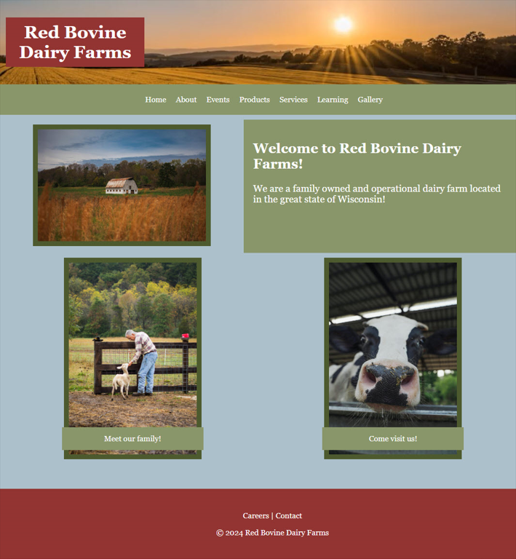

Color Scheme
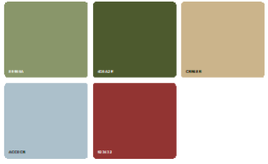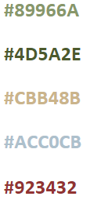

Global Elements

Global Header
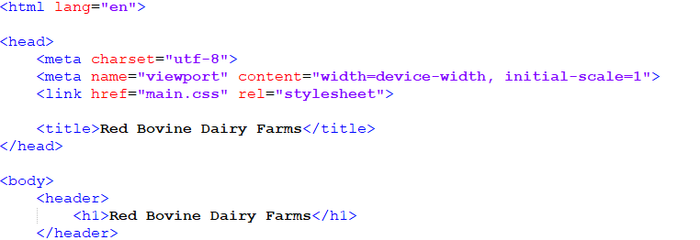
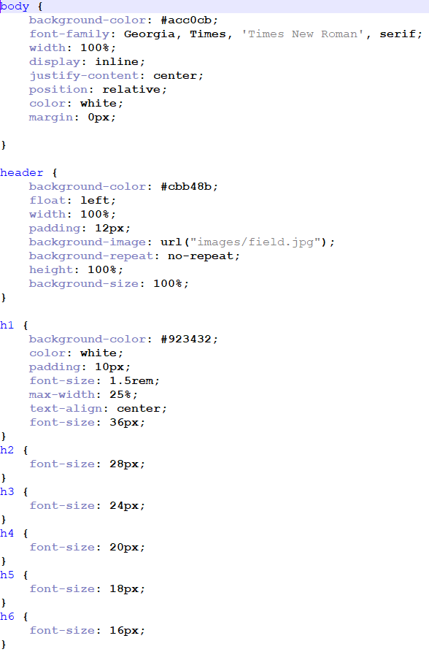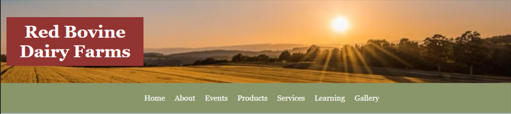

Global Navigation

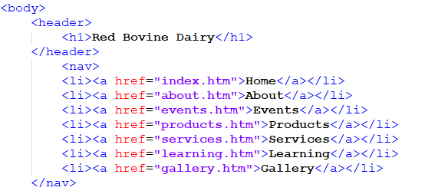
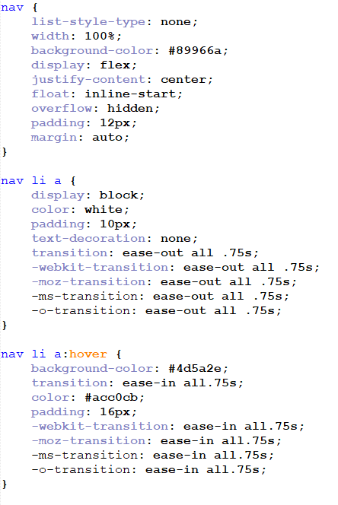

Global Footer
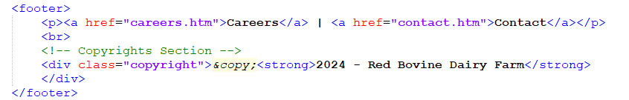
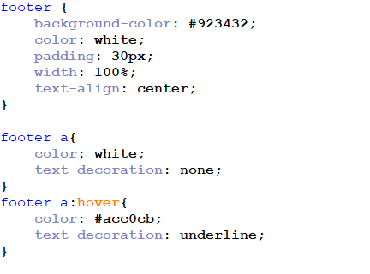


Page-Specific Elements
Since the content pages share a similar design and nature, only the home page will be displayed in the current version of the design style document. This decision was pre-approved by the client.

Home Page
When visitors access the Red Bovine Dairy Farm website, they will land on the home page. This page features a banner displaying the Red Bovine Dairy Farm company name, an image of the farmland, and a navigation bar. The main body of the page includes primary images positioned on the left and right sides, with the “Welcome” text box located on the right side.
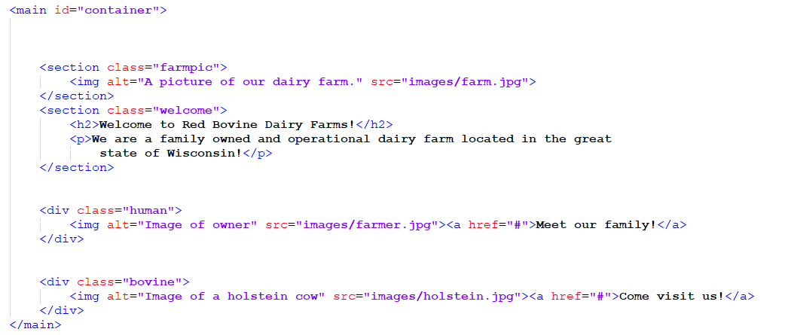
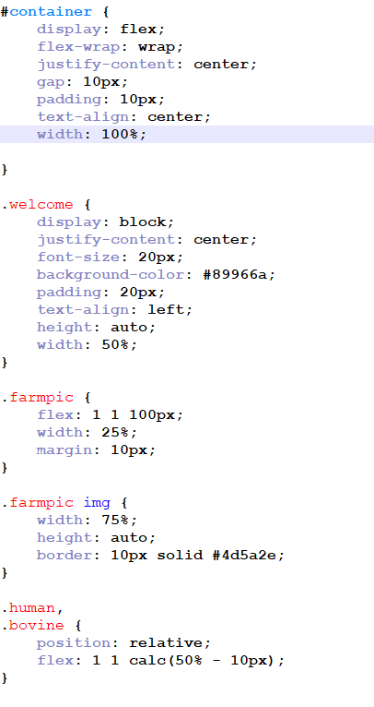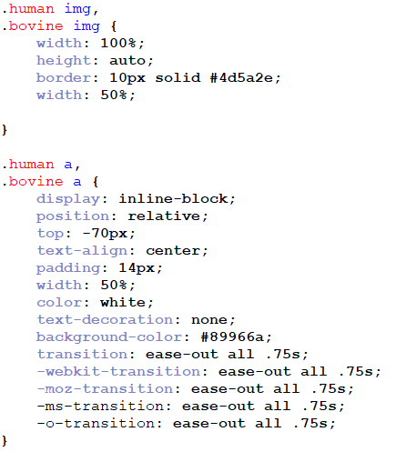
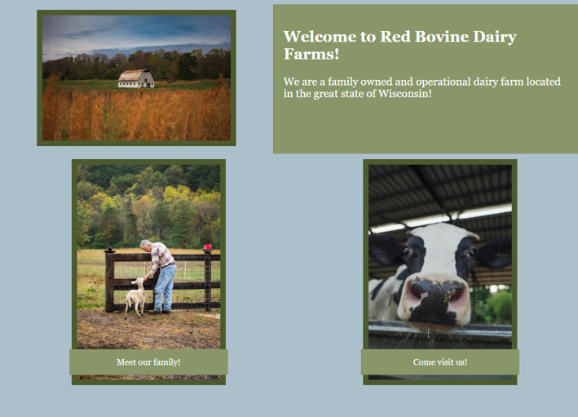

Naming Conventions
- Do not use special characters (!,@,#,$,%,^,&,*,(,), etc.)
- Use short and descriptive file names
- Use relevant keywords for all files
- Use underscores as separators
- Use all lowercase letters
- Avoid abbreviations
- Use meta tags and alt text when possible
Examples of filename: products.htm, cheddar_cheese.jpg
Both examples follow the naming convention guidelines: short, descriptive, lowercase, and using underscores to separate words.

File Extensions
- Web pages will end in: (.htm, .css, .php & .js)
- Image file extensions will be: (.jpg, .png, .gif, .svg)
- Text documents will be: (.pdf, .doc, .docx, .xls, .txt)

Navigation Bar Labels
- Company Name (top left of page) – index.htm
- Home – index.htm
- About – about.htm
- Events – events.htm
- Products – products.htm
- Services - services.htm
- Learning - learning.htm
- Careers - careers.htm
- Gallery - gallery.htm
- Contact– contact.htm

Programming
Document type declaration: <!DOCTYPE html>

Languages
HTML
CSS
JavaScript

Development Tools
Adobe Dreamweaver
Notepad++
Microsoft Office
GoDaddy Hosting
W3C HTML validation
W3C CSS validation
WAVE accessibility tool

Acknowledgment
The client consents to all the details outlined in the technical specifications section of the design style document. Any updates must be submitted through a change form and approved by Go Social Web Design.

Approval
Client Signature:
x_Adam Saddler___ Date: __4/8/2024___

