SEARCH ENGINE REGISTRATION PLAN
Red Bovine Dairy Farms

Molly Atkinson
Dorothy McChesney
Danielle Robinson

Table of Contents
OVERVIEW 3
SEARCH ENGINE USAGE STATISTICS 3
SEO 4
SEARCH TOOL PLAN 4
MANUALLY 5
AUTOMATICALLY 6
Option 1: GSA 7
Option 2: SEO ProHub 7
Option 3: Loganix 8
SEO PLAN RECOMMENDATION 8
SEO CONSULTING 9
PAYMENT 9
TERMS OF SERVICE 9
Acknowledgments 9

OVERVIEW
Search Engine Optimization (SEO) is a process that improves your website’s ranking and visibility in search engine results. We can optimize your search engine results by identifying keywords and phrases and drive more traffic to your website and visits to your farm.
Go Social Web Design can help you with SEO services and make it so your customers can find you more easily.

SEARCH ENGINE USAGE STATISTICS
From: https://www.netmarketshare.com/
March 2024
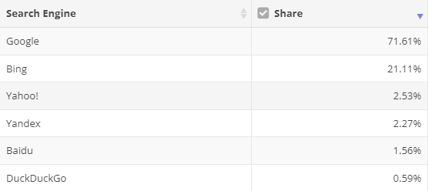
From: https://www.smartinsights.com/search-engine-marketing/search-engine-statistics/
December 2023
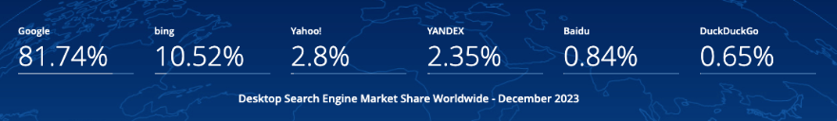

SEO
We have already implemented the following:
- Images contain “alt text” and include keywords
- File names are clear and concise
- Semantic structure is applied
- HTML and CSS have been validated
These implementations have already improved the searches for your website, helping your current and future customers find you more easily.

SEARCH TOOL PLAN
There are numerous plans available for submitting your site to search engines. Your choice depends mainly on the platform you prefer and are comfortable with. Below are two examples: manually submitting your site to the search engine or automatically using submission software.

MANUALLY
Manually submitting your websites to search engines is free but can be less efficient. The steps can be found at this website:
https://kinsta.com/blog/submit-website-to-search-engines/
First, set up your Google Search Console and verify ownership. Once this is set up you can use it to also import your site to Bing.
To submit to Google:
- Locate your XML Sitemap.
- Add Your Sitemap to the Google Search Console - https://kinsta.com/blog/google-search-console/
- Submit a Page URL to Google.
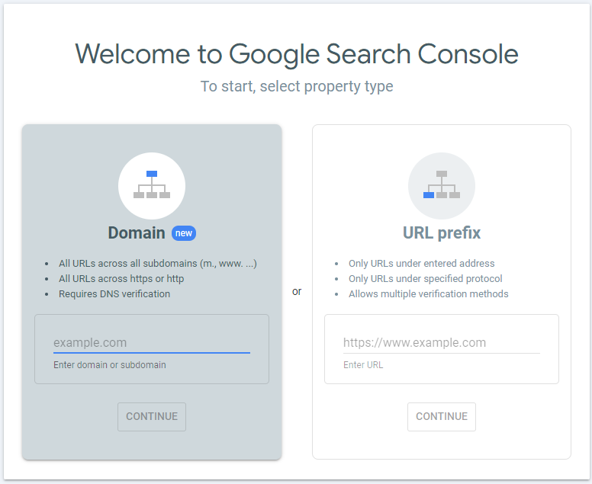
To submit to Bing (this will also submit to Yahoo):
- Go To Bing Webmaster Tools - https://www.bing.com/webmasters/about
- Submit your sitemap to Bing.
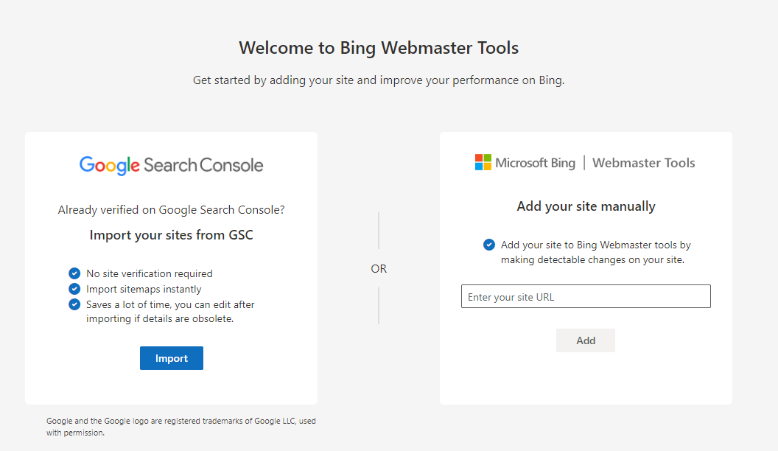

AUTOMATICALLY
Automatically submitting your websites to search engines can have a cost associated with it. Using the software can streamline the process and potentially save time. Please review the options listed.

Option 1: GSA
https://www.gsa-online.de/product/website_submitter/
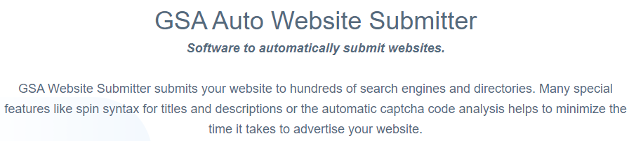
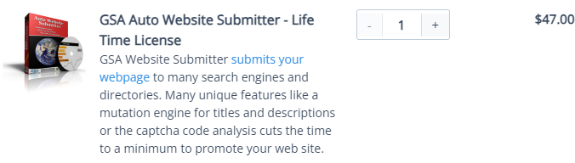

Option 2: SEO ProHub
https://seoprohub.com/seo
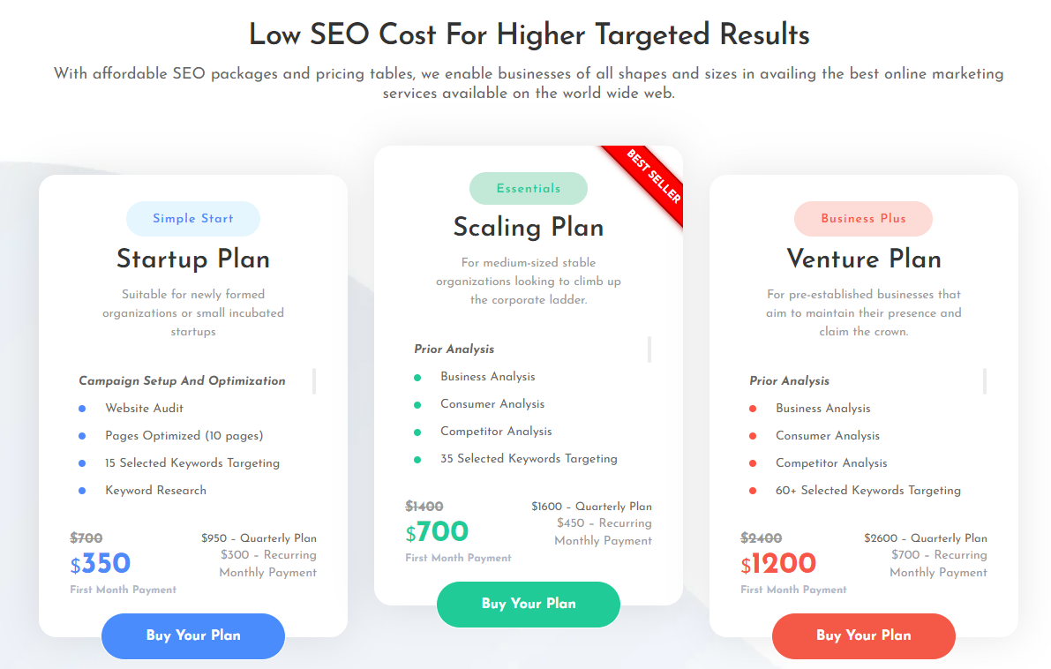

Option 3: Loganix
https://loganix.com/seo-packages/
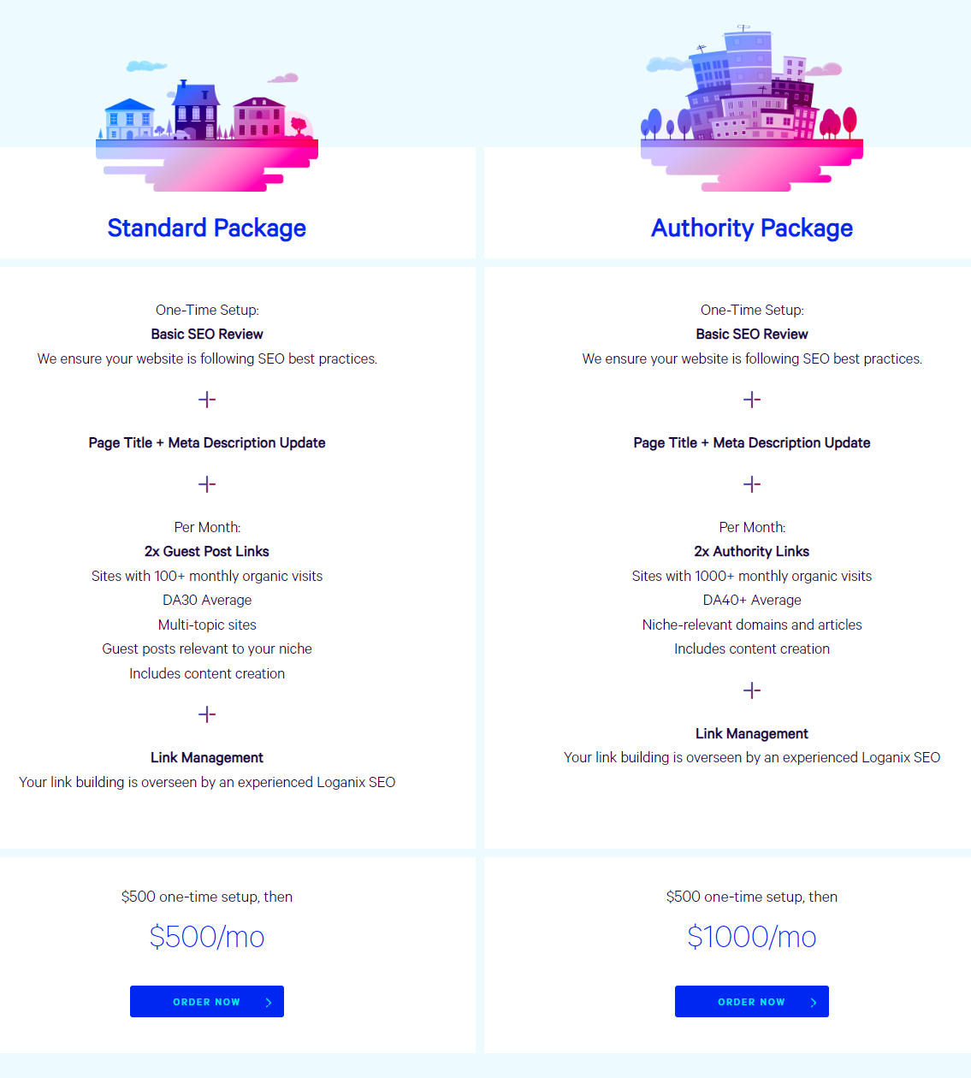

SEO PLAN RECOMMENDATION
Go Social Web Design recommends using the Start-Up Plan from SEO ProHub. This plan would serve you best as a small business looking to grow and expand. It is offered at a lower cost than most others and offers monthly tracking and reporting.

SEO CONSULTING
Go Social Web Design will create or implement the SEO plan you choose. Go Social Web Design’s cost for these SEO services will be $65 per hour.

PAYMENT
Go Social Web Design will send a detailed invoice for the service on the first of each month (for the prior month’s service). The amount will be due within 30 days or the client will risk service disruption until payment is received.

TERMS OF SERVICE
This is an optional add-on service. If the client agrees to the service, the term of service will be 12 months starting from the 1st day of the month following the website's launch date.

Acknowledgments
By signing this document, both parties have approved the recommended SEO plan from SEO ProHub for Red Bovine Dairy Farm’s website and agree to the terms of service.
x_Adam Saddler___ Date: __4/26/2024___
Project Manager Signature:
x_Molly Atkinson ___ Date: __4/26/24___

