
Client Handoff Packet
Red Bovine Dairy Farms

Molly Atkinson
Dorothy McChesney
Danielle Robinson

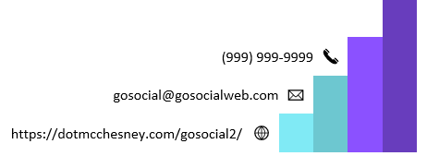
Table of Contents
Client Survey 7
Audience Analysis Report 9
Demographics 9
General User Profile 9
Detailed User Profile 10
User Scenario 1 10
User Scenario 2 10
Competitive Analysis Report 11
Executive Summary 11
Methodology/Process/Approach 11
Industry Information 12
Overview of Competition 12
Findings and Recommendations 12
Grid Overview 13
Overall Ratings 15
Appendix 16
Creative Brief 17
Overview 17
Mission Statement 17
Target Audience (Profile) 17
Competitive Positioning 17
Creative Tone (Perception) 17
Goals 18
Target Message 18
Signature 18
Mission Statement 19
Project Goals 19
Objective Statements 19
Schedule Overview 20
Budget Overview 21
Details and Assumptions 21
Contract Components 22
Appendix 24
Overview 24
Mission Statement 24
Target Audience (Profile) 24
Competitive Positioning 24
Creative Tone (Perception) 24
Goals 25
Target Message 25
Signature 25
Detailed Budget 26
Detailed Schedule 26
Work Breakdown Structure 29
Content Delivery Plan 30
Naming and Labeling Plan 31
Document Labels 31
Navigation Labels 31
NavBar: 31
Content Labels 31
SEO 32
Guidelines 32
Naming and Labeling Plan 32
Content Outline 32
Site Structure/Audit 34
Wireframe and Sitemap 36
Sitemap 37
User Scenarios 38
Detailed User Scenario 38
User Scenario 1 39
User Scenario 2 40
Key User Path 41
Style Document 51
Design Style 51
Global Elements 51
Page Dimensions 51
Colors 51
Global Element Sizes 52
HTML Text 52
Graphic Type 52
Page-Specific Elements 53
Home 53
About 53
Events 53
Products 53
Services 53
Learning 54
Gallery 54
Contact 54
Careers 54
Acknowledgment 54
Technical Specifications 55
Technical Summary 55
Assumptions 55
Global Elements 55
Template 56
Color Scheme 56
Global Elements 57
Global Header 57
Global Navigation 58
Global Footer 58
Home Page 59
Naming Conventions 61
File Extensions 61
Navigation Bar Labels 61
Programming 62
Languages 62
Development Tools 62
Summary 63
Assumptions 63
Global Elements 63
Page Specific Elements 63
Home Page 63
About Page 64
Events Page 64
Products Page 64
Services Page 64
Learning Page 64
Careers Page 64
Gallery Page 64
Contact Page 64
1. Information We Collect: 66
2. How We Use Your Information: 66
3. Information Sharing: 66
4. Security: 66
5. Third-Party Links: 66
6. Updates to Privacy Policy: 66
7. Contact information: 67
Type of Quality Assurance 68
Summary 68
Participants 68
Test Environments 69
Test Cases 69
Test Case 1 - Chrome 69
Web Standards 69
Page Content 70
Functionality 72
Links 72
Test Case 2 - Safari 74
Web Standards 74
Page Content 76
Functionality 77
Links 78
Test Case 3 - Firefox 80
Web Standards 80
Page Content 81
Functionality 82
Links 83
Bug Reporting Plan 85
Bug Fixing Plan 85
Bug Priority Scheme 85
Bug Severity Scheme 86
Bug Reports 87
Test Cases 88
Test Case 1 - Chrome 88
Web Standards 88
Page Content 89
Functionality 91
Links 91
Test Case 2 - Safari 93
Web Standards 93
Page Content 95
Functionality 96
Links 97
Test Case 3 - Firefox 98
Web Standards 98
Page Content 100
Functionality 101
Links 102
Bug Reports 104
Domain Name Plan 105
Domain Name Considerations 105
Our Domain Name Suggestions: 105
Registrar's: 105
Our Choice 106
Recommendation: 106
Web Hosting 106
Web Hosting Packages 107
Acknowledgment 107
SEO Plan 108
OVERVIEW 108
SEARCH ENGINE USAGE STATISTICS 108
SEO 109
SEARCH TOOL PLAN 109
MANUALLY 109
AUTOMATICALLY 110
Option 1: GSA 110
Option 2: SEO ProHub 111
Option 3: Loganix 111
SEO PLAN RECOMMENDATION 112
SEO CONSULTING 112
PAYMENT 112
TERMS OF SERVICE 112
Site Announcement Plan 113
Pre-Launch Activities 113
Launch Activities 113
Post-Launch Activities 113
Off-Site Activities 113
Budget Summary 114
Summary 115
Weekly Maintenance 115
Monthly Maintenance 115
Quarterly Maintenance 115
Annual Maintenance 116
Maintenance Renewal 116
Evaluation Plan 116

Client Survey
Thank you for considering our services for your web design and development needs. To better understand your requirements and preferences, please take a few moments to answer the following questions. Your input will help us create a website that meets your expectations and goals.
Company Name: Red Bovine Dairy
Contact Name: Adam Saddler
Email: asaddler@gmail.com OR redbovinedairy76@gmail.com
Phone Number: (906) 937-0011
Company Website (if applicable): redbovinedairy.com
Describe your company and its core services/products:
Dairy products, animal visits (new to us), cattle
What are the primary goals for your website?
Attract visitors to the farm, highlight our products and services

Describe your desired style for the website (e.g., modern, corporate, minimalist, etc.):
Warm, comforting, at-home, welcoming, natural

Provide URLs of websites you find appealing:
https://farmland.org/no-farms-no-food/?gad_source=1&gclid=CjwKCAiAivGuBhBEEiwAWiFmYQyRdi3ov492A3mGwHTMNG0U4_u7ZUl1v4dMuSsS0huMgNSIqjA9WRoCSp0QAvD_BwE
https://www.almanac.com/
https://bfarm.com/
What pages do you envision for your website? (e.g., Home, About Us, Services, Contact, etc.)
Home, about, contact, services, careers, events
Do you require any special features or functionality? (e.g., e-commerce, blog, portfolio, etc.)
No
Do you have content (text, images, videos) ready for the website, or will you need assistance with content creation?
I have images I can provide.
Do you have a domain name and hosting already? If not, do you need assistance with domain registration and hosting setup?
redbovinedairy.com
Do you have a budget in mind for this project?
$5000
Is there anything else you would like to share or any specific concerns you have regarding the project?
No

Audience Analysis Report
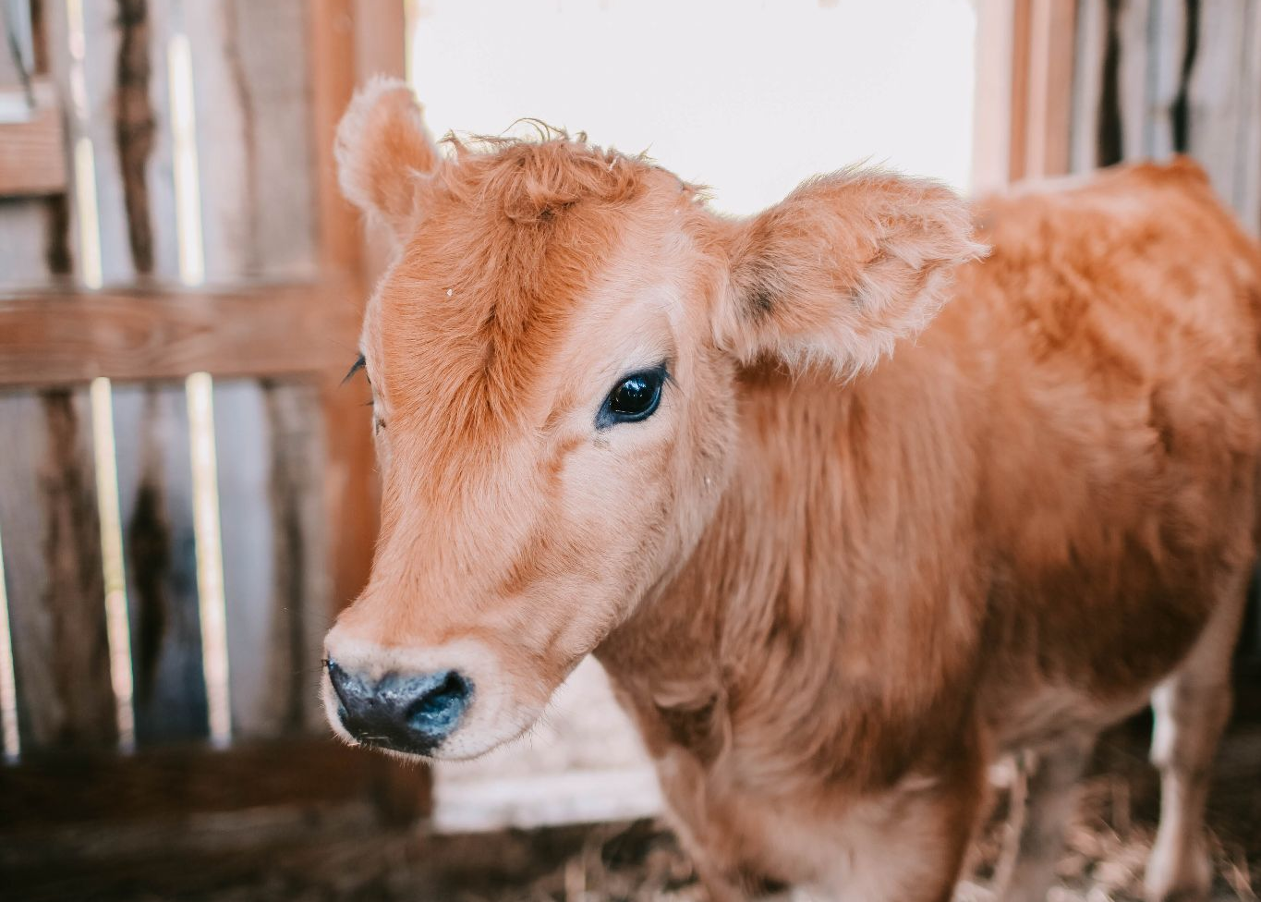
Photo by Leah Newhouse: https://www.pexels.com/photo/brown-calf-inside-barn-1449656/

Demographics
- 47% of dairy farmers are employed full-time while 53% are employed part-time.
- 57% of males are interested in dairy farming as a career and females are at 43%.
- The gender mix for a dairy farmer is 47% for men and 53% for females.

General User Profile
The average dairy farmer is usually a family member or relative of a family farm. They are often managed by the retired dairy farmer from the previous generation. The first generation mentoring the second generation of farmers to run the farm is common since they have the most experience on the farm (being born and raised on the farm). The average age of a dairy farmer is 40+ years old representing 50% of the dairy farmer population.

Detailed User Profile
Richard is a beef farmer looking to find a dairy farm to buy calves from. He has a growing beef herd that he wants to eventually combine with dairy cows, but he’ll keep the beef and dairy cattle separate. To make these changes possible, Richard plans on starting small using the two calves that he bought from the dairy farm. They are two Holsteins, female and male, and have genetics from the best cow on the farm.
With a local dairy farmer willing to mentor the beef farmer on his new dairy production future, Richard has doubled his herd from two to seventy-five head in as little as two years. Being able to use the milk to sell at his local farmers market makes a bit more profit than raising beef cattle alone.

User Scenario 1
Gilbert’s Dairy has been in the dairy business since 1956, starting with Richard Gilbert deciding to care for a Holstein calf whose mother no longer wants to care for. He bottle-fed her, made her a barn to sleep in safely, and decided to buy a tractor to plant corn to feed the calf when she was older. He stays up late at night working on his crop rotation and studying crops and basic bovine health. Richard had a calf that grew into a heifer and was ready to start producing milk. He started his family legacy with one calf named “Miss Moosy” and has since grown into a 500-head dairy farm. In memory of the first calf he raised with his own money, Richard still uses the barn he had built for Miss Moosy for calving.

User Scenario 2
Dairy Farmer Edward Hillbilly, age 65, is a first-generation dairy farmer. His son, Edward Jr, 23, is looking to take the reins of the 200-acre farm. He has a steady income but refuses to quit his job to take over full-time for his father's farm. Edward Jr is constantly watching the markets that his father often ignores. To keep his job and work full time on his father's farm, father and son decided to hire a few college kids who were looking for hands-on work. They would be paid the same salary as Edward Jr is being paid, which is $13 an hour, and all were in agreement. Today Hillbilly Dairy Farm's herd increased from 200 to 500 cattle, thanks to the three college men that worked while attending college, decided to continue working at the farm after graduation, and to Edward Jr for keeping the family farm running under his father's name.

Competitive Analysis Report
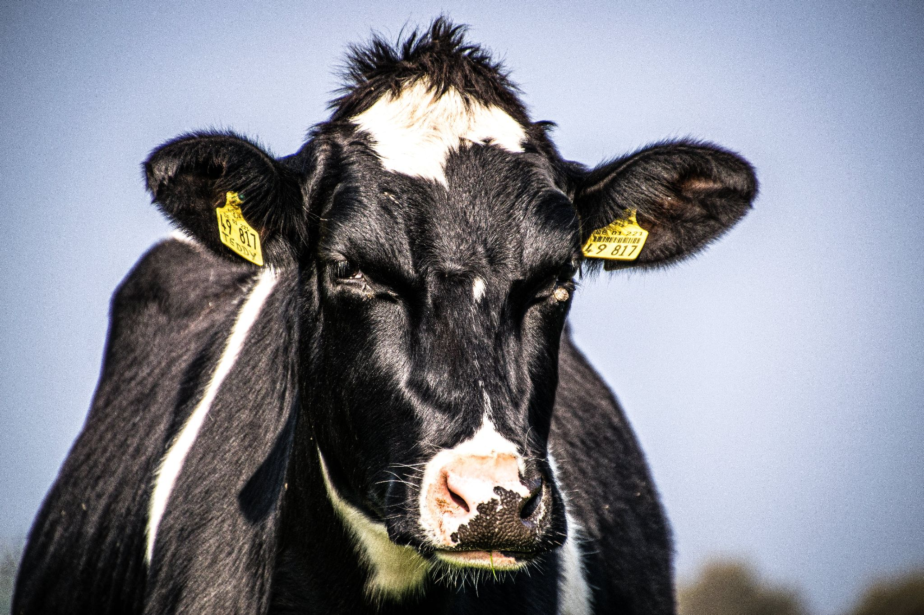
Photo by Matthis Volquardsen: https://www.pexels.com/photo/close-up-photo-of-cow-2350739/

Executive Summary
Red Bovine Dairy is a local dairy farm in south-eastern Wisconsin that's been in business for over 100 years. Its 100th year is coming up and the dairy farm came to us for assistance on promoting the 100th year on their website. With Red Bovine Dairy being a third generation family owned business, the need of a modern website layout and design would make new opportunities for growth.

Methodology/Process/Approach
Red Bovine Dairy’s Marketing Manager, Adam Northwest, approached us for assistance on creating an updated layout and modernizing the existing website to explore more growth opportunities, rather than be in employment or expansion.

Industry Information
According to the Wisconsin State Farmer, Dairy Farms in Wisconsin have been struggling since 2017. 10% of farms have been lost when the United State’s Agriculture census came out in 2022. 30% of farms are dairy. But the dairy farms that have been surviving thus far have only been getting bigger with expansions on herd and production. Milk cows have declined less than 2% by 2017, despite dairy farms calling it quits.

Overview of Competition
Pine Wood Farm’s
Pine Wood Farm’s is a growing herd of 200 head and is located just a few short miles East of where Red Bovine Dairy is located. They raise both beef and dairy cattle along with a flock of 20 southdown sheep. They have no website but do have a Facebook page showcasing their hard working farm hands, and their breeding stock. They also have a Twitter account that they haven’t updated in a while.

The Little Moo LLC
The Little Moo LLC is a family owned business with a 50 cow herd. They have a small blog consisting of pages that are outdated and unorganized. The menu is the only functioning item besides the content itself consisting of images of the cows and the ice cream the farm produces in its own facility.

Findings and Recommendations
Findings:
- Slow loading speeds
- Lack of contrast in navigation bar and links
- Not mobile friendly
- Various crawl errors
- Outdated Hours

Recommendations:
Ensure Website Functionality
- Check for abandoned links
- Make sure the header, nav, and footer match for every page
- Optimize images for faster loading speeds
Review Company Information
- Update hours to ones that are current
- Keep seasonal information seasonal, only release it when it's pertinent
Farm Design, but Modern
- Keep the color scheme of previous website, but improve on it
  - Less black coloring and more white, and include a hero image
  - Think https://www.almanac.com/

Grid Overview
Competitor Feature Comparison Card | Red Bovine Dairy | Pine Wood Farm's | The Little Moo LLC
URL | RedBovineDairy.com | https://www.pinewoodfarns.com/ | https://www.thelittlemoollc.com
Meta Keywords | No | Yes | No
Responsive Design | Yes | Yes | Yes
Logo | Yes | No | No
Navigation | Yes | Yes | Yes
User Friendly | No | No | No
Images | Yes | Yes | Yes
Online Store | Yes | No | No
Contact Info | Yes | No | Yes
Hours of Operation | Yes | Yes | No
Load Time | Fast | Good | Slow at times
Web Server | Wordpress | Facebook | None
Reviews | Yes | Yes | No

Overall Ratings
Competitor Scoring Card | Red Bovine Dairy | Pine Wood Farm's | The Little Moo LLC
Competitor Scoring Card | (Rank performance on a scale of 1-5) | (Rank performance on a scale of 1-5) | (Rank performance on a scale of 1-5)
Usability Rating of Site | 5 | 5 | 1
Content Rating of Site | 4 | 4 | 2
Design Rating of Site | 5 | 2 | 1
Average User Ratings of Business | 5 | 5 | 5
Total | 19 | 16 | 9

Appendix
Wisconsin lost 10% of farms, 30% of dairies in 5 years, U.S. agriculture census shows. (n.d.). Wisconsin State Farmer. https://www.wisfarmer.com/story/news/2024/02/15/latest-census-of-agriculture-finds-wisconsin-farms-still-declining/72570807007/
Dairy Farmer Demographics and Statistics [2024]: Number Of Dairy Farmers In The US. (2021, January 29). Dairy Farmer Demographics and Statistics [2024]: Number of Dairy Farmers in the US. https://www.zippia.com/dairy-farmer-jobs/demographics/
Dairy farmer demographics in the United States - CareerExplorer. (n.d.). Dairy Farmer Demographics in the United States - CareerExplorer. https://www.careerexplorer.com/careers/dairy-farmer/demographics/

Creative Brief

Overview
Red Bovine Dairy is a century-old dairy located in Southeastern Wisconsin. They are looking to create a warm and inviting online presence as they build on their history and offer new experiences. They would like to embrace a modernistic design while holding onto the authenticity and natural charm their current site has, resulting in a more efficient, easy-to-navigate site with a fresh look. They want to include smoother navigation, customer reviews, highlight upcoming events, showcase products and services, and offer a careers page.

Mission Statement
Our mission is to redesign our current website to promote the inviting feeling of home and community. We would like to build our brand as a place to visit with family or friends and build excitement around our farm and farming. We want to spread the knowledge and education of farming to those who visit with various classes and learning opportunities. We want to incorporate several new pages to include a variety of new events, our products, and the services we offer. We also want to make sure our new design emphasizes our core values of Tradition, Quality, and Integrity.

Target Audience (Profile)
People looking to have a good time or get a hand in the farming industry. Farming isn’t for the faint of heart, typically, young adults are brought into the farming business due to being raised on a farm or from working as a farm hand. Some people even start up their farming adventure from scratch. However, all adults must have experience with farming or agriculture in general. Agriculture is one of the most dangerous fields of work. Adults, men, and women can farm. With the celebration of 100 years, highlight the various services and products we have to offer.

Competitive Positioning
https://budjon.com/

Budjon Farms has a lot of experience in the dairy industry despite being in business for 25 years. I chose their website because the images were not only eye-catching, but they were telling a story. Their website is easy to navigate, and you don’t have to scroll as much for information about the farm. They value their clients and share their reviews on the page. A great website and an even better competitor.

Creative Tone (Perception)
The creative tone of this website should come off as a natural, welcoming, at-home experience. When one visits Red Bovine Dairy Farms, we want them to feel like they just stepped into a happy and welcoming environment, where they can have a great time with their friends or family (or, just solo). We want our clients to be excited to learn about our farm, and even more excited to come back.

Goals
- Increase web traffic to 1,500 viewers
- Increase foot traffic by at least 250 people
- Highlight the events we have planned for our 100-year celebration
- Revamp the site to look modern, comforting, warm, and natural
  - New fonts
  - Updated images
  - Updated open hours
- Include reviews
- Include a careers page
  - May or may not be hiring, but will deliberate
- Smoother navigation
- Highlight our core values
  - Family, organics, small business importance, quality
- Highlight products and services
  - Must be ordered via a form or via the phone

Target Message
After 100 years in the business, Red Bovine Dairy Farm wants to thank one person: you, the customer. Since we’ve been running, it’s you who’s kept us up and operating, especially through the rough patches. We want to show you how much we’ve grown over these years and appreciate all the support we’ve gotten from our neighbors, families, and friends, as we continue our business. Without you, we wouldn’t be where we are today, and by visiting our farm or buying products from us, you’ll get to experience the wonder that comes with our 100-year celebration.

Signature
Client Signature: x_Adam Saddler___ Date: __2/28/2024___

Mission Statement
Our mission is to redesign our current website to promote the inviting feeling of home and community. We would like to build our brand as a place to visit with family or friends and build excitement around our farm and farming. We want to spread the knowledge and education of farming to those who visit with various classes and learning opportunities. We want to incorporate several new pages to include several new events, our products, and the services we offer. We also want to make sure our new design emphasizes our core values of tradition, quality, and integrity.

Project Goals
- Redesigning current website to match the visual qualities of Red Bovine Dairy.
- Promote several events to educate the community about agriculture.
- Red Bovine Dairy wants to promote its milk, cheese, and a variety of products and services on its site to encourage people to support small businesses and farms.
- Having an accessible, family-friendly, and fun website will encourage people to visit the farm and meet our four-legged friends!

Objective Statements
- Craft a visually captivating website redesign for Red Bovine Dairy, capturing the essence of warmth and community, while spotlighting our core values of tradition, quality, and integrity.
- Introduce fresh website sections dedicated to upcoming events, product showcases, and detailed service descriptions for Red Bovine Dairy.
- Integrate informative content about farming, offering diverse classes and learning opportunities directly on the website.
- Boost website traffic by 20% within the initial two weeks of the redesign launch.
- Draw a minimum of 200 visitors to each event promotion through targeted website marketing efforts within the debut month.
- Attain a 10% uptick in online sales of Red Bovine Dairy products within three weeks of the website's fresh look.
- Ensure project feasibility within the allocated resources and budget, emphasizing streamlined processes and prioritizing essential features.
- Collaborate closely with Red Bovine Dairy to swiftly gather content and feedback, expediting the development process.
- Concentrate on key website components aligning with our mission and goals, avoiding unnecessary complexities in design or functionality.
- Harmonize the website redesign with our mission of fostering community, education, and support for small businesses and farms, spotlighting these aspects throughout the design and content.
- Reflect the brand identity of Red Bovine Dairy as a welcoming, family-oriented locale with a passion for agriculture, resonating with our intended audience.
- Achieve website redesign completion and launch within the one-month timeframe, honoring agreed-upon milestones and timelines.
- Coordinate educational content updates and event promotions to coincide with the website launch, sustaining engagement and momentum.
- Provide ongoing website support and updates post-launch, promptly addressing any issues or implementing enhancements.

Schedule Overview
Task | Date Started: Wed 3/13/24 | Final Day: Tue 6/18/24
Define the project | 3/13/24 | 3/25/24
Develop Project Analysis and Plan | 3/14/24 | 3/19/24
Develop Site Structure | 3/26/24 | 3/29/24
Design Visual Interface | 4/1/24 | 4/12/24
Create Design and Concepts | 4/1/24 | 4/10/24
Build and Integrate | 4/15/24 | 5/20/24
Content and File Structure | 4/15/24 | 5/10/24
Delivery and Launch | 5/21/24 | 5/31/24
Handoff and Launch | 5/24/24 | 5/27/24

Budget Overview
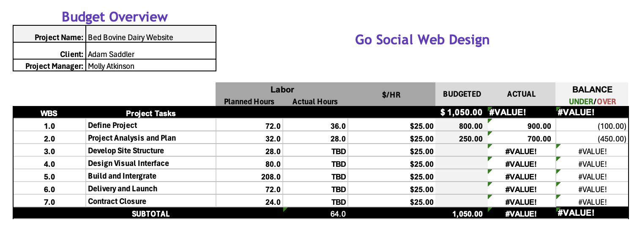

Details and Assumptions
PROJECT
- Go Social Web Design (GSWD) was hired by Red Bovine Dairy Farms to redesign their website with an estimated completion date of July 2024
- HTML5 and CSS3 coding will be used for site design
- Any additions or changes not included in this scope may result in additional time and costs
- Additions or changes will be relayed by using the change form and approved/denied by the Project Manager
- Website will have compatibility with Chrome, Edge, Firefox
CLIENT
- Required client documents for content should be submitted in MS Word format
- Required client graphics and images should be submitted in .jpg or .png format
- Client will meet all due dates or alert GSWD to the delay in delivery of any requested items promptly
- Client will provide logo and color palette before the start of the project
- Client will formally submit any additions or changes via the change form
- Client will follow the payment schedule
DEVELOPER
- GSWD will comply with current accessibility and validation standards
- GSWD will be consistent with the layout and theme of the website
- GSWD will use responsive design
- GSWD will provide weekly meetings or updates about progress
- GSWD will provide training on website maintenance and updates to the site
- GSWD will follow this Scope as closely as possible but it is subject to change

Please keep in mind, that 2 or 3 rounds of design are appropriate/expected, if more rounds are asked for or needed, it will affect the budgets and schedules.

Contract Components
Web Design Contract

Parties: [Name of Client] (“Red Bovine Dairy Farms”)
[Name of Designer/Agency] ("Go Social Website Design")

Date of Agreement: [3/13/2024]

1. Scope of Work: Designer agrees to provide web design services for the Client, including but not limited to:
- Creation of a custom website design
- Development of website functionality
- Integration of client-provided content
- Testing and deployment of the website
- Use responsive design

2. Payment Terms:
- The total project cost is [Total Amount], payable as follows:
  - $500 dollars will be deposited on agreement of terms.
  - Paid monthly.
- Payment shall be made in [U.S Dollars] via [check, debit, CC, PayPal].
- Late payments shall incur a [1.5%] fee for each [month] overdue.

3. Timeline: The project timeline shall be as follows:
Define the project | 3/13/24 | 3/25/24
Develop Project Analysis and Plan | 3/14/24 | 3/19/24
Develop Site Structure | 3/26/24 | 3/29/24
Design Visual Interface | 4/1/24 | 4/12/24
Create Design and Concepts | 4/1/24 | 4/10/24
Build and Integrate | 4/15/24 | 5/20/24
Content and File Structure | 4/15/24 | 5/10/24
Delivery and Launch | 5/21/24 | 5/31/24
Handoff and Launch | 5/24/24 | 5/27/24
Maintenance | 5/31/24 | 6/13/24
Contract Closure | 6/14/24 | 6/18/24

4. Client Responsibilities: Client agrees to provide the following:
- Required client documents for content should be submitted in MS Word format
- Required client graphics and images should be submitted in .jpg or .png format
- Client will meet all due dates or alert GSWD to the delay in delivery of any requested items promptly
- Client will provide logo and color palette before the start of the project
- Client will formally submit any additions or changes via the change form
- Client will follow the payment schedule

5. Revisions: Designer will provide [Number of Revisions] rounds of revisions. Additional revisions will be billed at an hourly rate of [$25.00].

6. Ownership and Rights: Upon full payment, the Client owns the website design and content. The Designer retains the right to showcase the project in their portfolio.

7. Termination: Either party may terminate this contract by providing written notice to the other party at least 30 days prior to the desired termination date.

8. Confidentiality: The Receiving Party agrees not to disclose any Confidential Information to any third parties without the prior written consent of the Disclosing Party.

9. Governing Law: This contract shall be governed by and construed in accordance with the laws of [United States of America] and the [State of Wisconsin].

10. Entire Agreement: This contract constitutes the entire agreement between the parties and supersedes all prior agreements or understandings.

IN WITNESS WHEREOF, the parties hereto have executed this contract as of the date first above written.

[Signature of Client] Adam Saddler/Red Bovine Dairy
[Printed Name of Client] Red Bovine Dairy

[Signature of Designer/Agency] Molly Atkinson/Go Social Website Design
[Printed Name of Designer/Agency] Go Social Website Design

Appendix

Overview
Red Bovine Dairy is a century-old dairy located in Southeastern Wisconsin. They are looking to create a warm and inviting online presence as they build on their history and offer new experiences. They would like to embrace a modernistic design while holding onto the authenticity and natural charm their current site has, resulting in a more efficient, easy-to-navigate site with a fresh look. They want to include smoother navigation, and customer reviews, highlight upcoming events, showcase products and services, and offer a careers page.

Mission Statement
Our mission is to redesign our current website to promote a homey and inviting feel. We want to incorporate several new events, products, and services, as well as emphasize our core values. We would like to build our brand as a place to visit with family or friends and build excitement around farming and our farm.

Target Audience (Profile)
People looking to have a good time or get a hand in the farming industry. Farming isn’t for the faint of heart, typically, young adults are brought into the farming business due to being raised on a farm or from working as a farm hand. Some people even start up their farming adventure from scratch. However, all adults must have some kind of experience with farming or with agriculture in general. Agriculture is one of the most dangerous fields of work. With the celebration of 100 years, highlight the various services and products we have to offer.

Competitive Positioning
https://budjon.com/

Budjon Farms has a lot of experience in the dairy industry despite being in business for 25 years. I chose their website because the images were not only eye-catching, but they were telling a story. Their website is easy to navigate and you don’t have to scroll as much for information about the farm. They value their clients and share their reviews on the page. A great website and an even better competitor.

Creative Tone (Perception)
The creative tone of this website should come off as a natural, welcoming, at-home experience. When one visits Bovine Dairy Farms, we want them to feel like they just stepped into a happy and welcoming environment, where they can have a great time with their friends or family (or, just solo). We want our clients to be excited to learn about our farm, and even more excited to come back.

Goals
- Increase web traffic to 1,500 viewers
- Increase foot traffic by at least 250 people
- Highlight the events we have planned for our 100-year celebration
- Revamp the site to look modern, comforting, warm, and natural
  - New fonts
  - Updated images
  - Updated open hours
- Include reviews
- Include a careers page
  - May or may not be hiring, but will deliberate
- Smoother navigation
- Highlight our core values
  - Family, organics, small business importance, quality
- Highlight products and services
  - Must be ordered via a form or via the phone

Target Message
After 100 years in the business, Red Bovine Dairy Farm wants to thank one person: you, the customer. Since we’ve been running, it’s you who’s kept us up and operating, especially through the rough patches. We want to show you just how much we’ve grown over these years and appreciate all of the support we’ve gotten from our neighbors, families, and friends, as we continue our business. Without you, we wouldn’t be where we are today, and by visiting our farm or buying products from us, you’ll get to experience the wonder that comes with our 100-year celebration.

Signature
Client Signature: x_Adam Saddler___ Date: __2/28/2024___

Detailed Budget
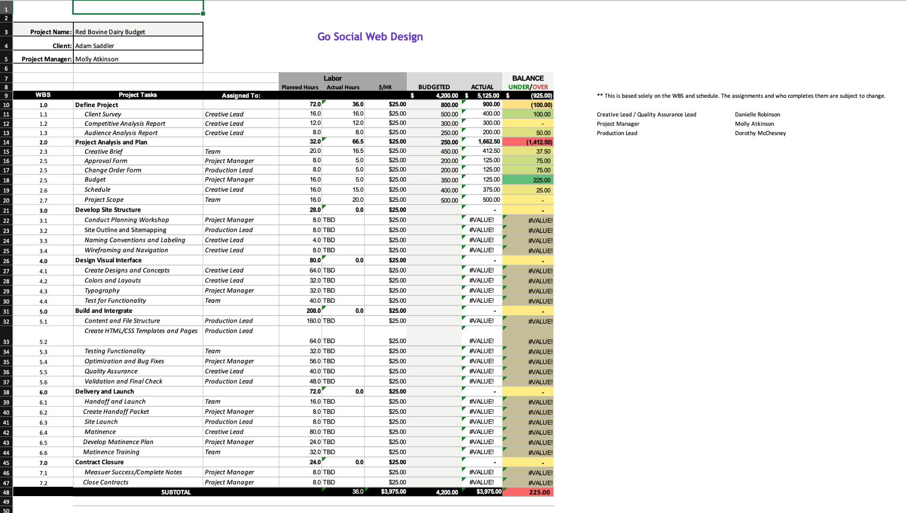

Detailed Schedule
Task | Work Days | Date Started: Wed 3/13/24 | Final Day: Tue 6/18/24
Define the project | 9 days | 3/13/24 | 3/25/24
Client Survey | 2 days | 3/14/24 | 3/19/24
Develop Project Analysis and Plan | 4 Days | 3/14/24 | 3/19/24
Competitive Analysis Report | 1 1/2 Days | 3/14/24 | 3/15/24
Audience Analysis Report | 1 Day | 3/15/24 | 3/18/24
Creative Brief | 1 Day | 3/18/24 | 3/19/24
Develop Project Plan | 1 day | 3/19/24 | 3/20/24
Set Budget and Create Schedules | 2 days | 3/20/24 | 3/21/24
Create Scope | 2 days | 3/21/24 | 3/22/24
Develop Site Structure | 3.5 days | 3/26/24 | 3/29/24
Conduct Planning Workshop | 1 dat | 3/26/24 | 3/29/24
Site Outline and Sitemapping | 1 day | 3/27/24 | 2/27/24
Technical Architect
Naming Conventions and Labeling | 1/2 day | 3/28/24 | 3/28/24
Technical Architect
Wireframing and Navigation | 1 day | 3/28/24 | 3/29/24
Technical Architect
Design Visual Interface | 10 days | 4/1/24 | 4/12/24
Create Design and Concepts | 8 days | 4/1/24 | 4/10/24
Colors and Layouts | 4 days | 4/1/24 | 4/4/24
Technical Architect
Typography and Graphics | 4 days | 4/3/24 | 4/8/24
Technical Architect
Test for Functionality | 5 days | 4/8/24 | 4/12/24
Technical Architect
Build and Integrate | 26 days | 4/15/24 | 5/20/24
Content and File Structure | 20 days | 4/15/24 | 5/10/24
Create HTML/CSS Templates and Pages | 8 days | 4/15/24 | 4/25/24
Technical Architect
Testing Functionality | 4 days | 4/24/24 | 4/29/24
Project Manager
Quality Assurance Manager
Technical Architect
Optimization and Bug Fixes | 5 days | 4/26/24 | 5/6/24
Technical Architect
Quality Assurance | 5 days | 4/26/24 | 5/6/24
Validation and Final Check | 6 days | 5/13/24 | 5/20/24
Quality Assurance Manager
Technical Architect
Project Manager
Delivery and Launch | 9 days | 5/21/24 | 5/31/24
Handoff and Launch | 2 days | 5/24/24 | 5/27/24
Create Handoff Packet | 1 day | 5/24/24 | 5/24/24
Site Launch | 1 day | 5/27/24 | 5/27/24
Maintenance | 10 days | 5/31/24 | 6/13/24
Develop Maintenance Training | 3 days | 6/5/24 | 6/7/24
Technical Architect
Maintenance Training | 4 days | 6/10/24 | 6/13/24
Technical Architect
Contract Closure | 3 days | 6/14/24 | 6/18/24
Measure Success/Complete Notes | 1 day | 6/17/24 | 6/17/24
Close Contract | 1 day | 6/18/24 | 18-Jun

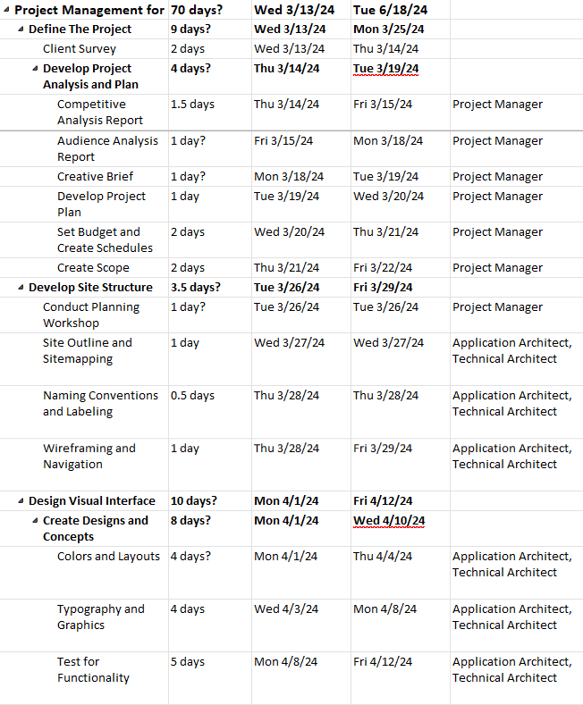
Work Breakdown Structure
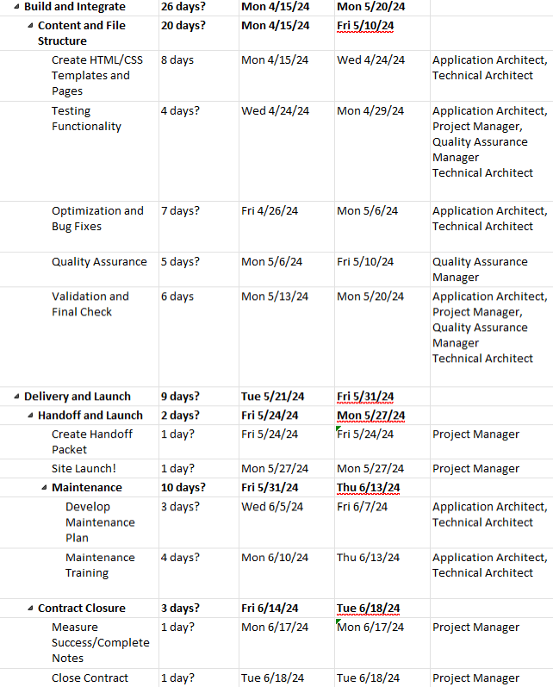

Content Delivery Plan

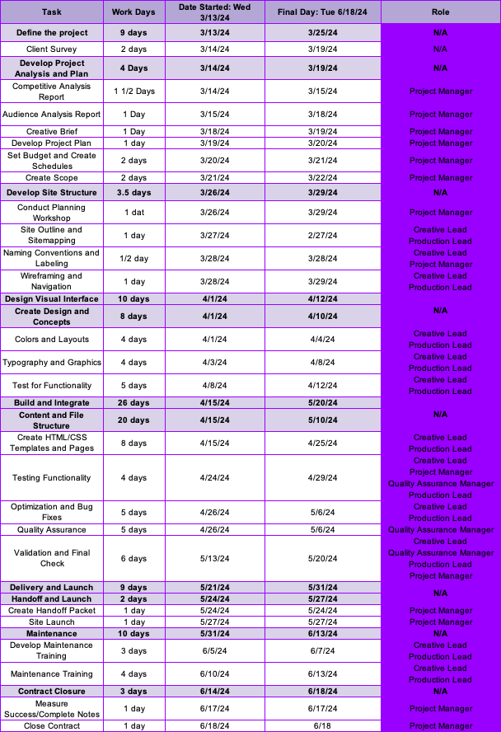

Naming and Labeling Plan

Document Labels
- No special characters
- Short and descriptive
- Relevant keywords
- Use underscores as separators
- All lowercase letters
- Avoid abbreviations
- Use meta tags and alt text when possible

Navigation Labels
Communicate:
- Where can I go? (Clear Navigation)
- Where am I now? (Arrival)
- Can I tell I have arrived at my destination? (Orientation)
- How can I get where I want to be? (Route)
- Does this link have the content I want? (Value)

NavBar:
- Company Name index.htm
- About about.htm
- Events events.htm
- Products products.htm
- Services services.htm
- Learning learning.htm
- Careers careers.htm
- Gallery gallery.htm
- Contact contact.htm

Content Labels
May include:
- Headings
- Subheadings
- Taglines
- Captions

SEO

Guidelines
- Images should have alt tags using keywords that describe the picture
- Saved images will have a descriptive name
- Images will be saved in the images folder
- Use meta tags and alt text

Naming and Labeling Plan
The website will be structured in a tabbed model for organization. The navigational links (Home, About, Events, Products, Services, Learning, and Gallery) will be located at the top of each page with clear and understandable wording to direct the user to the desired location. The company logo will be located in the upper left corner and will link to the home page.
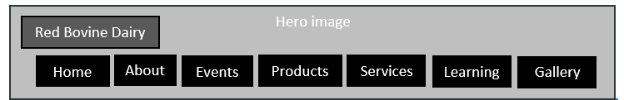
In the footer of each page, links to the Careers and Contact Information will be included as well as the copyright, address, and phone number of the business.

Content Outline
Due Date
- About 4/19/24
  - History 4/19/24
  - Location 4/19/24
  - Social Media 4/19/24
  - News 4/19/24
- Events 4/19/24
  - 100-Year Celebration 4/26/24
  - Farm Visits 4/26/24
    - Milking Tours 4/26/24
    - Cheese Tour 4/26/24
    - Ice Cream Tour 4/26/24
  - Spring Celebration 4/26/24
    - Baby Animal Photo Ops 4/26/24
    - Tulip Tour and Bouquets 4/26/24
    - Breakfast on the Farm 4/26/24
  - Summer Swing 4/26/24
    - Picnic On The Farm 4/26/24
    - Butterfly Garden 4/26/24
    - Horse-riding and Bonfire 4/26/24
  - Fall Festival 4/26/24
    - Farm To Table Dinner 4/26/24
    - Pumpkin Patch Hayride 4/26/24
    - Apple Picking 4/26/24
Due Date
- Products 5/3/24
  - Milk 5/3/24
  - Cheese 5/3/24
  - Ice Cream 5/3/24
  - Other 5/3/24
- Services 5/3/24
  - Boarding 5/3/24
  - Victory Gardens 5/3/24
- Learning 5/10/24
  - Becoming a Farmer 5/10/24
  - How To Start a Hobby Farm 5/10/24
  - Farming Professions 5/10/24
  - Farm Safety 5/10/24
  - Organic Farming 5/10/24
- Careers 5/20/24
  - Farming Careers 5/20/24
  - Open Positions 5/20/24
- Gallery 5/20/24
- Contact 5/20/24

Site Structure/Audit
A content audit for web design involves evaluating the existing content on a website to determine its relevance, effectiveness, and quality. Here's a basic template you can use for a content audit:
1. **Page URL**:
2. **Page Title**:
3. **Page Description**:
4. **Content Type** (e.g., text, image, video):
5. **Content Purpose**:
6. **Target Audience**:
7. **Content Relevance**:
- Is the content aligned with the website's goals and objectives?
- Is it still relevant to the target audience?
8. **Content Quality**:
- Is the content accurate and up-to-date?
- Is it well-written and easy to understand?
- Are there any spelling or grammatical errors?
9. **Content Formatting**:
- Is the content well-organized and easy to scan?
- Is it formatted using headings, bullet points, and other visual elements to improve readability?
10. **SEO**:
- Are keywords effectively incorporated into the content?
- Is the content optimized for search engines?
11. **Visual Content**:
- Are images and videos used effectively to enhance the content?
- Do they align with the overall design and branding of the website?
12. **Calls to Action (CTAs)**:
- Are there clear CTAs prompting users to take action?
- Do they stand out and encourage engagement?
13. **User Engagement**:
- Are there opportunities for users to interact with the content (e.g., comments, social sharing)?
- Are these features working as intended?
14. **Mobile Responsiveness**:
- Is the content displayed properly on mobile devices?
- Are there any issues with readability or usability on smaller screens?
15. **Accessibility**:
- Is the content accessible to users with disabilities?
- Does it comply with accessibility standards (e.g., WCAG)?
16. **Performance**:
- Does the content load quickly?
- Are there any issues with broken links or missing media files?
17. **Competitor Analysis**:
- How does the content compare to similar content on competitor websites?
- Are there any opportunities to improve or differentiate the content?
18. **Recommendations**:
- Based on the audit findings, provide recommendations for improving the content (e.g., updating outdated information, adding new sections, improving readability).
- Prioritize recommendations based on impact and feasibility.

Wireframe and Sitemap
Wireframe
Hero image
Red Bovine Dairy
Gallery
Learning
Services
Products
Events
About
Home
Welcome Paragraph
Lorem ipsum lorem ipsum Lorem ipsum lorem ipsum Lorem ipsum lorem ipsum Lorem ipsum lorem ipsum Lorem ipsum lorem ipsum Lorem ipsum lorem ipsum Lorem ipsum lorem ipsum Lorem ipsum lorem ipsum Lorem ipsum lorem ipsum Lorem ipsum lorem ipsum Lorem ipsum lorem ipsum Lorem ipsum lorem ipsum Lorem ipsum lorem ipsum Lorem ipsum lorem ipsum Lorem ipsum lorem ipsum

Picture of Farm
Careers
Contact
About Summary
Lorem ipsum lorem ipsum Lorem ipsum lorem ipsum Lorem ipsum lorem ipsum Lorem ipsum

Read More -> [About]
Meet the Farm ->
Picture of Cow
Picture of Owner
Meet Us ->

Sitemap
Zoom to see details.

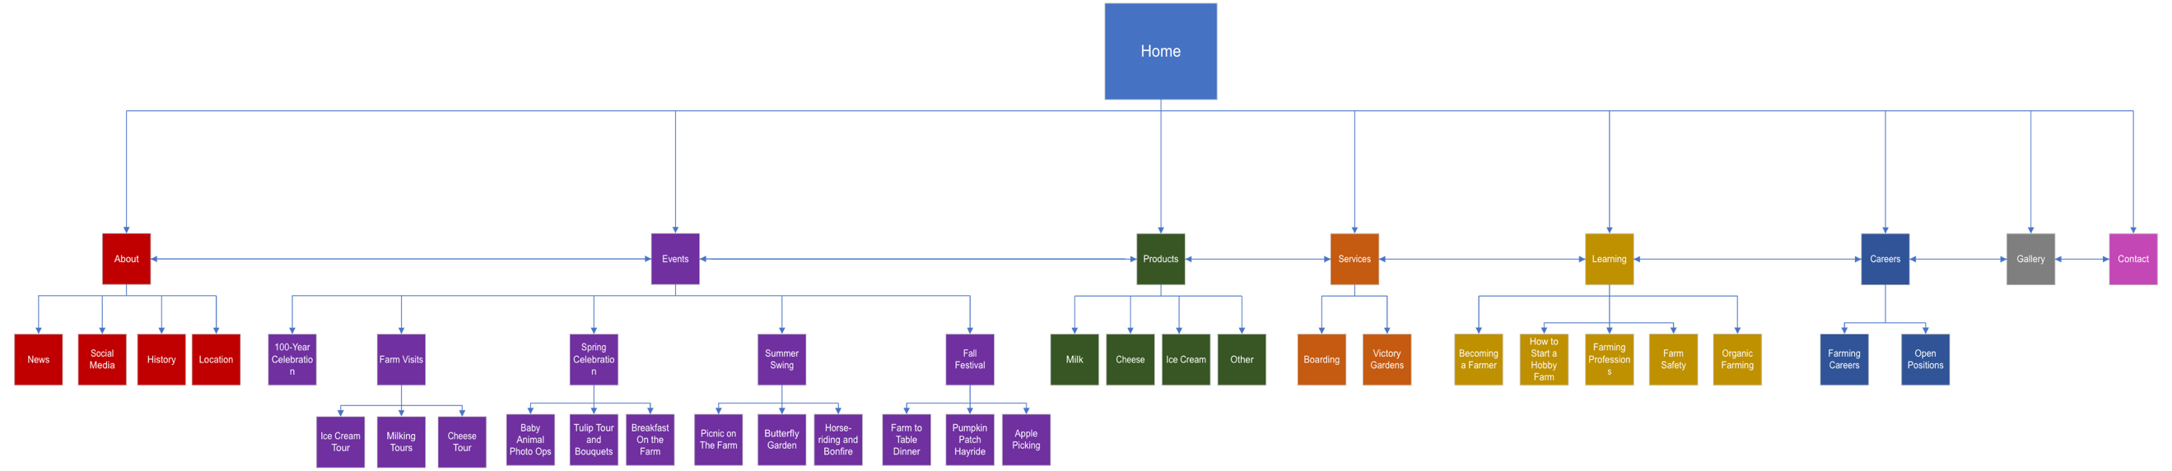

User Scenarios

Detailed User Scenario
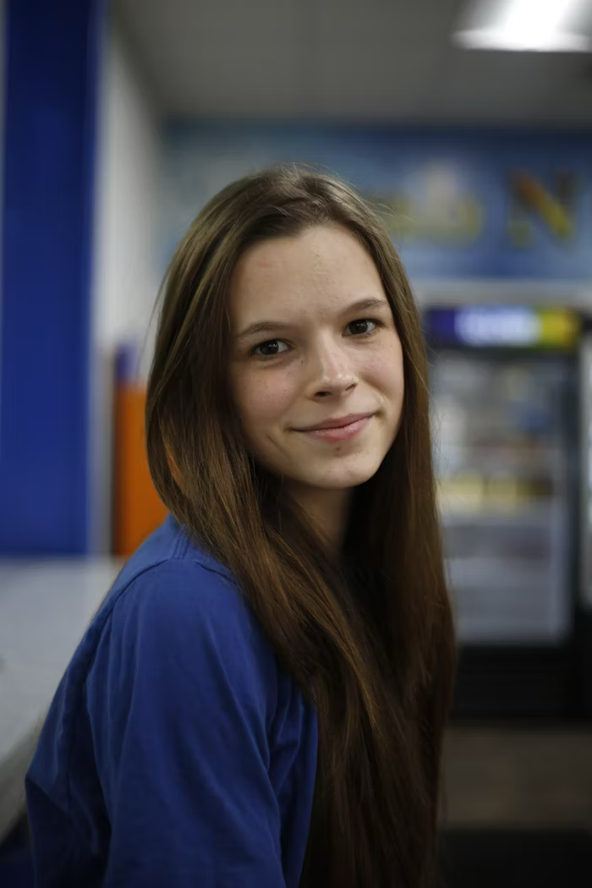
Pictured: Lorelai Martin
Lorelai Martin comes from Milwaukee, where she graduated from the University of Wisconsin Madison with a bachelor’s degree in accounting. After graduating, she found herself less than happy with the path her life was going and decided she wanted to have a more “hands-on” experience In the work field. She had heard about different opportunities that would allow her to remain in Milwaukee but decided she didn’t want to live there.
Using her laptop, she searched online for places in Wisconsin that were looking for help, like the DNR, city governments, and farms. After searching for a bit, she found Red Bovine Dairy’s website, saw they had a careers tab, and decided to fill out an application.
She heard back within a week and was told that they were looking for help around the farm during the upcoming summer season. Red Bovine Dairy sent over different benefits, including room and board, that she would get if she were to work there. Starting in May, Lorelai will start working at Red Bovine Dairy as a farm hand and has been told if it works out, she may be able to stay further than the season.

User Scenario 1

Pictured: Christine Diaz
Ms. Diaz is an elementary school teacher in the Brownsville area, and her class has begun their agriculture unit. She wants to take them on a field trip to a friendly, open environment where they can learn about the agriculture field, while still having fun. She has recently come across Red Bovine Dairy after her friend had told her about their 100-year celebration and thinks it would be a great experience for the kids.

User Scenario 2

Pictured: Dolly and Richard Lewis
Richard and Dolly are an older couple that have decided to spend their retirement venturing around their home state of Wisconsin. After their travels, they’d heard that Red Bovine Dairy was “being upgraded”, and had one of their children show them their website. There, they found out about their 100-year celebration event, and have decided that they wanted to attend, see some friends, and see how far the farm has come from when they saw it in their late teens.

Key User Path
The navigation bar will be the same across all pages, so the user is able to access them quickly and easily. There is the home, about, events, learning, and careers page, which all have a description below.
Home: Welcomes the user to the site, provides a few buttons that connect to about pages (owner and the farm), which connect to the history portion as well.
About: Introduces the owner of the farm, Adam Saddler, as well as has a virtual tour (images in a slideshow/column) that highlights the main parts of the farm and a one sentence description about them.
Products: View the products available from the farm
Services: View available services
Events: Provides information about upcoming events, where they take place, and when the take place
Learning: Provides how to bring students to the farm for a field trip or have some members of the farm come out to the school for an educational day.
Careers: Connects to the contact page as well as provides a download for an application to turn into the farm via mail (hardcopy/scanned email only)
Gallery: View photos of the farm!
Contact: Provides contact information for the farm.
Color And Design Choices

Wireframe Option 1
Color Palette 1
#89966A
#4D5A2E
#CBB48B
#ACC0CB
#923432
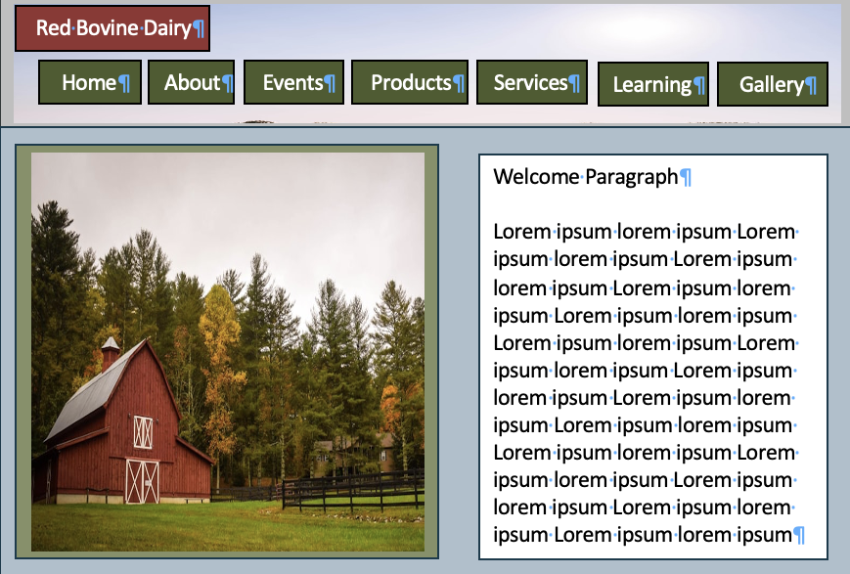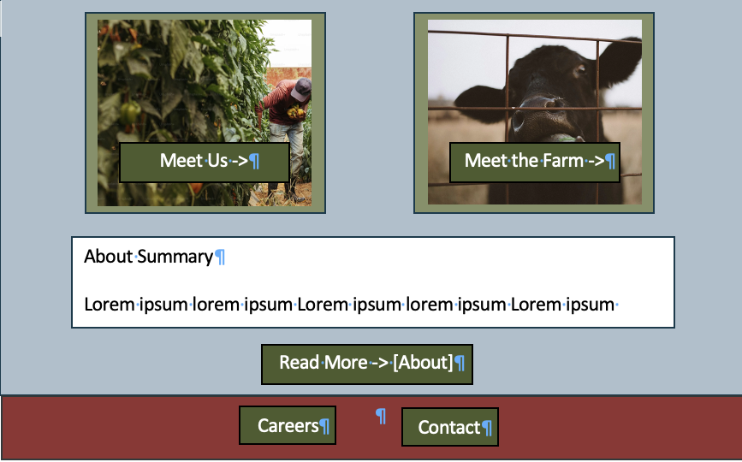

Color Palette 2
#8C1C13
#BF4342
#E7D7C1
#A78A7F
#735751
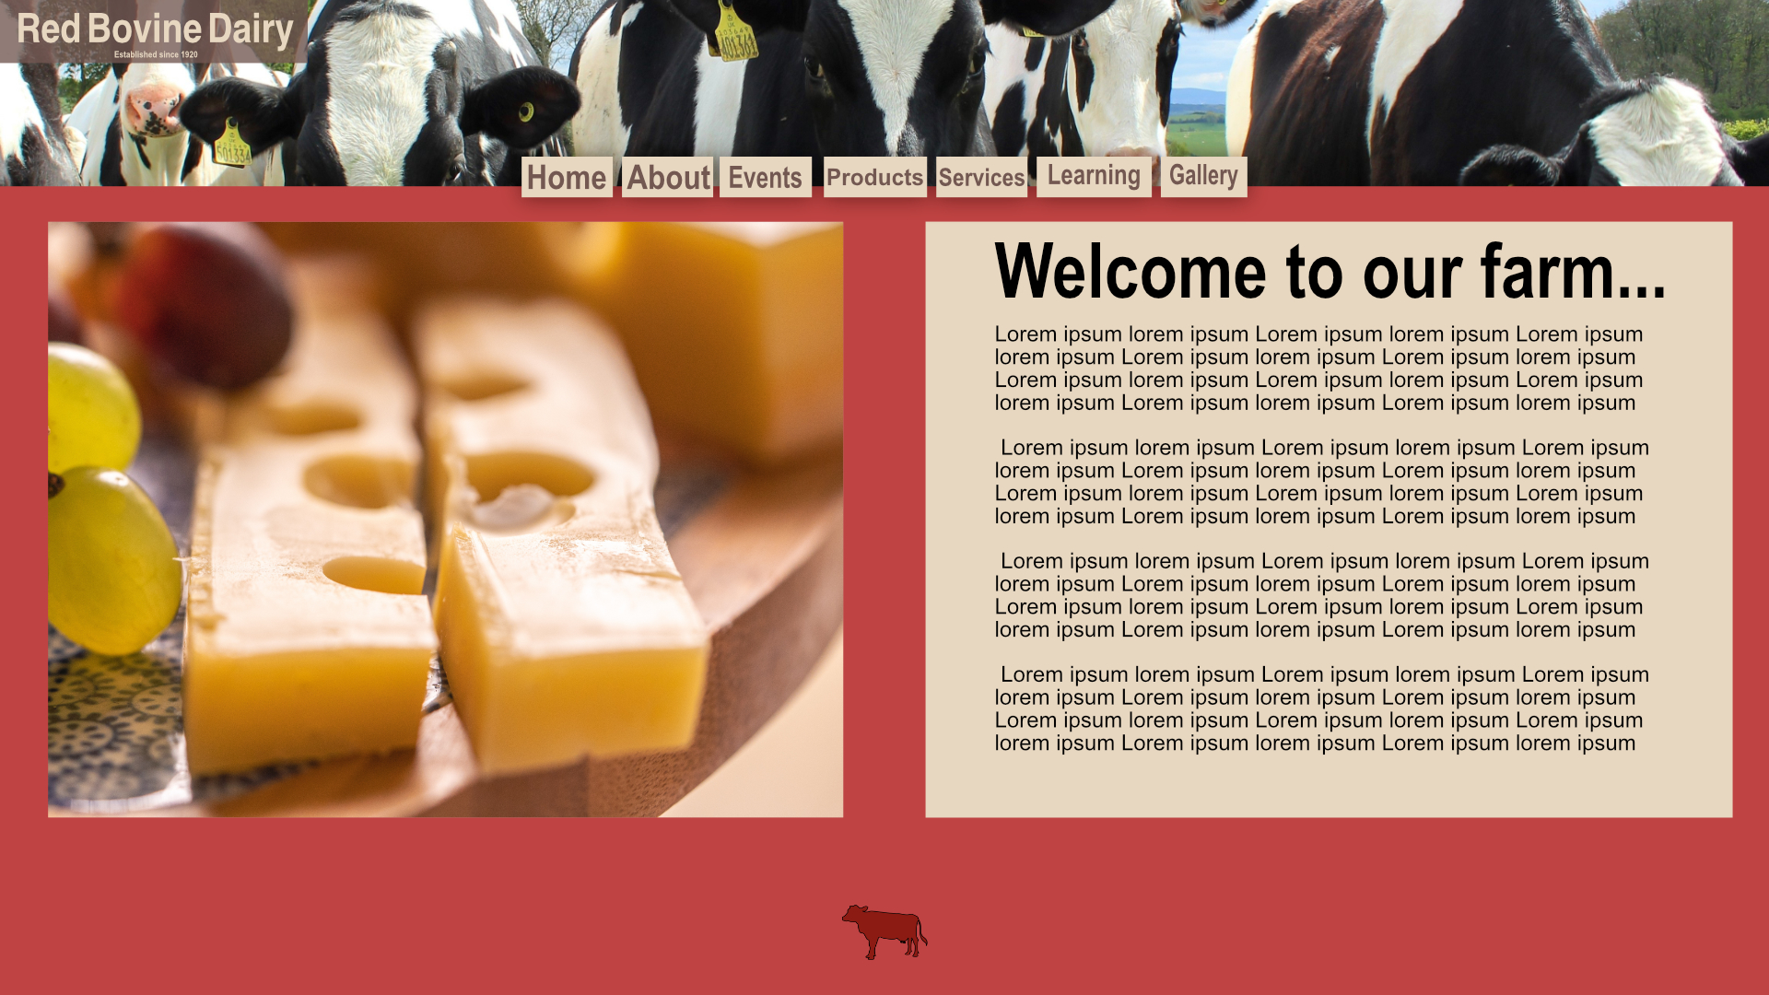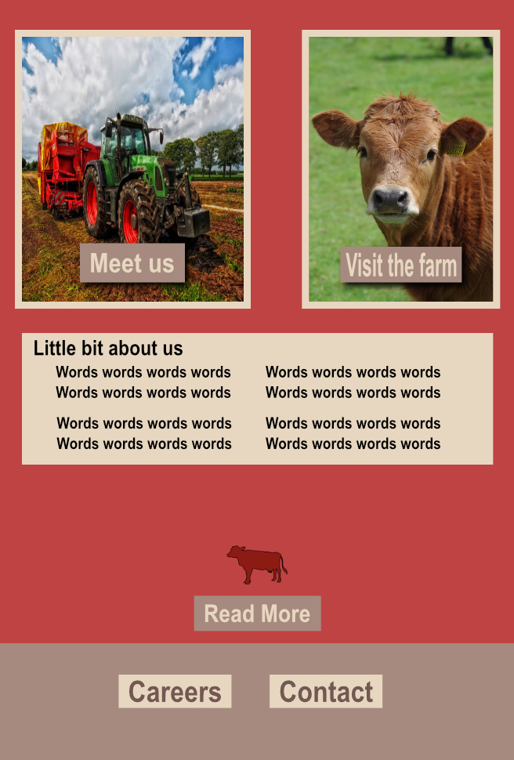

Color Palette 3
#141E28
#103F50
#770018
#903403
#E17C1D

Wireframe Option 2
Color Palette 1
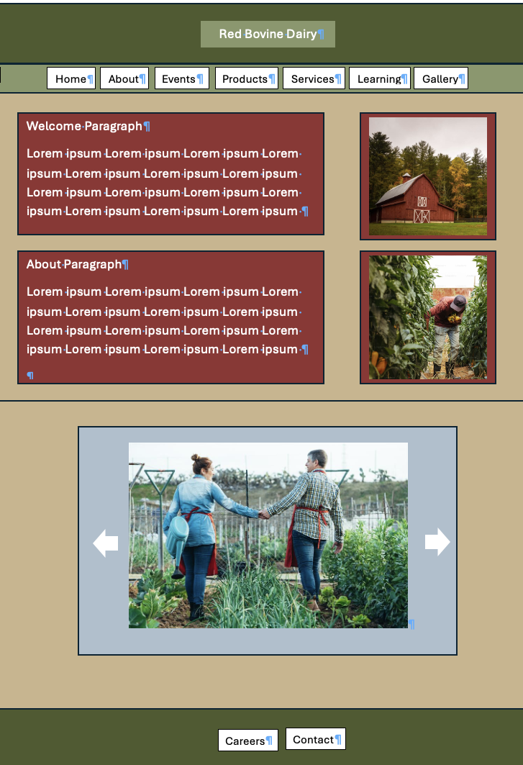

Color Palette 2
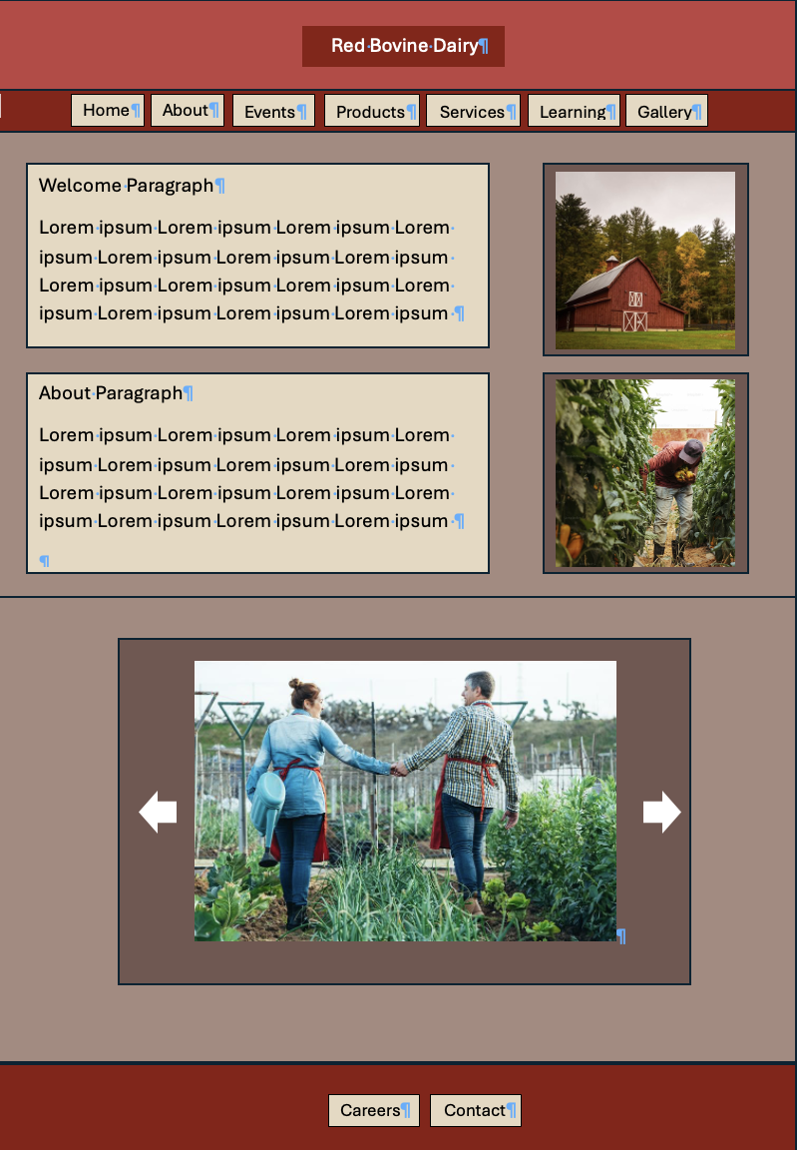

Color Palette 3
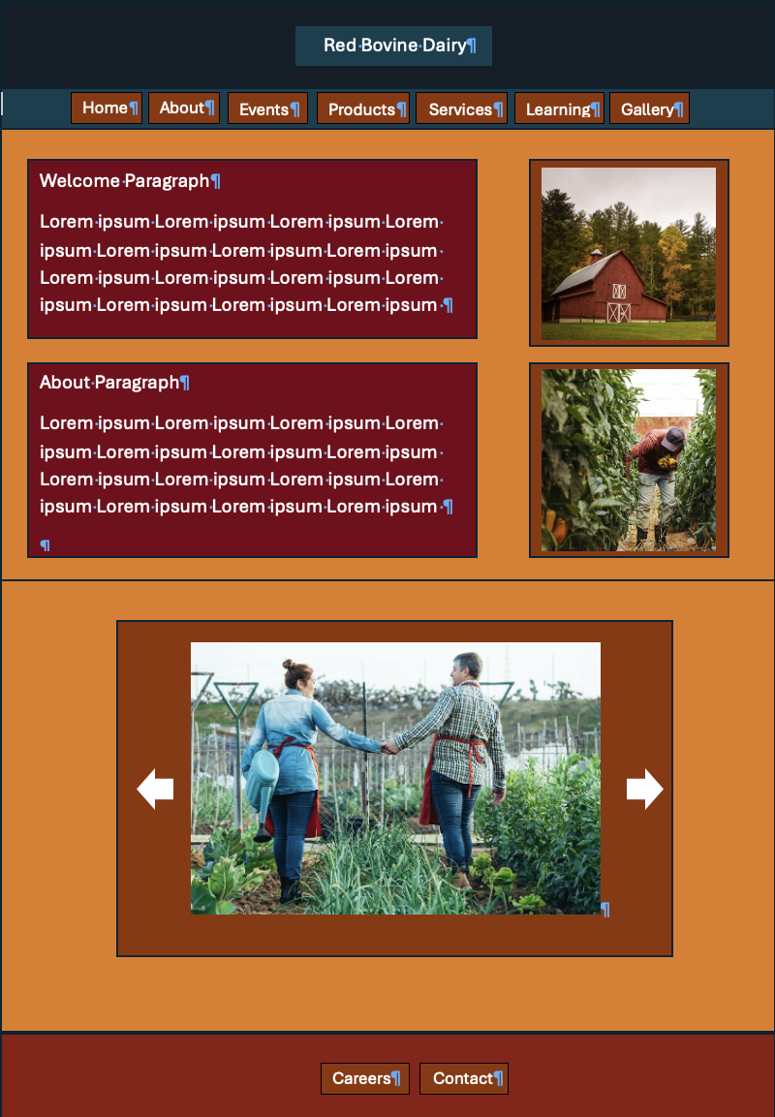

Style Document

Design Style
The information outlined in this document is for the code and design for Red Bovine Dairy, which can be found at: https://dotmcchesney.com/redbovinedairyfarms/

Global Elements

Page Dimensions
Page dimensions will vary under media queries, which ensures a responsive website.
- max-width: 600px
- max-width:767px
- min-width: 768px and max-width 1023px

Colors
Text Background: #89966A
Button Background, Image Border: #4D5A2E
Header Background: #CBB48B
Background: #ACC0CB
Logo Background: #923432

Global Element Sizes
Header Text: 10px padding on all sides, #923432, inside of banner, float center-left
Banner: Fixed at top of page, #CBB48B
Navigation: Fixed under the header, #89966A
Footer: Fixed at bottom of page, #923432

HTML Text
Primary: Georgia
Secondary: Times
Fallback Order: Georgia, Times, Times New Roman, Serif
H1 Text Size: 2.25 REM (36px)
H2 Text Size: 1.75 REM (28px)
H3 Text Size: 1.5 REM (24px)
H4 Text Size: 1.25 REM (20px)
H5 Text Size 1.125 REM (18px)
H6 Text Size: 1 REM (16px)
Navigation Text Size: 1 REM (16px)
Body Text Size: 1 REM (16px)

Graphic Type
The graphic type should match the font selected for the HTML of the page (Georgia) and should follow the same fallback hierarchy as the HTML as well (Times, Times New Roman, Serif) if the option before isn’t available.

Page-Specific Elements

Home
- Header-navigation spans the top of the page.
- Footer spans the bottom of the page.
- All text boxes have a white font color and a background color of #89966A
  - Text boxes are responsive and will change size depending on media query
- All images have a solid, 10px #4D5A2E border
  - Images are responsive and will change size depending on media query

About
- All text boxes have a white font color and a background color of #89966A
  - Location will be listed
  - Hours will be listed
  - Text boxes are responsive and will change size depending on media query
- All images have a solid, 10px #4D5A2E border
  - Image of Adam Saddler, including a brief history of the farm

Events
- All text boxes have a white font color and a background color of #89966A
  - List of events during the upcoming season (Summer 2024)
  - Description of events under listing
  - Text boxes are responsive and will change size depending on the media query
- All images have a solid, 10px #4D5A2E border
  - Images of the farm applicable to the season of the event

Products
- All text boxes have a white font color and a background color of #89966A
  - Feature products with images
  - All images have a solid, 10px #4D5A2E border
    - Cheese
    - Milk
    - Ice Cream

Services
- All text boxes have a white font color and a background color of #89966A
  - Feature services with images
    - Photo ops
    - Learning days (link to Learning page)

Learning
- All images have a solid, 10px #4D5A2E border
  - Images of kids with the animals OR with product
- All text boxes have a white font color and a background color of #89966A
  - Description of learning opportunities that RBD offers
    - Farm Visits
    - School Visits

Gallery
- All images have a solid, 10px #4D5A2E border
  - Feature major parts of the farm, animals, etc
- All text boxes have a white font color and a background color of #89966A
  - Provide a brief sentence for the gallery explaining what it is

Contact
- All text boxes have a white font color and a background color of #89966A
  - Provide phone number, email, and address of RBD / Adam Saddler
- Include a contact form to reach RBD

Careers
- All text boxes have a white font color and a background color of #89966A
  - Provide 1-2 job descriptions with application download
  - Link to contact page to submit application
    - Include email subject line to use when submitting

Acknowledgment
The client consents to all the details outlined in the technical specifications section of the design style document. Any updates must be submitted through a change form and approved by Go Social Web Design.
Client Signature:
x_Adam Saddler___ Date: __4/8/2024___

Technical Specifications

Technical Summary
The website of Red Bovine Dairy Farm can be reached via a sole homepage, providing users with access to all other pages through a navigation bar. The homepage includes the company name, images, text, and links.

Assumptions
Red Bovine Dairy Farm will supply Go Social Web Design with all current content, images, graphics, and specified color schemes outlined in the project documentation. Any additional content, including text, images, and graphics, will be generated or sourced by Go Social Web Design and undergo formal approval from Red Bovine Dairy Farm before integration into the website. Both parties will uphold the existing content through secure and backed-up systems.

Global Elements
Consistent global elements will be maintained across the entirety of the website. Red Bovine Dairy Farm can be accessed via a single homepage featuring a navigation bar enabling users to navigate to all relevant pages associated with the website.

Template
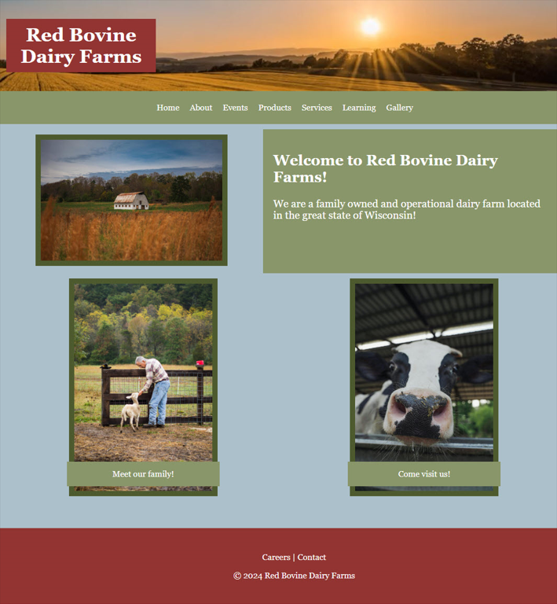

Color Scheme
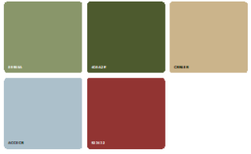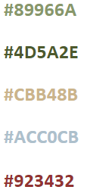

Global Elements

Global Header
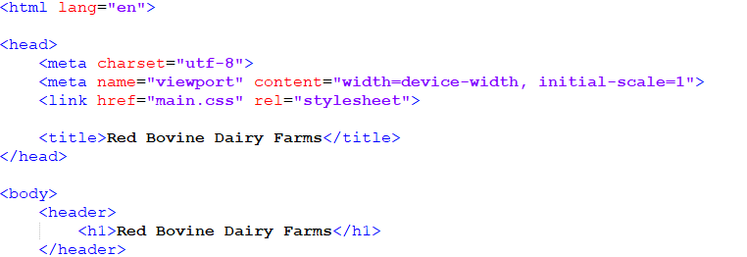
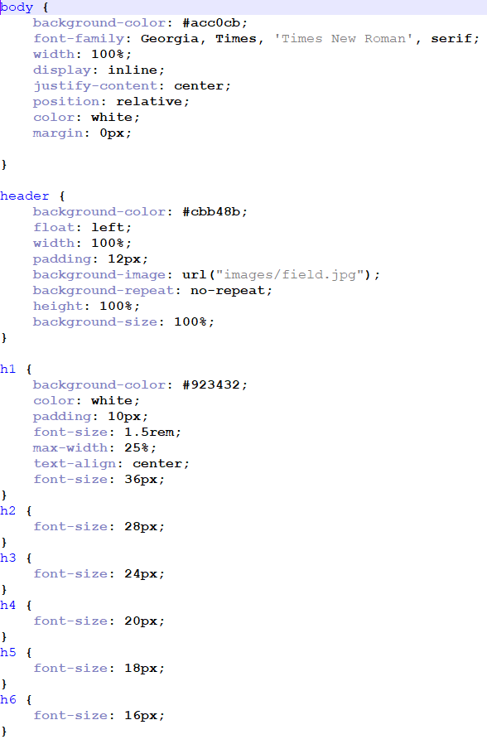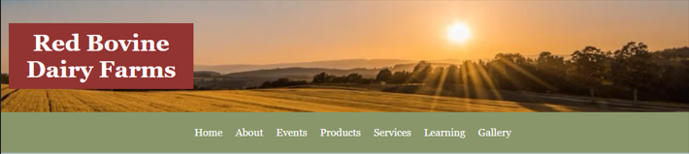

Global Navigation
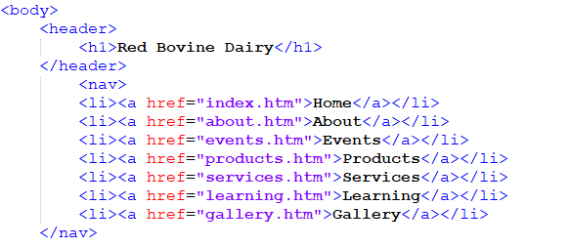
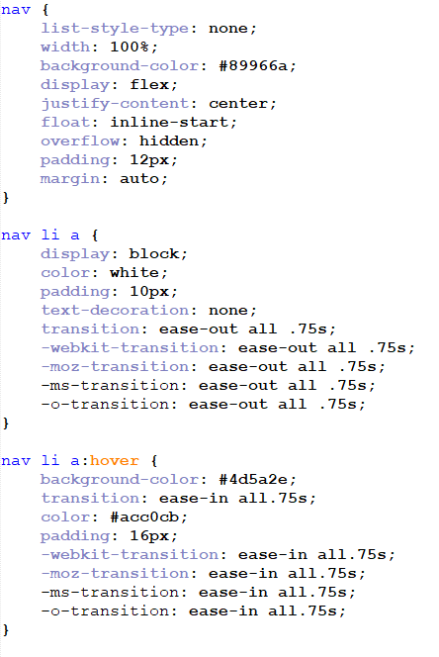

Global Footer
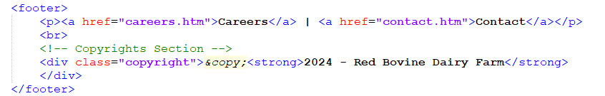
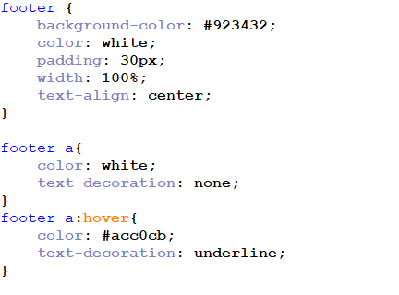


Page-Specific Elements
Since the content pages share a similar design and nature, only the home page will be displayed in the current version of the design style document. This decision was pre-approved by the client.

Home Page
When visitors access the Red Bovine Dairy Farm website, they will land on the home page. This page features a banner displaying the Red Bovine Dairy Farm company name, an image of the farmland, and a navigation bar. The main body of the page includes primary images positioned on the left and right sides, with the “Welcome” text box located on the right side.
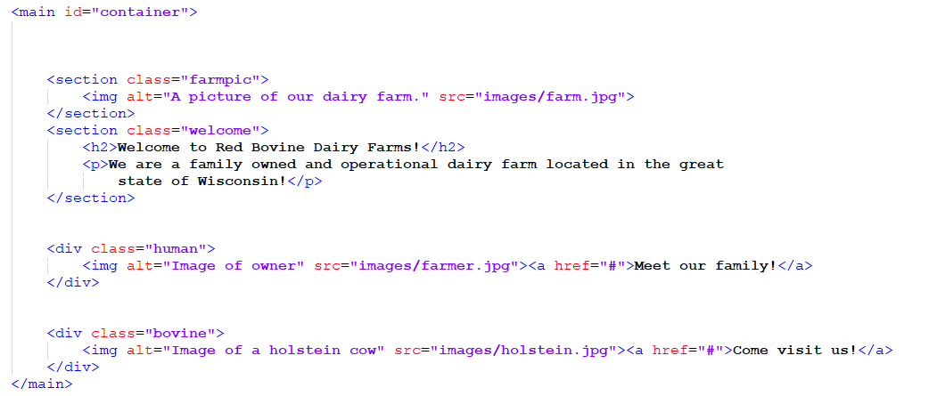
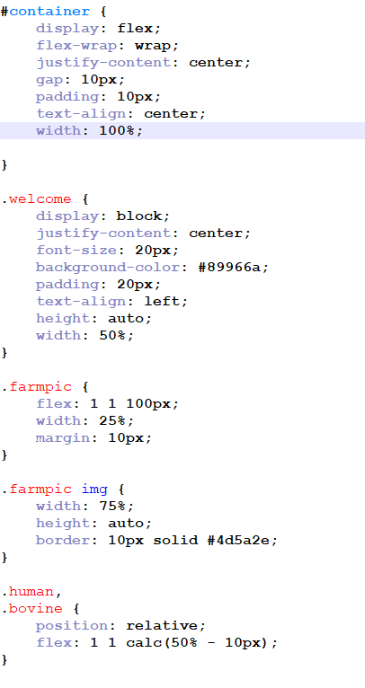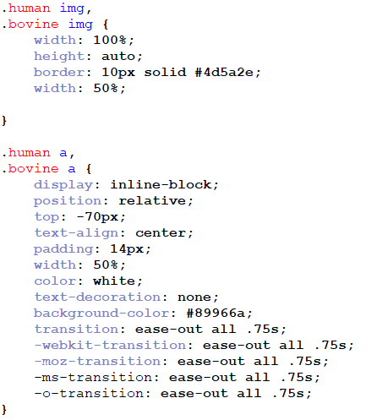
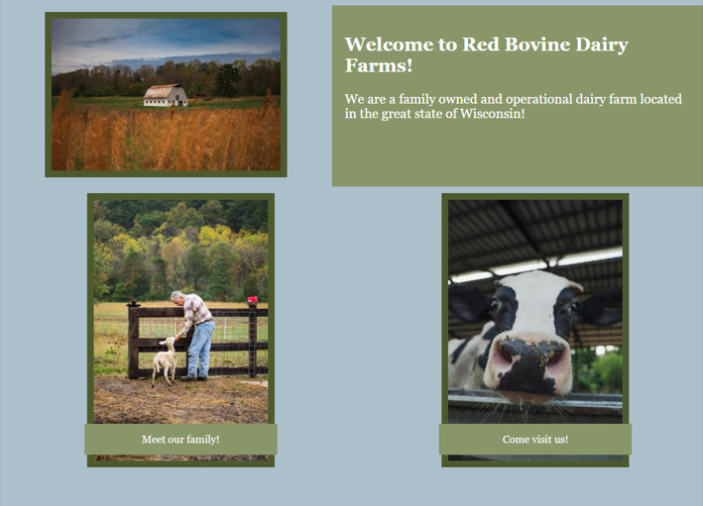

Naming Conventions
- Do not use special characters (!,@,#,$,%,^,&,*,(,), etc.)
- Use short and descriptive file names
- Use relevant keywords for all files
- Use underscores as separators
- Use all lowercase letters
- Avoid abbreviations
- Use meta tags and alt text when possible
Examples of filename: products.htm, cheddar_cheese.jpg
Both examples follow the naming convention guidelines: short, descriptive, lowercase, and using underscores to separate words.

File Extensions
- Web pages will end in: (.htm, .css, .php & .js)
- Image file extensions will be: (.jpg, .png, .gif, .svg)
- Text documents will be: (.pdf, .doc, .docx, .xls, .txt)

Navigation Bar Labels
- Company Name (top left of page) – index.htm
- Home – index.htm
- About – about.htm
- Events – events.htm
- Products – products.htm
- Services - services.htm
- Learning - learning.htm
- Careers - careers.htm
- Gallery - gallery.htm
- Contact– contact.htm

Programming
Document type declaration: <!DOCTYPE html>

Languages
HTML
CSS
JavaScript

Development Tools
Adobe Dreamweaver
Notepad++
Microsoft Office
GoDaddy Hosting
W3C HTML validation
W3C CSS validation
WAVE accessibility tool

Acknowledgment
The client consents to all the details outlined in the technical specifications section of the design style document. Any updates must be submitted through a change form and approved by Go Social Web Design.
Client Signature:
x_Adam Saddler___ Date: __4/8/2024___

Functional Specifications

Summary
The primary goal for the Red Bovine Dairy Farm website is to enable users to navigate effortlessly and explore all the products and services offered by the farm. The design strategy aims to maintain simplicity for universal usability, yet with sufficient sophistication to accommodate future enhancements and expansions.

Assumptions
The website will be functional and responsive on all device types, including smartphones, tablets, and computers.

Global Elements
All global elements will be consistent throughout the website, including the header, navigation, and footer.

Page Specific Elements

Home Page
The home page consists of a primary text box for welcome information and images representing the farm and its activities. It also includes links to position opportunities and career information.

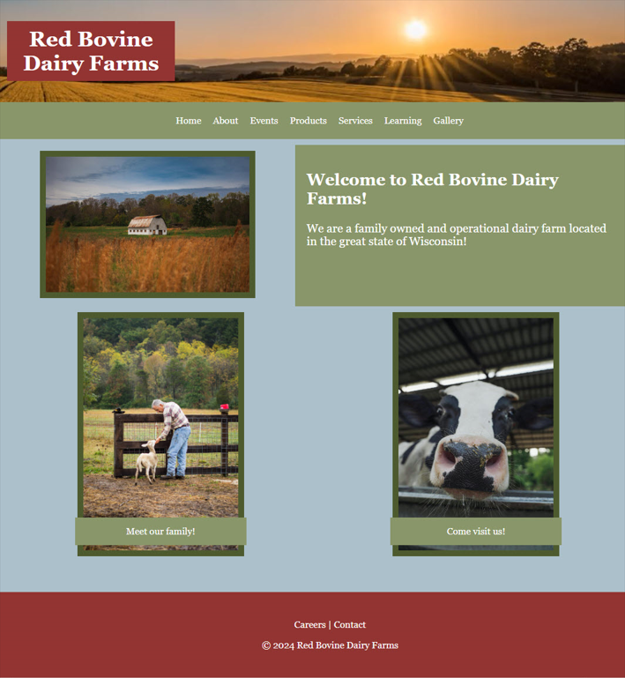

About Page
The About page will showcase images of the owner and the farm, along with general information about the farm. Additionally, secondary information related to the history of the farm will be included.

Events Page
The Events page will highlight the upcoming events, accompanied by images from previous events. The secondary details will provide expected dates, updates to the event, and a synopsis of the event.

Products Page
The Products page will feature images, descriptions, and prices for all available products at Red Bovine Dairy Farm. The description and price will be underneath the corresponding product image.

Services Page
The Services page will contain images and information on the services offered, boarding and Victory Gardens.

Learning Page
The learning page will contain images and information about farming, organic farming, hobby farming, professions in farming, and farm safety for educational purposes.

Careers Page
The Careers page will offer information on careers in farming and list open positions at the farm. There will be a link to an application to apply for any farm positions that are available.

Gallery Page
The Gallery page will highlight images from red Bovine Dairy Farm’s past events, family of animals, tours, and harvests.

Contact Page
The Contact page will have the Red Bovine Dairy Farm address, phone number, and map at the top of the page. Below will be a general contact form asking for name, email address, and feedback.

Acknowledgment
The client consents to all the details outlined in the technical specifications section of the design style document. Any updates must be submitted through a change form and approved by Go Social Web Design.
Client Signature:
x_Adam Saddler___ Date: __4/8/2024___

File Structure
Project Folder Name:
Folder Structure: redbovinedairy
- HTML Pages
  - index.html
  - about.html
  - events.html
  - products.html
  - services.html
  - learning.html
  - gallery.html
  - careers.html
  - contact.html
- CSS (all stylesheets)
- Images (Logos, feature images, etc)
  - JPG
  - PNG
  - GIF
- Metadata
  - <meta charset="utf-8">
  - <meta name="viewport" content="width=device-width, initial-scale=1">
  - <link href="main.css" rel="stylesheet">

Guidelines
- All documents’ images, etc, are to be kept in their respective folders
  - Contact website developer with questions
- HTML pages are to end with ‘.html’
- All documents are to be clean and easy to understand
Privacy Policy
This Privacy Policy outlines how Go Social collects, uses, discloses, and protects the information gathered from users of our website dotmcchesney.com/gosocial2/index.html and any related services. By using our Services, you agree to the terms outlined in this Privacy Policy.

1. Information We Collect:
We may collect personal information, including but not limited to names, email addresses, and other contact details, when you interact with our Services. Additionally, we may automatically collect non-personal information such as IP addresses, browser information, and usage data.

2. How We Use Your Information:
We use the collected information to provide and improve our Services, respond to inquiries, and personalize user experience. Your information may also be used for marketing and communication purposes, but only with your explicit consent.

3. Information Sharing:
We do not sell, trade, or otherwise transfer your personal information to outside parties unless we provide you with advance notice. This does not include trusted third parties who assist us in operating our website, conducting our business, or servicing you, as long as those parties agree to keep this information confidential.

4. Security:
We implement a variety of security measures to maintain the safety of your personal information. However, no data transmission over the internet or method of electronic storage is 100% secure, and we cannot guarantee absolute security.

5. Third-Party Links:
Our website may contain links to third-party websites. We have no control over the content or privacy practices of these sites and encourage you to review their privacy policies.

6. Updates to Privacy Policy:
We reserve the right to update this Privacy Policy at any time. The date of the latest revision will be displayed at the top of this page.

7. Contact information:
If you have any questions or concerns about this Privacy Policy, please contact us at gosocial@gosocialweb.com.

Acknowledgment
By signing this document, both parties have approved the layout and color palette for Red Bovine Dairy’s website. Any changes to be made going forward must be made through a change order form.

Client Signature:
x_Adam Saddler___ Date: __4/8/2024___
Project Manager Signature:
x_Molly Atkinson ___ Date: __4/8/24___

Quality Assurance Report

Type of Quality Assurance
The level of Quality Assurance that will be performed on the site is Light/Informal. The QA Lead or Project Manager will coordinate and track this process. A test team will go through the site; compiles and lists all the bugs for production to fix. Then the Lead person tracks the bug list, noting if the bug is being worked on, deferred or fixed, and dates it.

Summary
Schedule: General quality assurance testing should be done ASAP. Once quality assurance has been confirmed, recurrence should be once every time a major change is made to a site.
Methodology: During both composition and after completion, rigorous testing is essential. It should be timely to avoid delays, yet comprehensive to catch any issues. Balancing efficiency and thoroughness ensures a robust product.
Resources: HTML and CSS validators will be used for validation of code. JavaScript validation should be done after every major fix as well. Formatting the code to make it more organized and clean in order to avoid unnecessary setbacks

Participants
QA Lead: Danielle Robinson
- Will work to test the site for any errors/bugs with the client.
- Will regularly check in with the client with updates on the severity of all bugs/errors and if the site will be up to date by launch.
- Will give it her all to solve and fix the bugs in a timely manner.

Project Manager: Molly Atkinson
- Will assist the lead QA(Danielle Robinson) to test the site for errors/bugs.

Web Production Specialist: Dorothy McChesney
- Will fix any bugs found during testing.
- Will report any fixes to the lead QA and PM.

Client: Adam Saddler (Red Bovine Dairy)
- Works with the lead QA to test site for errors/bugs.
- Reports to Project Manager if any concerns arise before launch day.
- Signs and agrees to the QA plan.

Test Environments
Browsers that should be tested:
Google Chrome, Firefox, and Safari.
Platforms that should be tested:
Desktop and Mobile (IOS/Android)

Test Cases

Test Case 1 - Chrome

Web Standards
Reporter | Molly Atkinson | Date | 4/16/24
Platform | Laptop | Test Name | Web Standards
Operating System | Mac OS
Validation
Action | Expected | Satisfaction | Comments
CSS | CSS validates with no errors | Yes
HTML | HTML validates with no errors | Yes
SEO
Meta Author | Each page names author | No | Not present on any page
Meta Descriptions | Each page utilizes keywords up to 160 characters | No | Not present on any page
Meta Keywords | Each Page has 10 or less descriptive and relevant keywords/phrases | No | Not present on any page
Meta Robots | Robot tags present | No | Not preset on any page
Title Text | Each page gives page name | Yes
Optimized Images | Images are optimized for the web | Yes
Accessibility
Color Contrast | High contrast between text and backgrounds | Yes | Check ‘test accessibility’
Test Accessibility | Should come back with no errors | No | Contrast between light green color and white text, li are not contained in <ul>, <ol>, or <menu>
Headings | H1 tags present on each page | Yes
Alt tags | Descriptive alt tags should be present for every image | Yes

Page Content
Reporter | Molly Atkinson | Date | 4/16/24
Platform | Laptop | Test Name | Page Content
Operating System | Mac OS
Validation
Action | Expected | Satisfaction | Comments
CSS | Passes with no errors | Yes
HTML | Passes with no errors | Yes
SEO
Mobile Friendly | Displays properly on different devices | No | Pics don’t load properly on mobile, red Bovine Dairy Farms H1 is too small
Page Content | Displays well | No | Looks poor on mobile devices
Tags | Every tag is complete | Yes
Accessibility
Padding | Padding around edges | No | Extra gap on right side of page
Scrolls | Scrolling works | Yes
Consistency of color | Same color pattern | Yes
Page alignment | Everything on page is aligned well | Yes
Browsers | Loads in different browsers | Yes | Safari, Chrome, and Firefox
Icons | Loads in different browsers

Functionality
Reporter | Molly Atkinson | Date | 4/16/24
Platform | Laptop | Test Name | Functionality
Operating System | Mac OS
Validation
Action | Expected | Satisfaction | Comments
Navigation Bar Sectional Drop Downs | Navigation bar has drop down sections that appear when clicked on to lead to different pages | Yes
Font size is legible for mobile | Font size adjusts to remain large enough for easy legibility | Yes
Header and images are all responsive and line up | All images adjust to the size of the webpage | No | Mobile view images aren’t loading correctly
Responsive in design | Web page fits correctly on mobile screen | No | Images don’t load properly
Quick loading time of website | Site should load in 5 seconds or less | Yes

Links
Reporter | Molly Atkinson | Date | 4/16/24
Platform | Laptop | Test Name | Links
Operating System | Mac OS
Validation
Action | Expected | Satisfaction | Comments
Home page | Link leads to home page | Yes
About page | Link leads to about page | Yes
100-Year Celebration | Link leads to 100-year celebration page | Yes
Spring Celebration | Link leads to spring celebration page | Yes
Summer Swing | Link leads to summer swing page | Yes
Fall Festival | Link leads to fall festival page | Yes
Milk | Link leads to milk page | Yes
Cheese | Link leads to cheese page | Yes
Ice Cream | Link leads to ice cream page | Yes
Other | Link leads to other products page | Yes
Boarding | Link leads to boarding page | Yes
Victory Gardens | Link leads to Victory Gardens page | Yes
Becoming a Farmer | Link leads to Becoming a Farmer Page | Yes
Hobby Farm 101 | Link leads to hobby farm page | Yes
Farming Professions | Link leads to Farming Professions page | Yes
Farm Safety | Link leads to farm safety page | Yes
Organic Farming | Link leads to organic farming page | Yes
Gallery | Link leads to gallery page | Yes

Test Case 2 - Safari

Web Standards
Reporter | Molly Atkinson | Date | 4/17/24
Platform | Laptop | Test Name | Web Standards
Operating System | Mac OS
Validation
Action | Expected | Satisfaction | Comments
CSS | CSS validates with no errors | Yes
HTML | HTML validates with no errors | Yes
SEO
Meta Author | Each page names author | No | Not present on any page
Meta Descriptions | Each page utilizes keywords up to 160 characters | No | Not present on any page
Meta Keywords | Each Page has 10 or less descriptive and relevant keywords/phrases | No | Not present on any page
Meta Robots | Robot tags present | No | Not preset on any page
Title Text | Each page gives page name | Yes
Optimized Images | Images are optimized for the web | Yes
Accessibility
Color Contrast | High contrast between text and backgrounds | Yes | Check ‘test accessibility’
Test Accessibility | Should come back with no errors | No | Contrast between light green color and white text, li are not contained in <ul>, <ol>, or <menu>
Headings | H1 tags present on each page | Yes
Alt tags | Descriptive alt tags should be present for every image | Yes

Page Content
Reporter | Molly Atkinson | Date | 4/17/24
Platform | Laptop | Test Name | Page Content
Operating System | Mac OS
Validation
Action | Expected | Satisfaction | Comments
CSS | Passes with no errors | Yes
HTML | Passes with no errors | Yes
SEO
Mobile Friendly | Displays properly on different devices | No | Pics don’t load properly on mobile, red Bovine Dairy Farms H1 is too small
Page Content | Displays well | No | Looks poor on mobile devices
Tags | Every tag is complete | Yes
Accessibility
Padding | Padding around edges | No | Extra gap on right side of page
Scrolls | Scrolling works | Yes
Consistency of color | Same color pattern | Yes
Page alignment | Everything on page is aligned well | Yes
Browsers | Loads in different browsers | Yes | Safari, Chrome, and Firefox
Icons | Loads in different browsers

Functionality
Reporter | Molly Atkinson | Date | 4/17/24
Platform | Laptop | Test Name | Functionality
Operating System | Mac OS
Validation
Action | Expected | Satisfaction | Comments
Navigation Bar Sectional Drop Downs | Navigation bar has drop down sections that appear when clicked on to lead to different pages | Yes
Font size is legible for mobile | Font size adjusts to remain large enough for easy legibility | Yes
Header and images are all responsive and line up | All images adjust to the size of the webpage | No | Mobile view images aren’t loading correctly
Responsive in design | Web page fits correctly on mobile screen | No | Images don’t load properly
Quick loading time of website | Site should load in 5 seconds or less | Yes

Links
Reporter | Molly Atkinson | Date | 4/17/24
Platform | Laptop | Test Name | Links
Operating System | Mac OS
Validation
Action | Expected | Satisfaction | Comments
Home page | Link leads to home page | Yes
About page | Link leads to about page | Yes
100-Year Celebration | Link leads to 100-year celebration page | Yes
Spring Celebration | Link leads to spring celebration page | Yes
Summer Swing | Link leads to summer swing page | Yes
Fall Festival | Link leads to fall festival page | Yes
Milk | Link leads to milk page | Yes
Cheese | Link leads to cheese page | Yes
Ice Cream | Link leads to ice cream page | Yes
Other | Link leads to other products page | Yes
Boarding | Link leads to boarding page | Yes
Victory Gardens | Link leads to Victory Gardens page | Yes
Becoming a Farmer | Link leads to Becoming a Farmer Page | Yes
Hobby Farm 101 | Link leads to hobby farm page | Yes
Farming Professions | Link leads to Farming Professions page | Yes
Farm Safety | Link leads to farm safety page | Yes
Organic Farming | Link leads to organic farming page | Yes
Gallery | Link leads to gallery page | Yes

Test Case 3 - Firefox

Web Standards
Reporter | Molly Atkinson | Date | 4/17/24
Platform | Laptop | Test Name | Web Standards
Operating System | Mac OS
Validation
Action | Expected | Satisfaction | Comments
CSS | CSS validates with no errors | Yes
HTML | HTML validates with no errors | Yes
SEO
Meta Author | Each page names author | No | Not present on any page
Meta Descriptions | Each page utilizes keywords up to 160 characters | No | Not present on any page
Meta Keywords | Each Page has 10 or less descriptive and relevant keywords/phrases | No | Not present on any page
Meta Robots | Robot tags present | No | Not preset on any page
Title Text | Each page gives page name | Yes
Optimized Images | Images are optimized for the web | Yes
Accessibility
Color Contrast | High contrast between text and backgrounds | Yes | Check ‘test accessibility’
Test Accessibility | Should come back with no errors | No | Contrast between light green color and white text, li are not contained in <ul>, <ol>, or <menu>
Headings | H1 tags present on each page | Yes
Alt tags | Descriptive alt tags should be present for every image | Yes

Page Content
Reporter | Molly Atkinson | Date | 4/17/24
Platform | Laptop | Test Name | Page Content
Operating System | Mac OS
Validation
Action | Expected | Satisfaction | Comments
CSS | Passes with no errors | Yes
HTML | Passes with no errors | Yes
SEO
Mobile Friendly | Displays properly on different devices | No | Pics don’t load properly on mobile, red Bovine Dairy Farms H1 is too small
Page Content | Displays well | No | Looks poor on mobile devices
Tags | Every tag is complete | Yes
Accessibility
Padding | Padding around edges | No | Extra gap on right side of page
Scrolls | Scrolling works | Yes
Consistency of color | Same color pattern | Yes
Page alignment | Everything on page is aligned well | Yes
Browsers | Loads in different browsers | Yes | Safari, Chrome, and Firefox
Icons | Loads in different browsers

Functionality
Reporter | Molly Atkinson | Date | 4/17/24
Platform | Laptop | Test Name | Functionality
Operating System | Mac OS
Validation
Action | Expected | Satisfaction | Comments
Navigation Bar Sectional Drop Downs | Navigation bar has drop down sections that appear when clicked on to lead to different pages | Yes
Font size is legible for mobile | Font size adjusts to remain large enough for easy legibility | Yes
Header and images are all responsive and line up | All images adjust to the size of the webpage | No | Mobile view images aren’t loading correctly
Responsive in design | Web page fits correctly on mobile screen | No | Images don’t load properly
Quick loading time of website | Site should load in 5 seconds or less | Yes

Links
Reporter | Molly Atkinson | Date | 4/17/24
Platform | Laptop | Test Name | Links
Operating System | Mac OS
Validation
Action | Expected | Satisfaction | Comments
Home page | Link leads to home page | Yes
About page | Link leads to about page | Yes
100-Year Celebration | Link leads to 100-year celebration page | Yes
Spring Celebration | Link leads to spring celebration page | Yes
Summer Swing | Link leads to summer swing page | Yes
Fall Festival | Link leads to fall festival page | Yes
Milk | Link leads to milk page | Yes
Cheese | Link leads to cheese page | Yes
Ice Cream | Link leads to ice cream page | Yes
Other | Link leads to other products page | Yes
Boarding | Link leads to boarding page | Yes
Victory Gardens | Link leads to Victory Gardens page | Yes
Becoming a Farmer | Link leads to Becoming a Farmer Page | Yes
Hobby Farm 101 | Link leads to hobby farm page | Yes
Farming Professions | Link leads to Farming Professions page | Yes
Farm Safety | Link leads to farm safety page | Yes
Organic Farming | Link leads to organic farming page | Yes
Gallery | Link leads to gallery page | Yes

Bug Reporting Plan
The testers will be responsible for monitoring bugs/errors found on the site.
- Completing the form when necessary for documentation of the bug.
- Note the steps that were taken to locate and receive the bug/error.
- Report the URL of the bug's location.
- Screen capture will be critical in this effort to solve the bug.
- ID the browser or device used.
- ID the severity of the bug/error and how big of a priority it is to get solved.
- Explanation of how the solved bug/error came to be.

Bug Fixing Plan
Upon completion of testing, the filled-out forms are submitted for evaluation. The Quality Assurance Lead meticulously reviews each form, assessing any identified bugs. The severity and priority of each issue are determined to ensure timely attention to critical matters. Subsequently, the forms are handed over to the Production Lead, who revises the code to address the reported bugs. Revisions are thoroughly reviewed, and upon approval, the client signs off on the revised code. The QA Lead maintains ongoing communication with the Production Lead, diligently following up until all higher-level bugs (such as block, critical, and major issues) are resolved. This streamlined process ensures efficient bug resolution and upholds product quality.

Bug Priority Scheme
⦁ Priority 1: Critical bug/error (results in crashes or loss of data)
⦁ Priority 2: Major bug/error (loss of functionality or usability of the site)
⦁ Priority 3: Minor bug/error (minor loss of functionality or usability of the site)
⦁ Priority 4: Slight bug/error (lowest priority such as spelling errors or incorrect grammar)

Bug Severity Scheme
⦁ 1. Blocker- No further testing can be done.
⦁ 2. Critical- Broken website.
⦁ 3. Major- Major loss in Functionality.
⦁ 4. Minor- Minor loss in Functionality.
⦁ 5. Trivial- UI Enhancements
All efforts will be put forth into fixing any block, critical, or major bugs before launch of the website. If we are unable to fix the problems by the time the website is scheduled to launch, we will extend the launch date by 5 business days to further ensure all bugs are fixed and taken care of. Any remaining lower level bugs, such as medium, minor and trivial bugs, will be addressed within 5 business days of website launch.
Acknowledgment
By signing here I agree to the bug tracking and fixing plans as outlined above.
Signature: __Adam Saddler_______ Date: __4/17/2024___

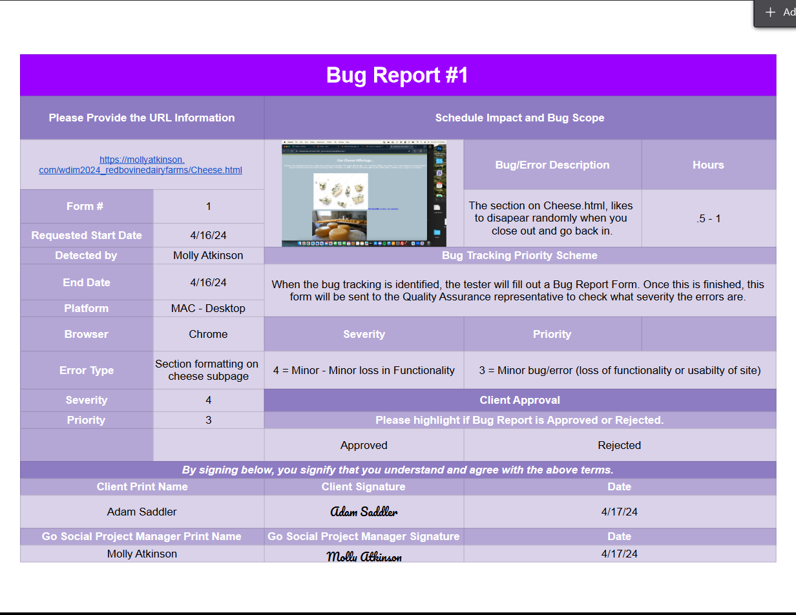
Bug Reports

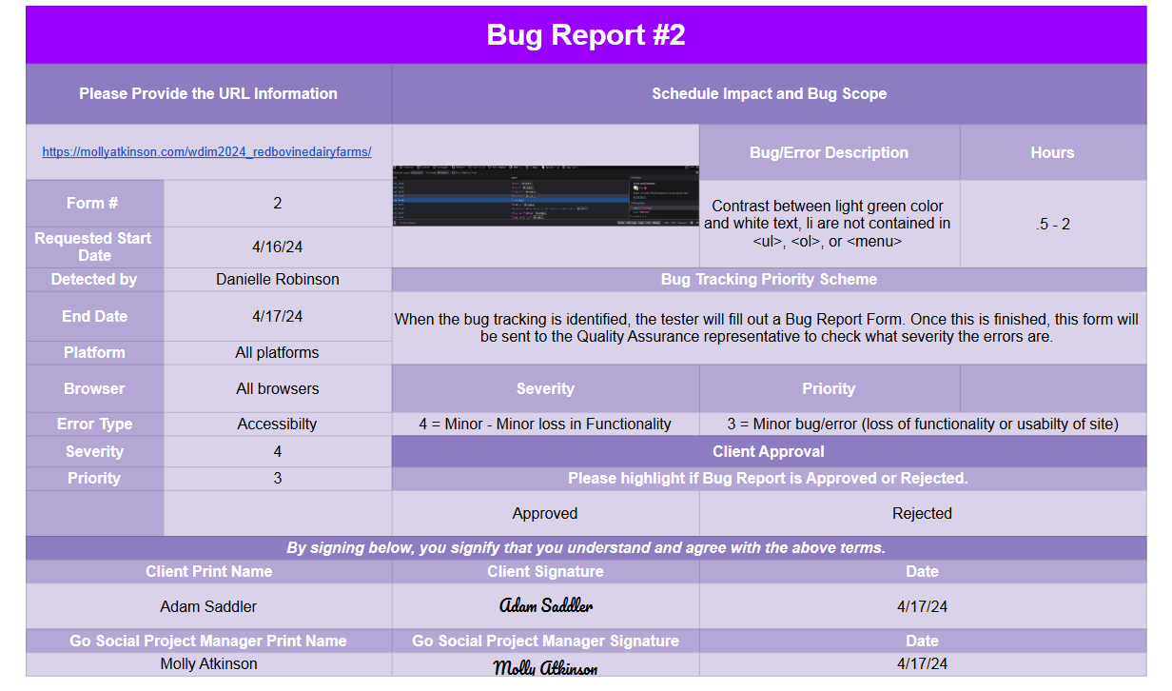

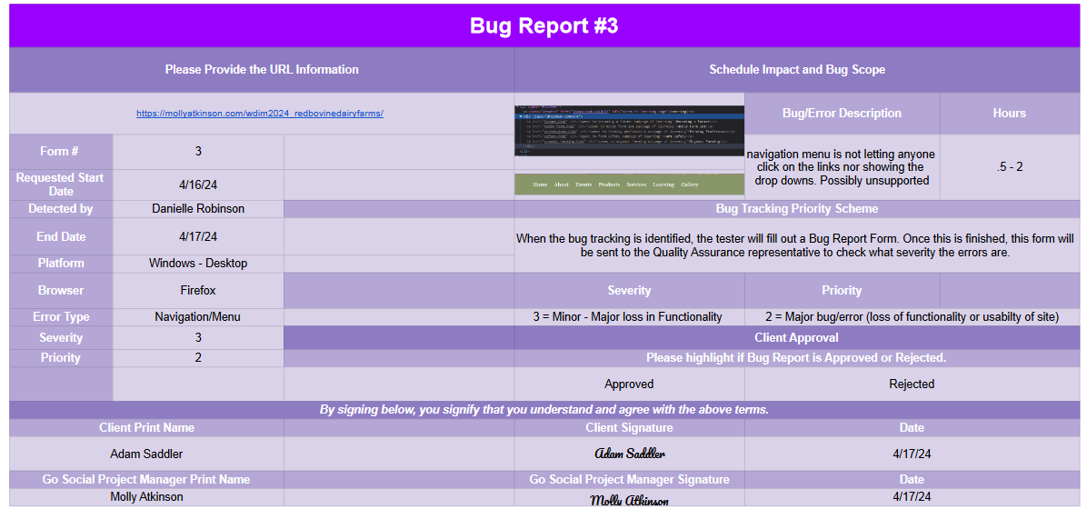

Test Cases

Test Case 1 - Chrome

Web Standards
Reporter | Molly Atkinson | Date | 4/16/24
Platform | Laptop | Test Name | Web Standards
Operating System | Mac OS
Validation
Action | Expected | Satisfaction | Comments
CSS | CSS validates with no errors | Yes
HTML | HTML validates with no errors | Yes
SEO
Meta Author | Each page names author | No | Not present on any page
Meta Descriptions | Each page utilizes keywords up to 160 characters | No | Not present on any page
Meta Keywords | Each Page has 10 or less descriptive and relevant keywords/phrases | No | Not present on any page
Meta Robots | Robot tags present | No | Not preset on any page
Title Text | Each page gives page name | Yes
Optimized Images | Images are optimized for the web | Yes
Accessibility
Color Contrast | High contrast between text and backgrounds | Yes | Check ‘test accessibility’
Test Accessibility | Should come back with no errors | No | Contrast between light green color and white text, li are not contained in <ul>, <ol>, or <menu>
Headings | H1 tags present on each page | Yes
Alt tags | Descriptive alt tags should be present for every image | Yes

Page Content
Reporter | Molly Atkinson | Date | 4/16/24
Platform | Laptop | Test Name | Page Content
Operating System | Mac OS
Validation
Action | Expected | Satisfaction | Comments
CSS | Passes with no errors | Yes
HTML | Passes with no errors | Yes
SEO
Mobile Friendly | Displays properly on different devices | No | Pics don’t load properly on mobile, red Bovine Dairy Farms H1 is too small
Page Content | Displays well | No | Looks poor on mobile devices
Tags | Every tag is complete | Yes
Accessibility
Padding | Padding around edges | No | Extra gap on right side of page
Scrolls | Scrolling works | Yes
Consistency of color | Same color pattern | Yes
Page alignment | Everything on page is aligned well | Yes
Browsers | Loads in different browsers | Yes | Safari, Chrome, and Firefox
Icons | Loads in different browsers

Functionality
Reporter | Molly Atkinson | Date | 4/16/24
Platform | Laptop | Test Name | Functionality
Operating System | Mac OS
Validation
Action | Expected | Satisfaction | Comments
Navigation Bar Sectional Drop Downs | Navigation bar has drop down sections that appear when clicked on to lead to different pages | Yes
Font size is legible for mobile | Font size adjusts to remain large enough for easy legibility | Yes
Header and images are all responsive and line up | All images adjust to the size of the webpage | No | Mobile view images aren’t loading correctly
Responsive in design | Web page fits correctly on mobile screen | No | Images don’t load properly
Quick loading time of website | Site should load in 5 seconds or less | Yes

Links
Reporter | Molly Atkinson | Date | 4/16/24
Platform | Laptop | Test Name | Links
Operating System | Mac OS
Validation
Action | Expected | Satisfaction | Comments
Home page | Link leads to home page | Yes
About page | Link leads to about page | Yes
100-Year Celebration | Link leads to 100-year celebration page | Yes
Spring Celebration | Link leads to spring celebration page | Yes
Summer Swing | Link leads to summer swing page | Yes
Fall Festival | Link leads to fall festival page | Yes
Milk | Link leads to milk page | Yes
Cheese | Link leads to cheese page | Yes
Ice Cream | Link leads to ice cream page | Yes
Other | Link leads to other products page | Yes
Boarding | Link leads to boarding page | Yes
Victory Gardens | Link leads to Victory Gardens page | Yes
Becoming a Farmer | Link leads to Becoming a Farmer Page | Yes
Hobby Farm 101 | Link leads to hobby farm page | Yes
Farming Professions | Link leads to Farming Professions page | Yes
Farm Safety | Link leads to farm safety page | Yes
Organic Farming | Link leads to organic farming page | Yes
Gallery | Link leads to gallery page | Yes

Test Case 2 - Safari

Web Standards
Reporter | Molly Atkinson | Date | 4/17/24
Platform | Laptop | Test Name | Web Standards
Operating System | Mac OS
Validation
Action | Expected | Satisfaction | Comments
CSS | CSS validates with no errors | Yes
HTML | HTML validates with no errors | Yes
SEO
Meta Author | Each page names author | No | Not present on any page
Meta Descriptions | Each page utilizes keywords up to 160 characters | No | Not present on any page
Meta Keywords | Each Page has 10 or less descriptive and relevant keywords/phrases | No | Not present on any page
Meta Robots | Robot tags present | No | Not preset on any page
Title Text | Each page gives page name | Yes
Optimized Images | Images are optimized for the web | Yes
Accessibility
Color Contrast | High contrast between text and backgrounds | Yes | Check ‘test accessibility’
Test Accessibility | Should come back with no errors | No | Contrast between light green color and white text, li are not contained in <ul>, <ol>, or <menu>
Headings | H1 tags present on each page | Yes
Alt tags | Descriptive alt tags should be present for every image | Yes

Page Content
Reporter | Molly Atkinson | Date | 4/17/24
Platform | Laptop | Test Name | Page Content
Operating System | Mac OS
Validation
Action | Expected | Satisfaction | Comments
CSS | Passes with no errors | Yes
HTML | Passes with no errors | Yes
SEO
Mobile Friendly | Displays properly on different devices | No | Pics don’t load properly on mobile, red Bovine Dairy Farms H1 is too small
Page Content | Displays well | No | Looks poor on mobile devices
Tags | Every tag is complete | Yes
Accessibility
Padding | Padding around edges | No | Extra gap on right side of page
Scrolls | Scrolling works | Yes
Consistency of color | Same color pattern | Yes
Page alignment | Everything on page is aligned well | Yes
Browsers | Loads in different browsers | Yes | Safari, Chrome, and Firefox
Icons | Loads in different browsers

Functionality
Reporter | Molly Atkinson | Date | 4/17/24
Platform | Laptop | Test Name | Functionality
Operating System | Mac OS
Validation
Action | Expected | Satisfaction | Comments
Navigation Bar Sectional Drop Downs | Navigation bar has drop down sections that appear when clicked on to lead to different pages | Yes
Font size is legible for mobile | Font size adjusts to remain large enough for easy legibility | Yes
Header and images are all responsive and line up | All images adjust to the size of the webpage | No | Mobile view images aren’t loading correctly
Responsive in design | Web page fits correctly on mobile screen | No | Images don’t load properly
Quick loading time of website | Site should load in 5 seconds or less | Yes

Links
Reporter | Molly Atkinson | Date | 4/17/24
Platform | Laptop | Test Name | Links
Operating System | Mac OS
Validation
Action | Expected | Satisfaction | Comments
Home page | Link leads to home page | Yes
About page | Link leads to about page | Yes
100-Year Celebration | Link leads to 100-year celebration page | Yes
Spring Celebration | Link leads to spring celebration page | Yes
Summer Swing | Link leads to summer swing page | Yes
Fall Festival | Link leads to fall festival page | Yes
Milk | Link leads to milk page | Yes
Cheese | Link leads to cheese page | Yes
Ice Cream | Link leads to ice cream page | Yes
Other | Link leads to other products page | Yes
Boarding | Link leads to boarding page | Yes
Victory Gardens | Link leads to Victory Gardens page | Yes
Becoming a Farmer | Link leads to Becoming a Farmer Page | Yes
Hobby Farm 101 | Link leads to hobby farm page | Yes
Farming Professions | Link leads to Farming Professions page | Yes
Farm Safety | Link leads to farm safety page | Yes
Organic Farming | Link leads to organic farming page | Yes
Gallery | Link leads to gallery page | Yes

Test Case 3 - Firefox

Web Standards
Reporter | Molly Atkinson | Date | 4/17/24
Platform | Laptop | Test Name | Web Standards
Operating System | Mac OS
Validation
Action | Expected | Satisfaction | Comments
CSS | CSS validates with no errors | Yes
HTML | HTML validates with no errors | Yes
SEO
Meta Author | Each page names author | No | Not present on any page
Meta Descriptions | Each page utilizes keywords up to 160 characters | No | Not present on any page
Meta Keywords | Each Page has 10 or less descriptive and relevant keywords/phrases | No | Not present on any page
Meta Robots | Robot tags present | No | Not preset on any page
Title Text | Each page gives page name | Yes
Optimized Images | Images are optimized for the web | Yes
Accessibility
Color Contrast | High contrast between text and backgrounds | Yes | Check ‘test accessibility’
Test Accessibility | Should come back with no errors | No | Contrast between light green color and white text, li are not contained in <ul>, <ol>, or <menu>
Headings | H1 tags present on each page | Yes
Alt tags | Descriptive alt tags should be present for every image | Yes

Page Content
Reporter | Molly Atkinson | Date | 4/17/24
Platform | Laptop | Test Name | Page Content
Operating System | Mac OS
Validation
Action | Expected | Satisfaction | Comments
CSS | Passes with no errors | Yes
HTML | Passes with no errors | Yes
SEO
Mobile Friendly | Displays properly on different devices | No | Pics don’t load properly on mobile, red Bovine Dairy Farms H1 is too small
Page Content | Displays well | No | Looks poor on mobile devices
Tags | Every tag is complete | Yes
Accessibility
Padding | Padding around edges | No | Extra gap on right side of page
Scrolls | Scrolling works | Yes
Consistency of color | Same color pattern | Yes
Page alignment | Everything on page is aligned well | Yes
Browsers | Loads in different browsers | Yes | Safari, Chrome, and Firefox
Icons | Loads in different browsers

Functionality
Reporter | Molly Atkinson | Date | 4/17/24
Platform | Laptop | Test Name | Functionality
Operating System | Mac OS
Validation
Action | Expected | Satisfaction | Comments
Navigation Bar Sectional Drop Downs | Navigation bar has drop down sections that appear when clicked on to lead to different pages | Yes
Font size is legible for mobile | Font size adjusts to remain large enough for easy legibility | Yes
Header and images are all responsive and line up | All images adjust to the size of the webpage | No | Mobile view images aren’t loading correctly
Responsive in design | Web page fits correctly on mobile screen | No | Images don’t load properly
Quick loading time of website | Site should load in 5 seconds or less | Yes

Links
Reporter | Molly Atkinson | Date | 4/17/24
Platform | Laptop | Test Name | Links
Operating System | Mac OS
Validation
Action | Expected | Satisfaction | Comments
Home page | Link leads to home page | Yes
About page | Link leads to about page | Yes
100-Year Celebration | Link leads to 100-year celebration page | Yes
Spring Celebration | Link leads to spring celebration page | Yes
Summer Swing | Link leads to summer swing page | Yes
Fall Festival | Link leads to fall festival page | Yes
Milk | Link leads to milk page | Yes
Cheese | Link leads to cheese page | Yes
Ice Cream | Link leads to ice cream page | Yes
Other | Link leads to other products page | Yes
Boarding | Link leads to boarding page | Yes
Victory Gardens | Link leads to Victory Gardens page | Yes
Becoming a Farmer | Link leads to Becoming a Farmer Page | Yes
Hobby Farm 101 | Link leads to hobby farm page | Yes
Farming Professions | Link leads to Farming Professions page | Yes
Farm Safety | Link leads to farm safety page | Yes
Organic Farming | Link leads to organic farming page | Yes
Gallery | Link leads to gallery page | Yes

Bug Reports

Domain Name Plan

Domain Name Considerations
A domain name is crucial when building a website as it is the first impression of your brand for your audience. The right domain name can boost website traffic and pique interest in your business, while an ill-chosen one can deter potential customers. An ideal domain name succinctly represents your business and is easy to remember.

Our Domain Name Suggestions:
- www.redbovinedairyfarms.com
- www.red-bovine-dairy-farms.com
- www.redbovinedairyfarms.org
- www.redbovinedairyfarms.net

Registrar's:
Pricing is based on RedBovineDairyFarms.com
Host Name | Price | Features
GoDaddy | $0.01 for the first year of a 3 year term, then its $21.99/yr | Adds Full Domain Protection for $11.99/domain per year
WordPress | Free domain for the first year with annual paid plans then its $12.00/year | Domain protection is included
Wix | Free domain for one year with premium plan
NameCheap | $5.96 with code: NEWCOM598 at checkout, otherwise $10.28/yr | Web Hosting, SSL $5.99/yr, Premium DNS protection for $4.88

Our Choice
Go Socials Web Site Design frequently faces the challenge of selecting the optimal web-hosting platform for our clients. This led us to choose GoDaddy over WordPress. While WordPress offers competitive pricing, the decision ultimately hinges on the features and benefits each platform provides.

Recommendation:
Go Social recommends the following domain name:
www.redbovinedairyfarms.com
Our recommendation is based on the commonality of .com endings for websites, which aids in memorability. Aligning the domain with your business name and primary product can further enhance recall for customers. Plus, it’s beneficial for SEO purposes. This approach ensures your website is both relevant and easy to find.

Web Hosting
Web hosting is a digital service that allows your website to be accessible on the internet. It involves storing your website's data, including text, photos, videos, and other files, on a physical server. This server is connected to the internet, allowing others to access your website at any time. Web hosting services also often assist with website maintenance, such as backups, security, and uptime. The choice of a hosting plan is crucial as features and prices can vary widely among providers. Overall, web hosting is an essential component of establishing an online presence.

Web Hosting Packages
The following plans offer similar services and features.

GoDaddy WordPress

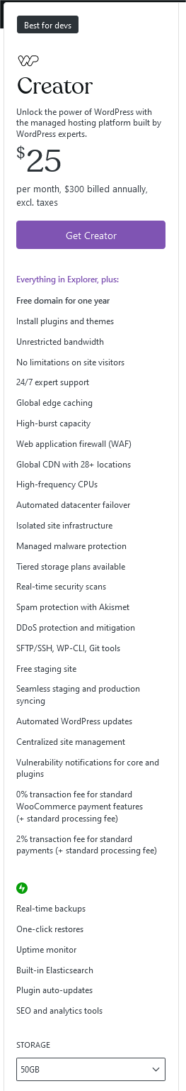

WordPress is an open-source content management system (CMS) that requires third-party hosting, offering extensive customization with numerous themes and plugins. GoDaddy is an all-in-one platform providing web hosting and a website builder with easy-to-use templates. WordPress is ideal for those seeking flexibility and customizability, while GoDaddy is suitable for those preferring an easy, all-in-one solution. Both platforms are popular for website creation and management.
Go Social recommends GoDaddy for the all-in-one solution for a successful website.

Acknowledgment
I understand that the recommendations listed above are simply suggestions and I am the final decision maker. Any changes I may make to my decision after today will affect the budget and development process and additional charges may be applied.

Client Signature:
x_Adam Saddler___ Date: __4/23/2024___

Project Manager Signature:
x_Molly Atkinson ___ Date: __4/23/24___

SEO Plan

OVERVIEW
Search Engine Optimization (SEO) is a process that improves your website’s ranking and visibility in search engine results. We can optimize your search engine results by identifying keywords and phrases and drive more traffic to your website and visits to your farm.
Go Social Web Design can help you with SEO services and make it so your customers can find you more easily.

SEARCH ENGINE USAGE STATISTICS
From: https://www.netmarketshare.com/
March 2024
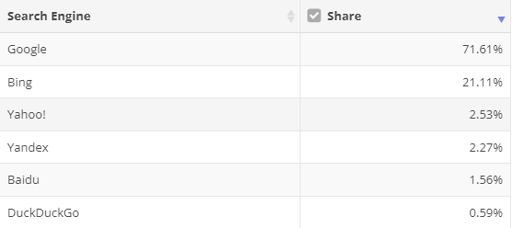
From: https://www.smartinsights.com/search-engine-marketing/search-engine-statistics/
December 2023
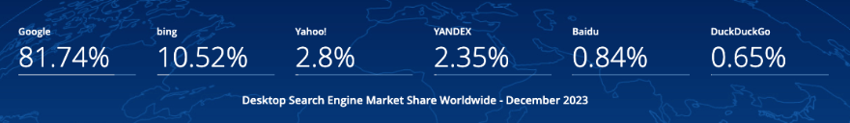

SEO
We have already implemented the following:
- Images contain “alt text” and include keywords
- File names are clear and concise
- Semantic structure is applied
- HTML and CSS have been validated
These implementations have already improved the searches for your website, helping your current and future customers find you more easily.

SEARCH TOOL PLAN
There are numerous plans available for submitting your site to search engines. Your choice depends mainly on the platform you prefer and are comfortable with. Below are two examples: manually submitting your site to the search engine or automatically using submission software.

MANUALLY
Manually submitting your websites to search engines is free but can be less efficient. The steps can be found at this website:
https://kinsta.com/blog/submit-website-to-search-engines/
First, set up your Google Search Console and verify ownership. Once this is set up you can use it to also import your site to Bing.
To submit to Google:
- Locate your XML Sitemap.
- Add Your Sitemap to the Google Search Console - https://kinsta.com/blog/google-search-console/
- Submit a Page URL to Google.
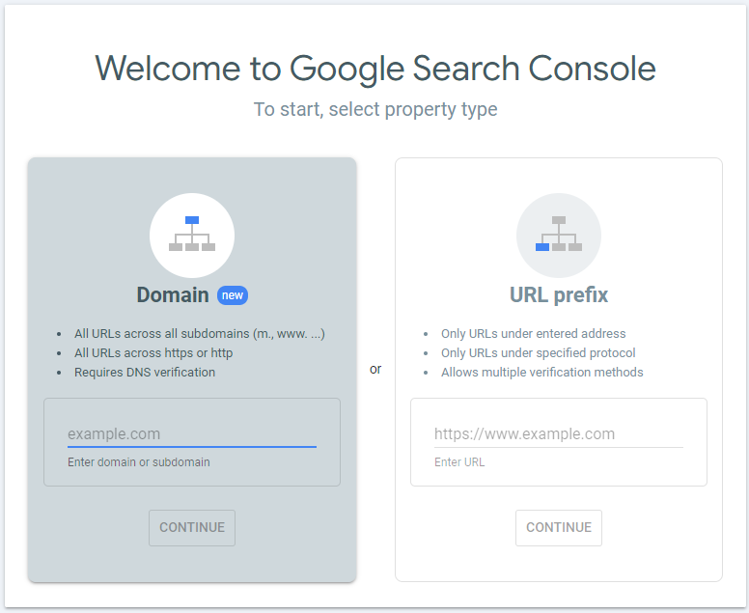
To submit to Bing (this will also submit to Yahoo):
- Go To Bing Webmaster Tools - https://www.bing.com/webmasters/about
- Submit your sitemap to Bing.
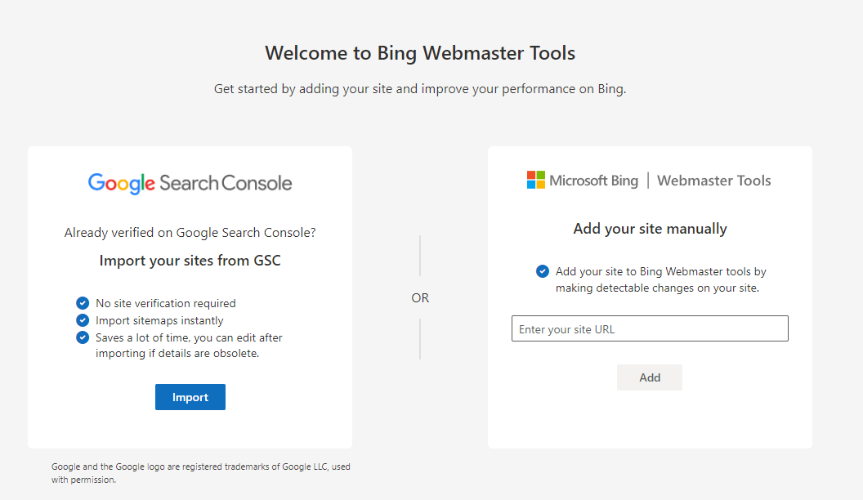

AUTOMATICALLY
Automatically submitting your websites to search engines can have a cost associated with it. Using the software can streamline the process and potentially save time. Please review the options listed.

Option 1: GSA
https://www.gsa-online.de/product/website_submitter/
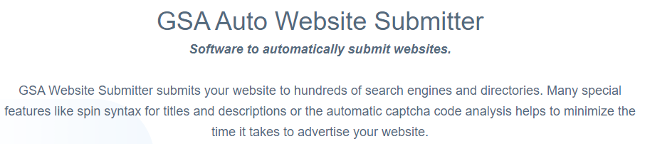
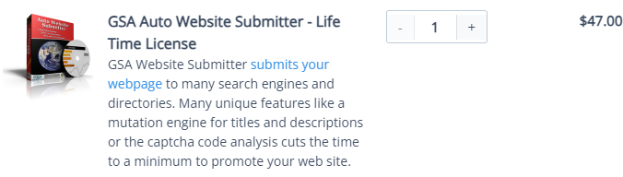

Option 2: SEO ProHub
https://seoprohub.com/seo
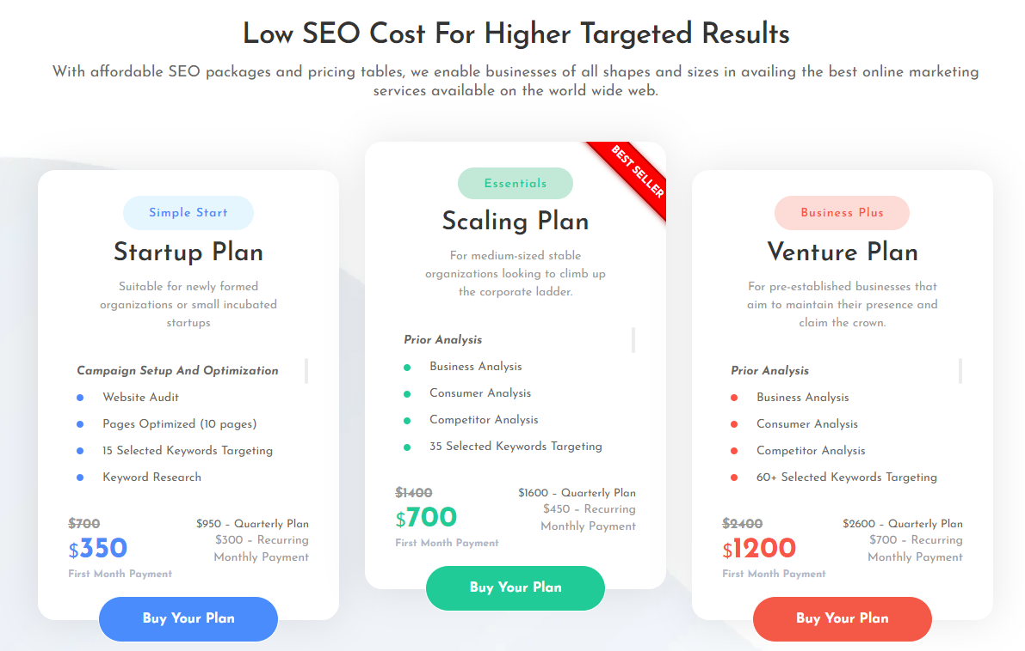

Option 3: Loganix
https://loganix.com/seo-packages/
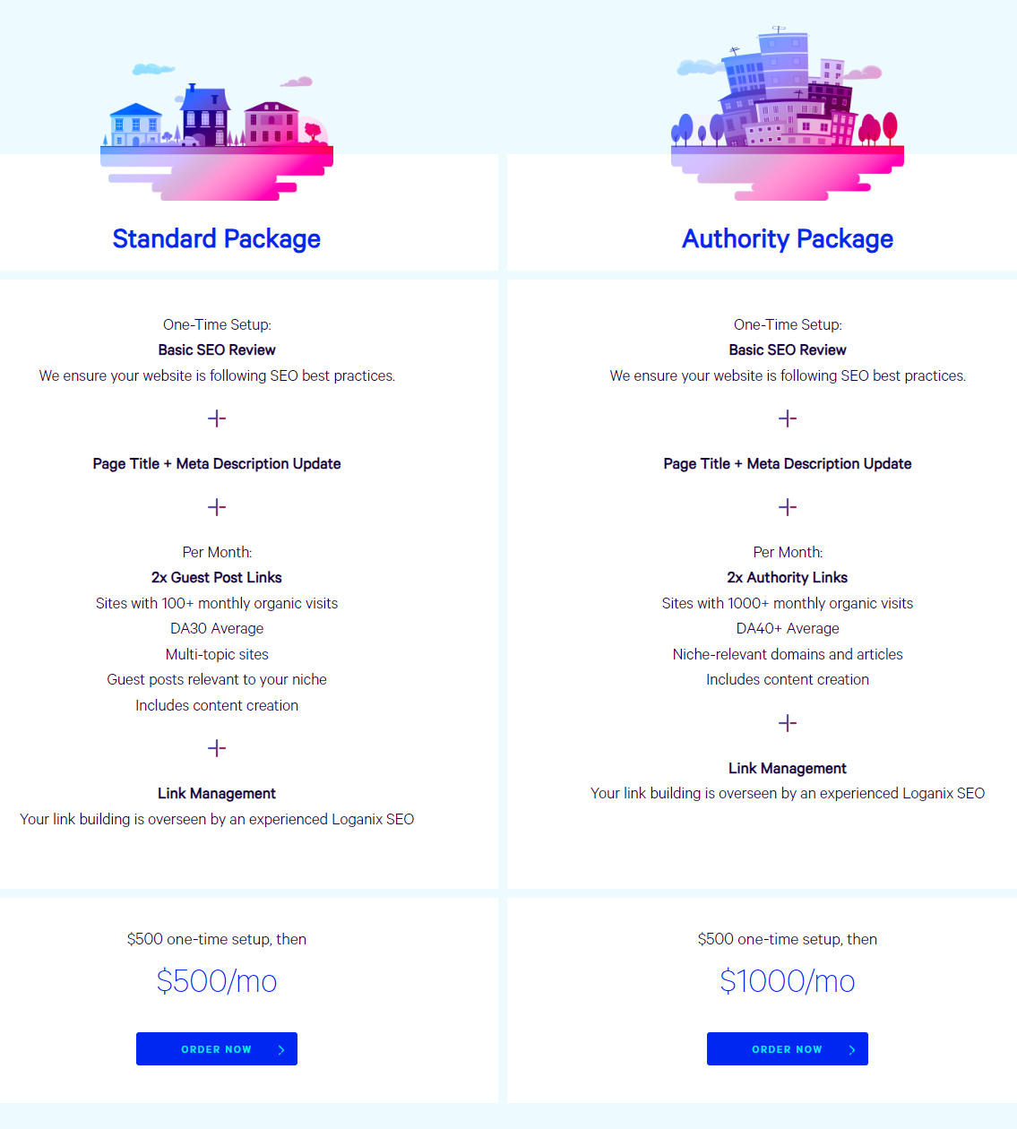

SEO PLAN RECOMMENDATION
Go Social Web Design recommends using the Start-Up Plan from SEO ProHub. This plan would serve you best as a small business looking to grow and expand. It is offered at a lower cost than most others and offers monthly tracking and reporting.

SEO CONSULTING
Go Social Web Design will create or implement the SEO plan you choose. Go Social Web Design’s cost for these SEO services will be $65 per hour.

PAYMENT
Go Social Web Design will send a detailed invoice for the service on the first of each month (for the prior month’s service). The amount will be due within 30 days or the client will risk service disruption until payment is received.

TERMS OF SERVICE
This is an optional add-on service. If the client agrees to the service, the term of service will be 12 months starting from the 1st day of the month following the website's launch date.

Acknowledgment
By signing this document, both parties have approved the recommended SEO plan from SEO ProHub for Red Bovine Dairy Farm’s website and agree to the terms of service.
Client Signature:
x_Adam Saddler___ Date: __4/26/2024___
Project Manager Signature:
x_Molly Atkinson ___ Date: __4/26/24___

Site Announcement Plan

Pre-Launch Activities
- Send emails to current customers who have signed up for mail through their orders.
  - Advertise the new site, and upcoming events, and showcase the 10% off $25 coupon that they get if they get a friend to sign up for the email list
- Advertise the site on social media platforms (Facebook and Instagram)
- Create graphics to share on social media
- Create flyers to post on public boards for those who don’t use the internet often, or those who simply read the news bulletin.
- Create business card designs to include with the bulletin postings
- Create gift card designs and print them through Clover for Businesses

Launch Activities
- Advertising will be changed to direct to the site URL
- Encouragement of sharing the site with friends, family, etc.
- Gift cards will be offered on-site
- Hand out a free ice cream scoop certificate to the first fifty people who visit the site and send in a comment
- The site will be featured on Go Social Website Design’s portfolio/previous client’s page

Post-Launch Activities
- A dedicated email for business inquiries for Red Bovine Dairy will be created, and the contact form will be re-routed to the inbox
- Business cards will continue to be distributed to local businesses or bulletin boards
- Claim business on Google, and link to new site
- Link site on Facebook and Instagram pages

Off-Site Activities
- Contact local newspapers/column editors to see if they are willing to advertise your new site
  - They are likely to charge a fee depending on the size of their audience.
- Contact local small business administration to connect the site to their portfolio/lineup
- Advertise the website through social media, word-of-mouth, and flyers
- Create merch that includes the website, events, etc.
  - This will have to be done independently.

Budget Summary
Go Social Website Design oversees all advertising, designing, and printing of new products. Any changes to designs after they have already been approved will incur a fee dependent on the product and must be done through a change order form.
A week of site maintenance is included for free after the launch. Any other maintenance will follow the maintenance plan and will include various fees dependent on the kind of maintenance.
Go Social is available to assist in the posting of social media posts for up to a month after launch, after that there is a $5 fee for every post created.
Any internal matters that do not include the site or the social media pages (for example, email) are not the responsibility of Go Social Website Design. These tasks fall to the members of Red Bovine Dairy Farms, as we will be unable to assist.
Acknowledgment
By signing this document, both parties have approved the site announcement plan for Red Bovine Dairy’s website.
Client Signature:
x_Adam Saddler___ Date: __4/23/2024___
Project Manager Signature:
x_Molly Atkinson ___ Date: __4/23/24___

Maintenance and Evaluation Plan

Summary
Go Social Website Design is committed to making sure your site performs as smoothly as possible. We perform weekly, monthly, quarterly, and annual maintenance of your website. Under each duration of maintenance is what will be done to your site. Please keep in mind that if a task is under a certain duration, that doesn’t mean it can’t be done earlier. Please contact our website design team if any problems occur before scheduled maintenance for that issue occurs.

Weekly Maintenance
Weekly maintenance will be completed on Sundays, by 11:59 PM (CST). These maintenance tasks include, but aren’t limited to:
- Backup Data: Regularly back up the website's data to ensure a recent copy in case of emergencies.
- Check Website Speed: Monitor website speed using tools like Google PageSpeed Insights or GTmetrix and address any issues affecting loading times.
- Review Security Logs: Check for any suspicious activities or security breaches in the website’s logs.
- Update Content: Refresh content, such as blog posts, news updates, or product listings.
- Test Contact Forms: Verify that all contact forms are functioning correctly, and inquiries are received.

Monthly Maintenance
- Software Updates: Update the website’s plugins, themes, and other software to the latest versions.
- SEO Analysis: Conduct an SEO audit to optimize website content, meta tags, and keywords.
- Review Analytics: Analyze website traffic, user behavior, and conversion rates using tools like Google Analytics.
- Check Broken Links: Scan the website for broken links
- Monitor Server Performance: Check server performance metrics to ensure optimal uptime and response times.

Quarterly Maintenance
- Security Audit: Conduct a security audit to identify and address any potential vulnerabilities or weaknesses in the website's infrastructure.
- Review Backup Procedures: Evaluate backup procedures and ensure that backups are being stored securely and are easily retrievable if needed.
- Update Policies and Terms: Review and update website policies, terms of service, and privacy policies to comply with any regulatory or business practice changes
- Check Mobile Compatibility: Test the website's compatibility and performance on various mobile devices and screen sizes.

Annual Maintenance
- Domain Renewal: Renew the website's domain name registration
- Content Audit: Conduct a thorough review of all website content, archiving outdated or irrelevant material and updating or creating new content as needed.
- Accessibility Compliance: Ensure that the website meets accessibility standards, such as Web Content Accessibility Guidelines, to accommodate users with disabilities.
- Performance Review: Assess overall website performance and user experience, making strategic improvements to enhance functionality, design, and content.
- Disaster Recovery Test: Perform a simulated disaster recovery test to ensure that backup procedures are effective, and that the website can be restored quickly

Maintenance Renewal
Go Social Website Design is devoted to keeping Red Bovine Dairy’s website functional, up-to-date, and safe. If the client wishes to renew the above maintenance agreement following the agreed upon time period of one yea, they will contact Go Social. From there, a new agreement will be written, followed by the signatures of the client and one of the Go Social team members dedicated to the site.

Evaluation Plan
Go Social Website Design will review Red Bovine Dairy’s website yearly to analyze the website. SEO, UI, and performance will be evaluated. The following steps will be taken when evaluating the website:
- SEO Optimization
- User interface
- Usability
- Accessibility
- Graphic design
- Navigation
After the initial evaluation, Go Social Website Design will develop an update based on key points from the evaluation. After this update is planned, it will be presented to the client, who will then either confirm or deny it. If the update is denied, the client must give valid reasoning as to their denial, and what they would want to change instead. These updates do not include making the site over from scratch. The site’s files will be updated to reflect the changes highlighted in the update plan.

Acknowledgments
By signing this document, both parties have approved the maintenance and evaluation plan for Red Bovine Dairy’s website.
x_Adam Saddler___ Date: __4/23/2024___
Project Manager Signature:
x_Molly Atkinson ___ Date: __4/23/24___

Dairy farmer demographics in the United States - CareerExplorer. (n.d.). Dairy Farmer Demographics in the United States - CareerExplorer. https://www.careerexplorer.com/careers/dairy-farmer/demographics/
Dairy Farmer Demographics and Statistics [2024]: Number Of Dairy Farmers In The US. (2021, January 29). Dairy Farmer Demographics and Statistics [2024]: Number of Dairy Farmers in the US. https://www.zippia.com/dairy-farmer-jobs/demographics/
Wisconsin lost 10% of farms, 30% of dairies in 5 years, U.S. agriculture census shows. (n.d.). Wisconsin State Farmer. https://www.wisfarmer.com/story/news/2024/02/15/latest-census-of-agriculture-finds-wisconsin-farms-still-declining/72570807007/

